Exhibit No.:
Issues: Block Allocation GS Class
Witness: Kim J. Elvington
Sponsoring Party: MO PSC Staff
Type of Exhibit: Direct Testimony
Case No.: GR-2003-0517
Date Testimony Prepared: October 24, 2003

MISSOURI PUBLIC SERVICE COMMISSION

Utility Operations DIVISION

DIRECT TESTIMONY

OF

KIM J. ELVINGTON

UNION ELECTRIC d/b/a

AMERENUE

CASE NO. GR-2003-0517

Jefferson City, Missouri
October 2003
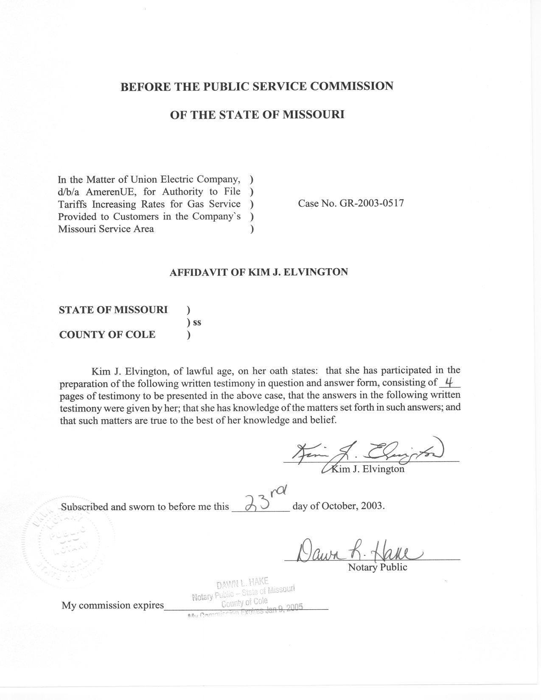

DIRECT TESTIMONY
OF
KIM J. ELVINGTON
UNION ELECTRIC COMPANY
d/b/a/ AMERENUE
CASE NO. GR-2003-0517
Q. Please state your name and business address.
A. Kim J. Elvington, P.O. Box 360, Jefferson City, Missouri 65102.
Q. By whom are you employed and in what capacity?
A. I am a Regulatory Economist with the Missouri Public Service Commission (Commission).
Q. Please describe your educational background.
A. I attended William Woods University in Fulton, Missouri, where I obtained a Master of Business Administration degree in December 1998. Prior to graduate school, I attended Columbia College in Columbia, Missouri, from which I received a Bachelor of Science degree in Business Administration, with a major in Management, in May 1997.
Q. What has been the nature of your duties with the Commission?
A. Since January 2000, I have worked in the Commission’s Energy Tariffs/Rate Design Department, where my main duties consist of analyzing and evaluating various tariff filings from regulated utilities operating in the state of Missouri and making recommendations to the Commission regarding those filings.
Q. Have you previously filed testimony before this Commission?
A. Yes, I have filed testimony relating to Case Nos. GR-2001-292 involving Missouri Gas Energy and GR-2002-356 regarding Laclede Gas Company.
Q. With reference to Case No. GR-2003-0517, have you made an examination and study of the material filed by Union Electric Company d/b/a/ AmernUE, (AmerenUE or Company) relating to its proposed increase in rates?
A. Yes, I have.
Q. What is the purpose of your Direct Testimony?
A. My Direct Testimony covers the billing unit allocation for adjustments to test-year volumes for AmerenUE’s General Service rate class computed by Staff Witness Mr. James Gray of the Commission’s Energy Tariff/Rate Design Department, based on the difference between test-year and normal weather. The monthly, test-year volumes (Schedule 1), computed adjustments allocated to the rate blocks (Schedule 2), and the final results of this adjustment for weather (Schedule 3) are shown on Schedules 1-3.
GENERAL SERVICE BILLING DETERMINANTS
Q. What are the billing determinants established for the General Service (GS) class by the current rate design and how are Mr. Gray’s usage adjustments for weather allocated according to these billing determinants?
A. The General Service (GS) class rates are differentiated into two blocks. The first block for the GS Commercial and Industrial class includes usage from 0 - 7,000 Ccf per billing cycle and the second block includes all usage over 7000 Ccf per billing cycle. In order for Staff Witness Ms. Leasha S. Teel of the Commission’s Auditing Department to compute the revenues associated with the weather adjusted volumes, these volumes must be properly allocated to the blocks to determine the rate at which they would be billed.
Q. What data are used to compute these billing determinants?
A. The Company provided Staff with test year billed volumes by rate block for the GS Commercial and Industrial customer class and rate codes through the known and measurable period. I used the Company's blocked volumes for the period of July 2002 through June 2003 to determine the percentage of usage falling into each rate block for each month. Staff utilized this period due to a change in the Company’s accounting system. The July 2002 through June 2003 period provided Staff with a full 12 months of data accounted for under the Company’s new accounting system.
Q. How did you use that data to determine normal billing determinants for the test-year?
A. For the GS customer class, the monthly bill frequency data and the percent of use in the initial block is highly correlated with the monthly average use per customer per day. Regression analysis was used to derive an equation that quantified the relationship between the percentage of use in a given block in a month and the average use per customer per month. This equation was used to allocate normal volumes, computed by Mr. Gray, to rate blocks in each month. Estimated normal usage per customer, computed by Mr. Gray, was used as the independent variable in the estimated regression equations to estimate normal usage in the initial block. The difference between the predicted normal initial block volumes and predicted actual first block volumes gives an estimated adjustment for each month for the first block, and the adjustment in the second block is set equal to the total volumes adjustment minus the initial block volumes adjustment.
The block adjustments are restricted in each month so the individual block adjustments cannot have different signs than the total adjustment. If a block adjustment initially has a sign different than the total adjustment, the adjustment to the volumes in the first block is set to zero. The second block is then equal to the total adjustment. The allocations of monthly adjusted test-year volumes to the blocks for the GS customer class are provided in Schedule 1. The normal blocked billing units for the GS class (Schedule 3) are obtained by adding the test-year adjustments (Schedule 2) to the test-year actual volumes (Schedule 1).
Q. What is the Staff's recommendation for weather adjusted gas usage for the GS customer classes?
A. Staff recommends that the adjustments to volumes in each billing month of the test-year that appear in Schedule 2 be used to calculate revenue adjustments in this case. These monthly adjustments are computed for each block in the GS customer class. Q. Does this conclude your Direct Testimony?
A. Yes, it does.

