Exhibit No.:
Issues: Weather Normalization
and Normal Weather

Witness: Richard J. Campbell
Sponsoring Party: MO PSC Staff
Type of Exhibit: Direct Testimony
Case No.: ER-2004-0570
Date Testimony Prepared: September 20, 2004

MISSOURI PUBLIC SERVICE COMMISSION
UTILITY OPERATIONS DIVISION
DIRECT TESTIMONY
OF
RICHARD J. CAMPBELL
THE EMPIRE DISTRICT ELECTRIC COMPANY
CASE NO. ER-2004-0570

Jefferson City, Missouri
September 2004
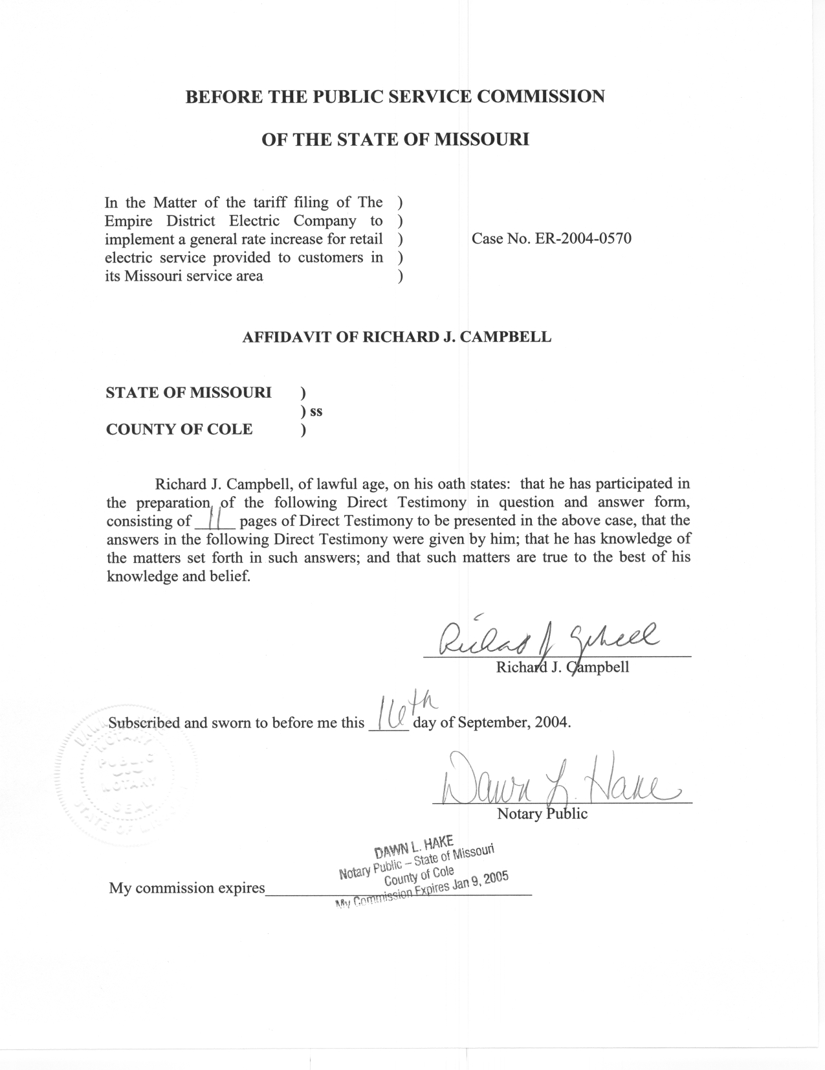
TABLE OF CONTENTS

NORMALIZATION OF USAGE 2
HOURLY NET SYSTEM LOADS 5
NORMAL WEATHER VARIABLES 9

DIRECT TESTIMONY
OF

RICHARD J. CAMPBELL
EMPIRE DISTRICT ELECTRIC COMPANY
CASE NO. ER-2004-0570

- Please state your name and business address.
A. My name is Richard J. Campbell and my business address is Missouri Public Service Commission, P.O. Box 360, Jefferson City, MO 65102.
Q. What is your present position with the Missouri Public Service Commission (Commission)?
A. I am a Utility Regulatory Engineer I in the Engineering Analysis Section, Energy Department, Utility Operations Division.
Q. Would you please review your educational background and work experience.
A. In May of 1995, I received a Bachelor of Science Degree in Chemical Engineering from the University of Missouri in Columbia. In July of 1995, I began working for the Missouri Department of Natural Resource Air Pollution Control Program as an environmental engineer. I was employed with the Air Pollution Control Program from July 1995 until November 2001. I joined the Commission Staff (Staff) in November 2001. I am a registered Professional Engineer in the State of Missouri.
Q. Have you previously filed testimony before this Commission?
A. Yes, please refer to Schedule 1 for a list of the cases that I have filed testimony in.
Q. What is the purpose of your Direct Testimony?
A. The purpose of my testimony is to recommend that the Commission adopt the weather and days adjustments to class usage for the weather sensitive rate classes of The Empire District Electric Company (EDE). These adjustments are listed in Schedule 2 by rate class. Staff witness Janice Pyatte calculated adjustments to revenues based on these weather adjustments to class usage. These adjustments to class usage were also included in the calculation of hourly generation requirements.
I also recommend that the Commission adopt the hourly net system load that I calculated. Staff witness Leon Bender used these hourly loads in estimating the normalized fuel and purchased power expenses for the test year. A monthly summary of the normalized net system load for EDE is shown in Schedule 3.

NORMALIZATION OF USAGE

Q. Why is it necessary to weather normalize electricity usage?
A. Electricity use is very sensitive to weather conditions. Because of the high saturation of air conditioning and electric space heating in EDE’s Missouri territory, the magnitude of EDE’s load is directly related to daily temperatures. The weather during the test year differed from normal conditions. The average daily temperatures during the months of January, February, and March of the test year were cooler than normal, resulting in greater usage than normally would have occurred. The month of June and the first half of September were cooler than normal resulting in lower electricity usage. The month of August was warmer than normal resulting in higher electricity usage than what would normally be expected. November and December of 2003 were also warmer on average than normal, which resulted in less heating use and lower total electricity usage.
Q. What method did you use to calculate the weather adjustments to class usage?
A. I used the Electric Power Research Institute (EPRI) Hourly Electric Load Model (HELM) to calculate the weather adjustments to class usage. In this model, the response to daily weather is first estimated for each of the rate classes from hourly load data. Weather normalized usage is then calculated for each month for each of the weather sensitive classes, based on the estimated response given normal weather variables (discussed later in this testimony). The weather adjustment to class usage is calculated as the difference between the weather normalized usage and the actual usage.
Q. How did you calculate the days adjustment?
A. HELM’s output provides weather normalized usage on both a billing month and a calendar month basis. The difference between billing month and calendar month usage is referred to as the days adjustment.
Q. What are the inputs to this model?
A. There are four data inputs into the model – actual billing month class usage, hourly class load data, and actual and normal daily weather variables. The actual month class usage and the hourly class loads were supplied by EDE in response to Staff Data Request Nos. 16, 145, and 328. Staff witness George Chikhladze supplied the actual high and low temperatures for the test year and the history of high and low temperatures that I used to calculate daily normal weather, as described in the normal weather section of this testimony.
Q. How did you determine which rate classes were weather sensitive and did you independently perform a weather impact analysis on hourly class load data to determine the appropriate weather response functions?
A. Yes. EDE supplied hourly class load data for the time period dating January 1, 2002 through December 31, 2003. The hourly loads were plotted against mean daily temperature to ascertain the weather sensitivity of each class. The hourly loads from the classes that were found to be weather sensitive were then used to develop weather response functions in the HELM model.
Q. Which classes were deemed to be weather sensitive?
A. The rate classes that were deemed to be weather sensitive were the residential (RG), commercial (CB), space heating (SH), total electric building (TEB), and general power (GP) classes.
Q. Were weather and days adjustments made to non-Missouri usage?
A. Yes, non-Missouri usage was weather normalized and days adjustments were calculated using the same method used for Missouri usage. I combined all of the usage for each rate class that was weather sensitive from all of the non-Missouri jurisdictions by billing month, and billing cycle to calculate non-Missouri weather normalized usage.
Q. Did you make any adjustments or corrections to the billing cycle usage data?
A. Yes. The usage data provided by EDE, in response to Staff DR No. 16, was disaggregated by billing cycle. While reviewing this billing cycle data, I noticed that the usage in some billing cycles was negative, indicating billing corrections had occured. I was able to eliminate the negative usage by combining obvious incorrectly billed usage with the corresponding canceled usage and rebilled usage from the billing cycle data.
Q. Do any Missouri electric utilities use HELM?
A. Yes. Kansas City Power & Light Company (KCPL), Aquila, AmerenUE, and EDE have all used HELM to analyze loads in the past as part of their Missouri resource planning programs. KCPL and EDE have both used HELM to weather normalize billing month usage and hourly loads in recent rate design cases. EDE also used HELM to weather normalize usage in this case as well as its most recent prior rate case. In the AmerenUE complaint case, Case No. EC-2002-1, Staff adopted AmerenUE’s weather normalized usage, which was normalized using HELM.
Q. Has Staff previously used HELM?
A. Yes, Staff has used HELM in rate cases involving EDE and Aquila.
Q. Which Staff witnesses relied on the adjustments to usage that you calculated?
A. Staff witness Janice Pyatte calculated the corresponding adjustments to Missouri retail revenues. The weather and days adjustments were also included in the adjustments provided by Ms. Pyatte to Staff witness Alan J. Bax for use in deriving the Staff’s energy allocation factors.
These adjustments to class usage were also included in the hourly net system loads that I provided to Staff witness Leon Bender for use in the normalization of fuel costs.

HOURLY NET SYSTEM LOADS

- What are hourly net system loads?
A. Hourly net system loads are the hourly electric supply necessary to meet the energy demands of the company’s customers and the company’s own internal needs. It is net of (i.e., does not include) station use, which is the electricity requirement of the company’s generating plants. The hourly loads used in my analysis of the test year January 2003 through December 2003 were provided to Staff in response to Data Request No. 15. I also used hourly load data submitted monthly by EDE in response to the Commission’s rule 4 CSR 240-3.190 as a cross check to correct errors that were found in the data request response.
Q. What method did Staff use to weather normalize net system hourly loads?
A. The Staff’s weather normalization procedure was developed by the Economic Analysis Department of the Commission in 1988. The process is described in detail in the document Weather Normalization of Electric Loads, Part A: Hourly Net System Loads (November 28, 1990), written by Dr. Michael Proctor, who at the time was Manager of the Economic Analysis Department.
Q. Briefly summarize the process you use.
A. In order to reflect normal weather, daily peak and average loads are adjusted independently, but using the same methodology. Independent adjustments are necessary because average loads respond differently to weather than peak loads.
Daily average load is calculated as the daily energy divided by 24-hours and the daily peak is the maximum hourly load for the day. Separate regression models estimate both a base component, which is allowed to fluctuate across time, and a weather sensitive component, which measures the response to daily fluctuations in weather for daily average loads and peak loads. The regression parameters, along with the difference between normal and actual cooling and heating measures, are used to calculate weather adjustments to both the average and peak loads for each day. The adjustments for each day are then added respectively to the actual average and peak loads for each day.
The starting point for allocating the weather normalized daily peak and average loads to the hours of the test year is the actual hourly loads. A unitized load curve is calculated for each day as a function of the actual peak and average loads for that day. The corresponding weather normalized daily peak and average loads, along with the unitized load curves, are used to calculate weather normalized hourly loads.
This process includes many checks and balances, which are included in the spreadsheets that are used. In addition, the analyst is required to examine the data at several points in the process.
Q. Has this method been used in other rate cases?
A. Yes, this method has been used in several cases before this Commission. Please refer to Schedule 4 for a list of these cases.
Q. What data was used in this process?
A. Actual hourly net system loads for the time period from October 1, 2002 through March 31, 2004, were provided by EDE in response to Staff Data Request No.15. The actual daily weather variables were supplied to me by Staff witness George Chikhladze. I calculated the normal weather variables using a method developed by the Staff in 1991. The process is described later in this testimony.
Q. Were modifications made to the test year weather normalized hourly net system loads to account for Staff adjustments to test year usage?
A. Yes. I adjusted the weather-normalized hourly net system loads to be consistent with the Staff’s weather-normalized, annualized test year usage so that the estimated fuel expense would be consistent with the usage level Staff used in calculating revenues.
Q. How were the hourly loads adjusted to account for the annual adjustments to usage?
A. I added weather normalized wholesale usage and company usage to the Staff’s weather normalized, annualized test year usage for both Missouri and non-Missouri. Then, I increased the adjusted annual usage by the loss factor supplied to me by Staff witness Alan Bax in order to include the additional amount of generation and/or purchased power necessary to serve this additional usage. A factor was applied to each hour of the weather normalized loads to produce an annual sum of the hourly net system loads that equals the adjusted test year usage, consistent with normalized revenues, plus losses. A monthly summary of the adjusted loads is shown on Schedule 3.
Q. How was the weather adjustment for wholesale usage calculated?
A. The weather adjustment for wholesale usage was calculated using the same methodology used to weather normalize the net system load. EDE supplied hourly wholesale load data for October 1, 2002 through March 31, 2004, in response to Staff Data Request No. 294.
Q. Did any other staff witness use the weather normalized wholesale usage?
A. No. However, Staff witness Alan J. Bax used the weather adjustment to wholesale usage in his calculation of the Staff’s energy allocation factor.
Q. Which Staff witness used your hourly normalized net system loads?
A. Staff witness Leon Bender used the test year hourly normalized system loads in developing test year fuel and purchase power expense.

NORMAL WEATHER VARIABLES

Q. Who developed the methodology for calculating normal weather variables?
A. Staff developed the methodology for calculating normal weather variables in 1991. This methodology is in the document Weather Normalization of Electric Loads, Demonstration: Calculation of Weather Normals, October 25, 1991.
Q. Briefly explain how normal weather variables are calculated.
A. The normal weather variables are used in both the normalization of class usage and hourly net system loads, and are calculated using Staff’s ranking method and daily weather values for the time period January 1, 1971 through December 31, 2000. Staff’s ranking method calculates daily normal temperature and degree days values for the test year. The primary objective of the Staff’s method is to obtain calculated normal values that range from the temperature value that is “normally” the hottest to the temperature value that is “normally” the coldest because every year in Missouri normally has at least one very hot day and one very cold day.
The calculation of daily normal values begins by ranking the daily mean temperatures in each year of the historical period, 1971 through 2000 in this case. These temperatures are then averaged by rank, not by the day of the year. This results in the normal extreme being the average of the most extreme daily mean temperatures in each year of the historical period. Similarly, the second most extreme normal variable is the average of the second most extreme day of each year and so forth. A similar process is used to calculate monthly rankings for each year in the historical period and a corresponding “normal” monthly ranking and temperature. The “normal” monthly temperatures and rankings are used to maintain the weather patterns present in the test year and the “normal” annual rankings and corresponding temperatures are used to determine magnitude of the normal weather variables for the test year.
Q. Why is the Staff’s method of calculating normal weather variables appropriate?
A. Using ranked normals to calculate the weather adjustment to usage is appropriate because electricity use does not respond to temperature by a constant factor. Customer response to a change in temperature of one degree from 70 to 71 is very different from a change in temperature of one degree from 90 to 91. One of the properties of the Staff’s method is that it minimizes the difference between actual and normal weather. This is very important in trying to capture the characteristic of customer response to weather. The ranking method of calculating normals allows for a more accurate estimate of changes in usage due to deviations from normal weather.
Using ranked normals is therefore important in estimating fuel and purchased power expense because these expenses are greatly impacted by daily weather extremes. Since every year has days with extreme temperatures, the daily normals should also contain extremes. The Staff’s ranking method calculates normal extremes.
In addition, the Staff method of allocating weather normalized net system loads back to the hours of the test year uses the actual hourly load for that day. Daily load shapes are dependent upon the temperature for the day. The Staff’s method for calculating normal weather values and distributing them to the days, minimizes the difference between actual and normal weather. This minimization of weather adjustments is important to the accuracy of the load shape of the net system input for that day.
Q. Who supplied the history of daily temperatures used in your calculation of daily normals?
A. Staff witness George Chikhladze supplied the history of daily temperatures that I used in calculating the daily normal weather values.
Q. Does this conclude your Direct Testimony?
A. Yes, it does.

