Exhibit No.:
Issues: Weather Normalization

Witness: Richard J. Campbell
Sponsoring Party: MO PSC Staff
Type of Exhibit: Direct Testimony
Case No.: ER-2004-0570
Date Testimony Prepared: September 27, 2004

MISSOURI PUBLIC SERVICE COMMISSION

UTILITY OPERATIONS DIVISION

DIRECT TESTIMONY

OF

RICHARD J. CAMPBELL

THE EMPIRE DISTRICT ELECTRIC COMPANY

CASE NO. ER-2004-0570

Jefferson City, Missouri
September 2004
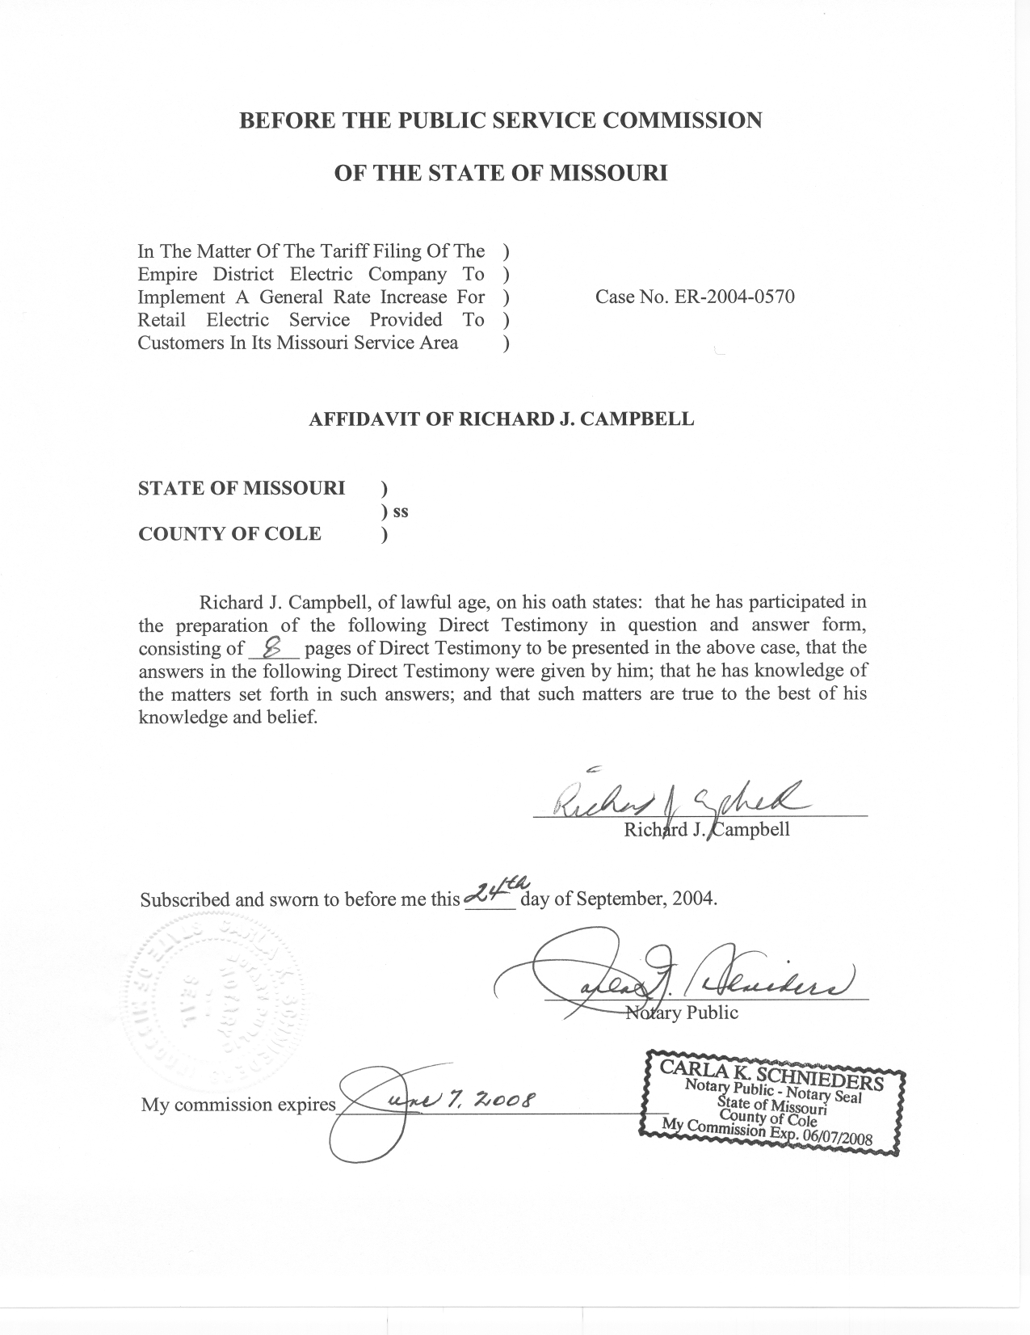

TABLE OF CONTENTS

WEATHER NORMALIZATION OF HOURLY CLASS LOADS 2
LOSS-ADJUSTED CLASS DEMANDS 5
NORMAL WEATHER VARIABLES 6

DIRECT TESTIMONY
OF

RICHARD J. CAMPBELL
THE EMPIRE DISTRICT ELECTRIC COMPANY
CASE NO. ER-2004-0570

Q. Please state your name and business address.
A. My name is Richard J. Campbell and my business address is Missouri Public Service Commission, P.O. Box 360, Jefferson City, MO 65102.
Q. What is your present position with the Missouri Public Service Commission (Commission)?
A. I am a Utility Regulatory Engineer I in the Engineering Analysis Section, Energy Department, Utility Operations Division.
Q. Would you please review your educational background and work experience.
A. In May of 1995, I received a Bachelor of Science Degree in Chemical Engineering from the University of Missouri in Columbia. In July of 1995, I began working for the Missouri Department of Natural Resource Air Pollution Control Program as an environmental engineer. I was employed with the Air Pollution Control Program from July 1995 until November 2001. I joined the Commission Staff (Staff) in November 2001. I am a registered Professional Engineer in the State of Missouri.
Q. Have you previously filed testimony before this Commission?
A. Yes, please refer to Schedule 1 for a list of the cases in which I have filed testimony.
Q. What is the purpose of your Direct Testimony?
A. The purpose of my testimony is to recommend that the Commission adopt the weather normalized hourly class loads, which I calculated. These hourly class loads were used by Staff witness Janice Pyatte in her analysis of The Empire District Electric Company’s (EDE) rate structure. A summary of these loads and adjustments is given by class in schedules two (2) through six (6).
I also recommend that the Commission adopt the loss-adjusted demands that I calculated, and that were used by Staff witness Hong Hu in the evaluation of class cost of service.

WEATHER NORMALIZATION OF HOURLY CLASS LOADS

Q. Why is it necessary to weather normalize hourly class loads?
A. Electricity use is very sensitive to weather conditions. Because of the high saturation of air conditioning and electric space heating in EDE’s Missouri territory, the magnitudes of EDE’s hourly class loads are directly related to daily temperatures. The weather during the test year differed from normal conditions. The average daily temperatures during the months of January, February, and March of the test year were cooler than normal, resulting in greater usage of electricity than normal. The month of June and the first half of September were cooler than normal resulting in lower electricity usage. The month of August was warmer than normal resulting in higher electricity usage than what would normally be expected. November and December of 2003 were also warmer on average than normal, which resulted in less heating use and lower total electricity usage.
Q. What method did you use to calculate the weather adjustments to hourly class loads?
A. The Staff’s weather normalization procedure was developed by the Economic Analysis Department of the Commission in 1988. The process is described in detail in the document Weather Normalization of Electric Loads, Part A: Hourly Net System Loads (November 28, 1990), written by Dr. Michael Proctor, who at the time was Manager of the Economic Analysis Department. While this document describes the application of the method on net system hourly loads, the method is also applicable to hourly class loads.
Q. Briefly summarize the Staff’s weather normalization procedure.
A. In order to reflect normal weather, daily peak and average loads are adjusted independently, but using the same methodology. Independent adjustments are necessary because average loads and peak loads respond differently to weather.
Daily average load is the total daily energy usage divided by 24-hours and daily peak load is the maximum hourly load during the day. Separate regression models estimate both a base component, which is allowed to fluctuate across time, and a weather sensitive component, which measures the response to daily fluctuations in weather, for both daily average loads and peak loads. The regression parameters, along with the difference between normal and actual cooling and heating measures, are used to calculate weather adjustments to both the average and peak loads for each day. The adjustments for each day are then added respectively to the actual daily average load and daily peak load.
The starting point for allocating the weather normalized daily peak load and daily average load to the hours of the test year is the actual hourly loads. A unitized load curve is calculated for each day as a function of the actual peak load and average load for that day. The corresponding weather normalized daily peak load and average load, along with the unitized load curves, are used to calculate weather-normalized hourly loads.
This procedure includes many checks and balances, which are built into in the spreadsheets that are used. In addition, the analyst is required to examine the data at several points in the procedure.
Q. What data did you use in calculating weather-normalized hourly class loads?
A. EDE provided to the Staff hourly class level loads for the time period from July 1, 2002 through December 31, 2003, in response to Staff Data Request No. 145. Staff witness George Chikhladze supplied to me the actual daily weather variables. I calculated the normal weather variables using a method developed by the Staff in 1991. The method is described later in this testimony.
Q. Did you have to make any adjustments to the data before you began the procedure to obtain weather-normalized hourly loads?
A. Yes. When I plotted the average daily class loads against the two-day weighted mean temperature, average daily loads during the month of September 2002 were consistently outside the normal scatter of data that was seen in the remainder of the months. In order to correct, or adjust, for this deviation, I added a linear spline for the month of September in which I used to scale the average daily load to be within the remainder of the data. This adjustment was necessary to keep this high month’s data from causing the model to over predict the cooling response during the test year.
I found the same problem with September 2002 when I plotted the daily peak loads. Therefore, I made a similar correction to the daily peaks in September 2002.
Q. How did you determine which rate classes were weather sensitive?
A. EDE supplied hourly class load data for the time period dating January 1, 2002 through December 31, 2003. I plotted the hourly loads against the two-day weighted mean daily temperature to ascertain the weather sensitivity of each class.
Q. Did you conclude that any classes were weather sensitive?
A. Yes. I concluded that the residential (RG), commercial (CB), space heating (SH), total electric building (TEB), and general power (GP) rate classes were weather sensitive.
Q. Which Staff witnesses in this case use the weather normalized hourly class loads you calculated?
A. Staff witness Janice Pyatte uses the weather normalized hourly class loads in her analysis of EDE’s rate design. Staff witness Hong Hu uses the peak hourly demands calculated from the weather normalized hourly class loads in her analysis of the class cost of service for EDE.

LOSS-ADJUSTED CLASS DEMANDS

- What are loss-adjusted class demands?
A. The loss-adjusted class demands are peak hourly weather normalized loads by class by month for the test year that have been adjust for losses that occur a different stages in the transmission and distribution system.
Q. How did you calculate loss-adjusted class demands in this case?
A. I used my calculated weather normalized hourly class loads to calculate, by class, each peak monthly demand during the test year. I then scaled the peak monthly demands, using loss factors, to reflect the demands that would be required at the generator, primary distribution, and secondary distribution levels.
Q. Who provided the loss factors that you used in calculating the loss-adjusted class demands?
A. I used the loss factor that Staff witness Alan Bax calculated for the hourly net system input along with the loss study EDE provided to the Staff.
Q. Which Staff witness uses the loss-adjusted demands in preparing their testimony in this case?
A. Staff witness Hong Hu uses the loss-adjusted demands in the class cost-of-service study to allocate costs to the individual rate classes.

NORMAL WEATHER VARIABLES

Q. Who developed the methodology you used for calculating normal weather variables?
A. Staff developed the methodology for calculating normal weather variables in 1991. This methodology is in the document Weather Normalization of Electric Loads, Demonstration: Calculation of Weather Normals, October 25, 1991.
Q. Briefly explain how the Staff calculates normal weather variables.
A. Staff uses a ranking method and daily weather values for the time period January 1, 1971 through December 31, 2000. The primary objective of the Staff’s method is to obtain calculated normal values that range from the temperature value that is “normally” the hottest to the temperature value that is “normally” the coldest because every year in Missouri normally has at least one very hot day and one very cold day.
Staff ranks the daily mean temperatures in each year of the historical period, 1971 through 2000 in this case. These temperatures are then averaged by rank, not by the day of the year. Given that the historical period is 30-years, each rank in this case consists of a group of 30 temperatures. Thus, for example, the highest daily mean temperature is calculated by averaging the 30 highest daily temperatures that occurred in the period 1971 through 2000. This results in the normal extreme being the average of the most extreme daily mean temperatures in each year of the historical period. Similarly, the second most extreme normal variable is the average of the second most extreme day of each year and so forth. A similar process is used to calculate monthly rankings for each year in the historical period and a corresponding “normal” monthly ranking and temperature. The “normal” monthly temperatures and rankings are used to maintain the weather patterns present in the test year and the “normal” annual rankings and corresponding temperatures are used to determine magnitude of the normal weather variables for the test year.
Q. Why is the Staff’s method of calculating normal weather variables appropriate?
A. Using ranked normals to calculate the weather adjustment to usage is appropriate because electricity use does not respond to temperature by a constant factor. Customer response to a change in temperature of one degree from 70 to 71 is very different from a change in temperature of one degree from 90 to 91. One of the properties of the Staff’s method is that it minimizes the difference between actual and normal weather. This is very important in trying to capture the characteristic of customer response to weather. The ranking method of calculating normal variables allows for a more accurate estimate of changes in usage due to deviations from normal weather. In addition, the Staff method of allocating weather normalized net system loads back to the hours of the test year uses the actual hourly load for that day. Daily load shapes are dependent upon the temperature for the day. The Staff’s method for calculating normal weather values and distributing them to the days, minimizes the difference between actual and normal weather. This minimization of weather adjustments is important to the accuracy of the load shape of the net system input for that day.
Q. Who supplied the history of daily temperatures that you used in your calculation of daily and monthly normal weather variables?
A. Staff witness George Chikhladze supplied the history of daily temperatures that I used in calculating the daily normal weather values.
Q. Does this conclude your Direct Testimony?
A. Yes, it does.

