Exhibit No.:
Issues: Revenue-Weather
Normalization

Witness: Richard J. Campbell
Sponsoring Party: MO PSC Staff
Type of Exhibit: Rebuttal Testimony
Case No.: ER-2004-0034
& HR-2004-024
Date Testimony Prepared: January 26, 2004

MISSOURI PUBLIC SERVICE COMMISSION

Utility Operations DIVISION

REBUTTAL testimony

OF

Richard J. Campbell

AQUILA, INC.
D/B/A AQUILA NETWORKS – MPS
AND AQUILA NETWORKS – L&P

CASE NOS. ER-2004-0034 & HR-2004-0024
(CONSOLIDATED)

Jefferson City, Missouri
January 2004

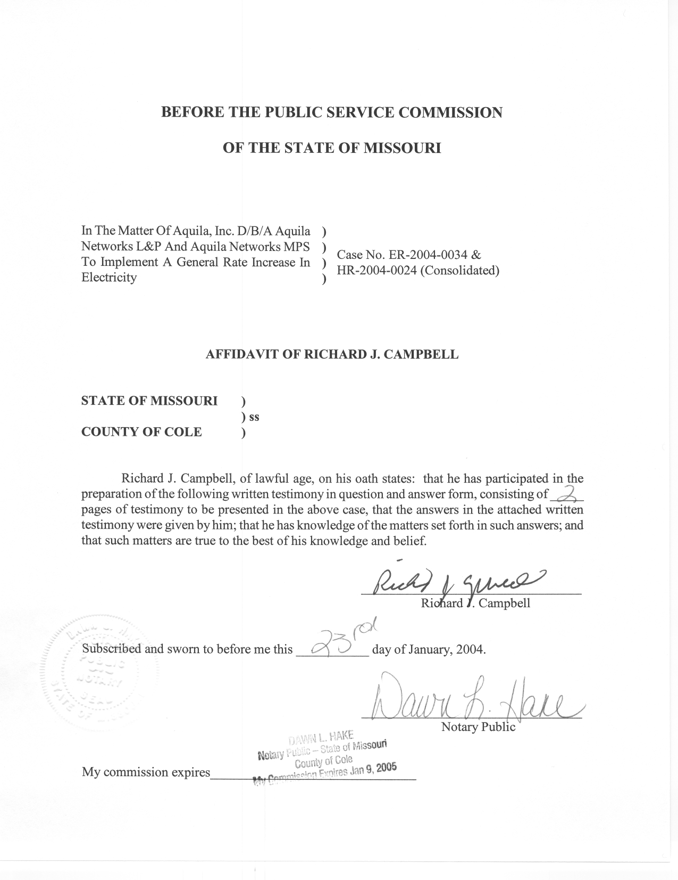
REBUTTAL TESTIMONY

OF
RICHARD J. CAMPBELL
AQUILA NETWORKS, INC.
D/B/A AQUILA NETWORKS – MPS
AND AQUILA NETWORKS – L&P
CASE NOS. ER-2004-0034 AND HR-2004-0024
(CONSOLIDATED)

Q. Please state your name.
A. My name is Richard J. Campbell.
Q. Are you the same Richard J. Campbell that previously filed direct testimony in this case?
A. Yes, I am.
Q. What is the purpose of your rebuttal testimony?
A. The purpose of my rebuttal testimony is to introduce revised net system hourly loads for Aquila Networks - MPS.
Q. Did any party raise any issue regarding net system hourly loads during the prehearing conference?
A. No issues were raised regarding the methodology I used or the calculations I performed.
Q. Did the net system hourly loads for the MPS system change? Why?
A. Yes, the net system hourly loads for the MPS system changed. The load changes reflect adjustments to normalized customer usage made by Staff Witness Amanda McMellen.
Q. Did the changes in load affect any other staff witness?
A. Yes. I supplied the revised hourly loads to Staff witness David Elliott.
Q. Did any party raise any issue regarding the weather normalization or days adjustments to usage that you presented in your direct testimony during the prehearing conference?
A. No issues were raised regarding the methodology I used or the calculations I performed.
Q. Did any party raise any other issue regarding normal weather variables during the prehearing conference?
A. No issues were raised regarding the methodology I used or the calculations I performed.
Q. Does this conclude your rebuttal testimony?
A. Yes, it does.

