Exhibit No.:
Issues: Block Allocation for SGS

Witness: Kim J. Elvington
Sponsoring Party: MO PSC Staff
Type of Exhibit: Direct Testimony
Case No.: GR-2004-0209
Date Testimony Prepared: April 15, 2004

MISSOURI PUBLIC SERVICE COMMISSION

UTILITY OPERATIONS DIVISION

DIRECT TESTIMONY

OF

KIM J. ELVINGTON

MISSOURI GAS ENERGY

CASE NO. GR-2004-0209

Jefferson City, Missouri
April 2004
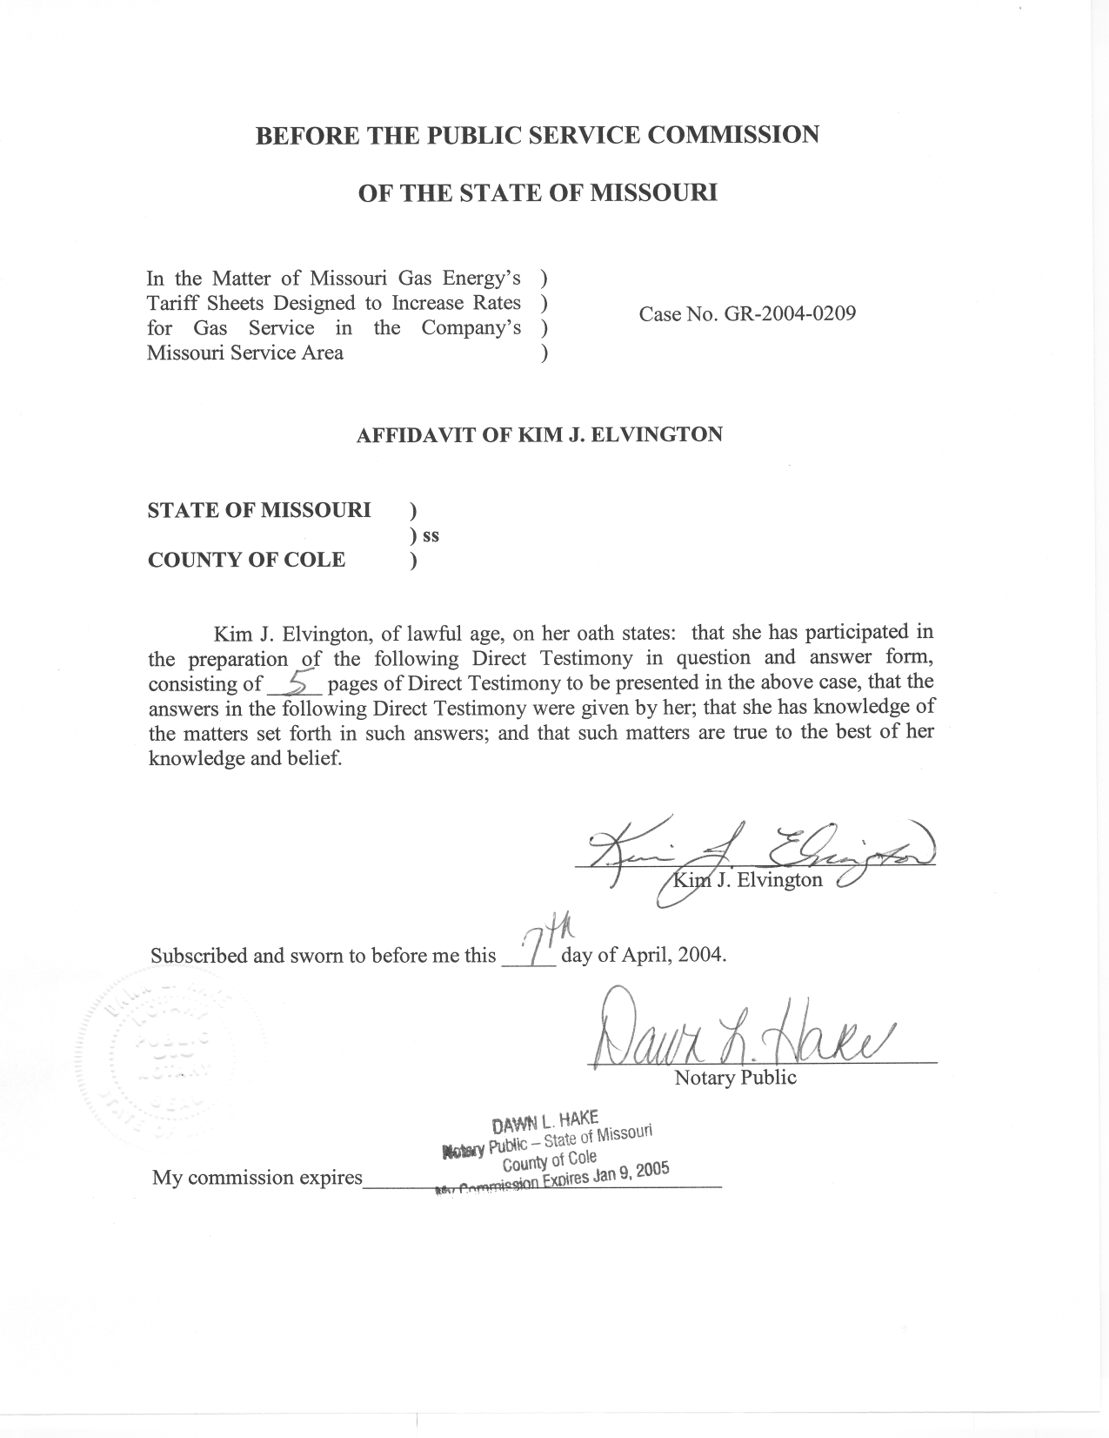

DIRECT TESTIMONY

OF

KIM J. ELVINGTON

MISSOURI GAS ENERGY
CASE NO. GR-2004-0209

Q. Please state your name and business address.
A. My name is Kim J. Elvington and my business address is P. O. Box 360, Jefferson City, Missouri, 65102.
Q. By whom are you employed and in what capacity?
A. I am employed by the Missouri Public Service Commission (PSC or Commission) as a Regulatory Economist in the Energy Department of the Utility Operations Division.
Q. How long have you been employed by the Commission?
A. I have worked at the Commission approximately four years.
Q. Please describe your educational background.
A. I attended William Woods University in Fulton, Missouri, where I obtained a Master of Business Administration degree in December 1998. Prior to graduate school, I attended Columbia College in Columbia, Missouri, from which I received a Bachelor of Science degree in Business Administration, with a major in Management, in May 1997.
Q. What has been the nature of your duties with the Commission?
A. Since January 2000, I have worked in the Commission’s Energy Tariffs/Rate Design Department, where my main duties consist of analyzing and evaluating various tariff filings from regulated utilities operating in the state of Missouri and making recommendations to the Commission regarding those filings.
Q. Have you previously filed testimony before the Commission?
A. Yes, I have filed testimony relating to Case Nos. GR-2001-292 involving Missouri Gas Energy, GR-2002-356 regarding Laclede Gas Company and GR-2003-0517 involving AmerenUE.
Q. What is the purpose of your direct testimony?
A. My direct testimony covers the billing unit allocation for volumes normalized for weather and read cycle days computed by Staff Witness James A. Gray, of the Energy Tariffs/Rate Design Department, in the test year for MGE's Small General Service (SGS) rate class. The test year volumes, the normal volumes, and computed adjustments are shown in Schedules 2-1 through 2-3. The regression is demonstrated in schedule 1.

SMALL GENERAL SERVICE BILLING DETERMINANTS
Q. What billing determinants were established for the SGS class by the current rate design and how are Mr. Gray's normalized volumes allocated according to these billing determinants?
A. MGE's current SGS rates are differentiated into two blocks and two seasons. For SGS customers, the first block, or initial block, contains the first 600 Ccf (hundred cubic feet) of natural gas used in the month and the second block, or tail block, contains all volumes over 600 Ccf per month. In order for Staff witness, Mr. Paul Harrison of the Auditing Department to compute the revenues associated with the normal volumes, the normal volumes must be properly allocated monthly to each block and season to determine the rate at which the volumes are to be computed.
Q. What data are used to compute these billing determinants?
A. The Company provided Staff with test year (July 2002 – June 2003) monthly active meters and volumes by block for the SGS rate code and customer classes served on the SGS tariff. I used the Company's test year blocked volumes to determine the percentage of usage falling into each rate block for each month. Because the rates are the same for the three divisions of their service area – Joplin District, Kansas City District, and St. Joseph District, the monthly data were aggregated over the service areas and the SGS active meters (a.k.a. customers) were combined into a system total.
Q. How did you use that data to determine normalized billing determinants for the test year?
A. For the SGS class, using the monthly bill frequency data for July 2002 – June 2003, the monthly percent of use in the initial block has a high correlation with the monthly average use per customer per day. I observed that in the lower heating months of June through October the percent in the first block is nearly constant. In these months the use per customer is less than 100 Ccf. I used a simple average of the percent in the first block in the test year months June-October to estimate the normal percent in the first block for the months of June-October. For the remaining months, November-May, which have more heating use, I used a regression to estimate an equation that quantified the relationship between the percentage of use in the first block in a month and the average use per customer per month. I used this relationship in order to estimate normal billing units in each month. Using the Company’s test year monthly customer counts and bill frequencies for the SGS class, I used the monthly Ccf per customer per day in the test year months of November 2002 –May 2003 to estimate an equation that related it to the monthly percent use in the first block. Next, the normal monthly usage per customer, computed by Staff Witness Gray, was used in the regression equation to estimate the normal monthly percent in the first block.
In computing the adjustment to the observed test year volumes (Schedule 2-1) that will yield the estimated normal volumes (Schedule 2-2), the adjustment in the second block is set equal to the total minus initial block adjustment (Schedule 2-3). In each month the block adjustments are restricted so neither block can go in a different direction than the total adjustment. If the block adjustments initially have opposite signs, the adjustment of the volumes in the first block is set to zero. The second block adjustment is then equal to the total adjustment. All of the monthly block adjustments were initially in the same direction as the total adjustment so this procedure to make adjustments consistent was not used.
The difference between the predicted normal volumes and test year volumes gives an estimated monthly adjustment for the first block (Schedule 2-3). The monthly adjustments to Test Year volumes in the blocks are in the third column of the Tables in Schedule 2-3. The monthly adjustments are summed into seasonal and annual totals. The normal volumes in the first block are estimated to be 61% of the total and the second block 39% of the total annual volumes (Schedule 2-2).
Q. What is the Staff's recommendation for weather adjusted gas usage for the SGS class?
A. Schedule 2-3 contains the adjustment volumes for each billing month during the test year. The total adjustment for the SGS customer classes is a negative 817,394 Ccf. The total of these adjustments accounts for 100% of the adjustments made to both the first and second blocks. The volumes were allocated to the blocks for the SGS class as shown in Schedule 2-3. These adjustments were supplied to Staff witness Harrison for use in revenue normalization.
Q. Does this conclude your prepared Direct Testimony?
A. Yes, it does.

