Exhibit No.:
Issues: Suspension &
Modification of LNP
Requirements

Witness: Natelle Dietrich
Sponsoring Party: MO PSC Staff
Type of Exhibit: Rebuttal Testimony Case No.: TO-2004-0401
Date Testimony Prepared: July 2, 2004

MISSOURI PUBLIC SERVICE COMMISSION

UTILITY OPERATIONS DIVISION

REBUTTAL TESTIMONY

OF

NATELLE DIETRICH

KLM TELEPHONE COMPANY

CASE NO. TO-2004-0401

Jefferson City, Missouri
July 2004
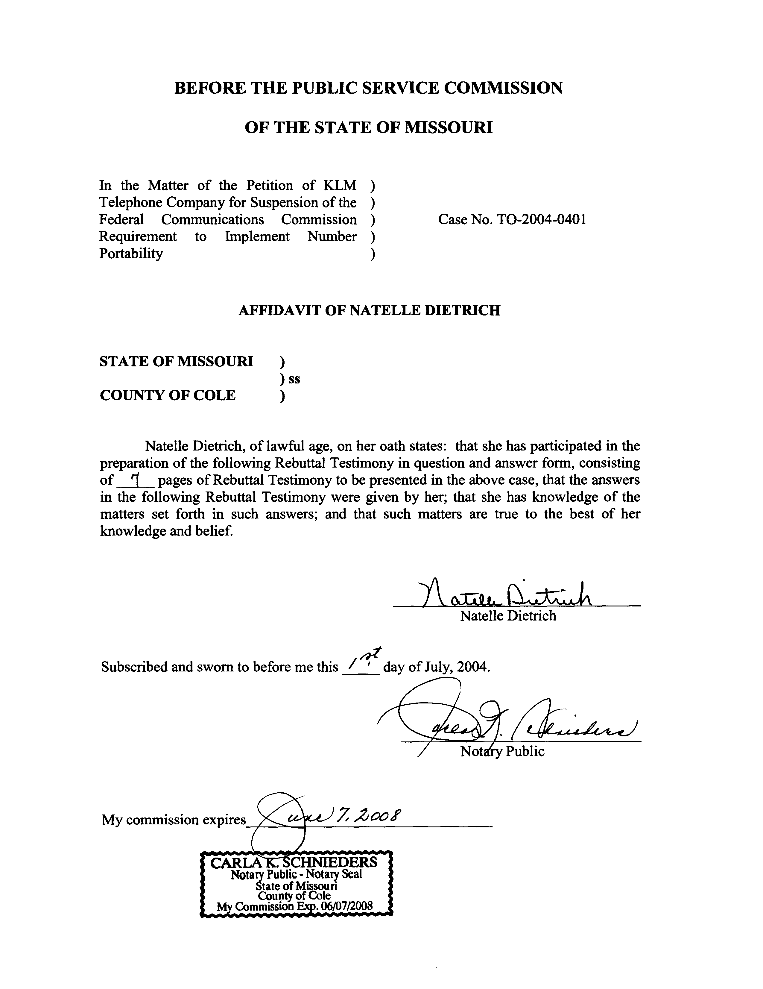

REBUTTAL TESTIMONY

OF

NATELLE DIETRICH

KLM TELEPHONE COMPANY

CASE NO. TO-2004-0401

Q. Please state your name and business address.
A. My name is Natelle Dietrich. I am employed by the Missouri Public Service Commission (Commission), 200 Madison Street, Jefferson City, Missouri, 65101.
Q. Please describe your work experience.
A. I am employed as a supervisor and regulatory economist for the Telecommunications Department Staff (Staff) of the Commission. My duties include the review and analysis of cost studies and the application of general costing theory as it relates to the regulation of telecommunications services with supervisory responsibility to ensure thorough and complete economic analysis of telecommunications issues by the economic/competitive analysis Staff. I have previously testified or filed affidavits in Case Nos. TA-99-405, an analysis of the appropriateness of a “payday loan” company providing prepaid telecommunications service; TO-2001-455, the AT&T/Southwestern Bell Telephone Company (SWBT) arbitration, which included issues associated with unbundled network elements; TO-2001-222, the MCI/SWBT arbitration, which also included issues related to unbundled network elements; TR-2002-251, Sprint’s price cap adjustments; and TO-2004-0370, IO-2004-0467, TO-2004-0505 et al., the present LNP
suspension/modification cases. I have also prepared comments and testified in several proposed rulemakings before the Commission.
As supervisor of the Telecommunications Department economic/competitive analysis group, I have reviewed many cost studies and have had testimony prepared at my direction and under my supervision on many cost related dockets including, but not limited to TO-2001-437, TO-2001-438 and TO-2001-440 (the SWBT 271 “spin-off cases); TR-2001-65, an investigation into the cost of providing switched access service in Missouri; TO-2001-455, the AT&T/SWBT arbitration; TO-2001-222, the MCI/SWBT arbitration; and, TO-2004-0207, the Triennial Review Order proceeding.
Through an appointment to the National Association of Regulatory Utility Commissioners Staff Subcommittee on Telecommunications and as Assistant Chair to the Federal Regulatory Policy Sub-Group, I am responsible for monitoring federal telecommunications activity and informing the Commission of relevant federal activity. I have prepared comments on behalf of the Commission to be filed at the Federal Communications Commission (FCC) on several occasions. These comments included such issues as the Coalition for Affordable Local and Long Distance Service’s (CALLS) modified access charge reform proposal; the Multi-Association Group’s (“MAG”) interstate access reform and universal service support proposal for incumbent local exchange carriers subject to rate-of-return regulation; and, the feasibility of a bill-and-keep approach as means of attaining a unified regime for the flows of payments between carriers. I have also prepared congressional testimony on behalf of the Commission on number conservation efforts in Missouri.
I also worked for over 13 years in lending, analyzing customer credit, financial histories and payment capabilities of individuals and businesses. The last five plus years were spent working in the risk asset unit where I was responsible for and successful in reducing the bank’s risk exposure by several million dollars per year through restructuring high-risk customer debt using means that continue to meet the customer’s financial needs and payment abilities.
Q. Please describe your educational background.
A. I hold a Bachelor of Arts Degree in English from the University of Missouri-St. Louis and a Master’s Degree in Business Administration from William Woods University.
Q. Are you the same Natelle Dietrich that provided testimony during the May 5, 2004 local number portability on-the-record-presentation in Case Nos. TO-2004-0370, IO-2004-0467, TO-2004-0505, et al.?
A. Yes I am.
Q. What is the purpose of your testimony?
A. The purpose of my testimony is to respond to the Direct Testimonies of Mr. Bruce Copsey and Mr. William Warriner on behalf of KLM Telephone Company (KLM) and to support KLM’s request for a two-year suspension of the FCC’s intermodal porting obligations.
Q. What are the issues in this case?
A. The issues in this case are whether KLM should be granted a suspension and modification of the FCC's Local Number Portability (LNP) requirements, and for how long such suspension or modification should be granted.
Q. Has the FCC provided any guidance to state commissions when reviewing requests for suspension of the intermodal porting requirements?
A. Yes. In my opinion, in its November 2003 Memorandum Opinion and Order and Further Notice of Proposed Rulemaking (Order), the FCC made it clear that intermodal porting was required as a means for advancing competition. In its Order, the FCC stated, “the public interest is served by requiring the provision of number portability by CMRS providers because number portability will promote competition between providers of local telephone services and thereby promote competition between providers of interstate access services.” On May 6, 2004, Dane Snowden, Chief of the FCC’s Consumer and Governmental Affairs Bureau sent a letter to Stan Wise, NARUC President, indicating the FCC’s expectations that state commissions carefully consider requests for suspension. On June 18, 2004, Chairman Powell sent a letter to President Wise indicating the FCC’s intent to allow state commissions limited latitude in reviewing requests for suspension. This letter encouraged state commissions to consider relevant cost information when addressing requests for suspension. These letters are attached to my testimony as Exhibits A and B.
Q. In your opinion, is a two-year suspension necessary to avoid a significant adverse economic impact on users of telecommunications generally and also in the public interest?
A. Yes, it is. The FCC indicated that the intermodal porting obligations will promote competition, and in my opinion made it clear that it expected carriers to comply with the May 24, 2004, deadline. For this reason, Staff has only supported suspensions of the FCC’s requirements in limited circumstances. As Mr. Copsey states on page 6 of his Direct Testimony, KLM exchanges are served by Mitel GX 5000 switches. Technical support for Mitel switches will cease on December 31, 2007. In my opinion, it does not make economic sense for KLM to implement local number portability, only to replace the switches in the next few years. Therefore, Staff recommended in its Memorandum filed March 3, 2004, that the Commission grant KLM a two-year suspension to allow time to pursue switch replacement prior to implementing local number portability. The Staff Recommendation is incorporated and attached as Exhibit C.
Q. Does Mr. Warriner or Mr. Copsey indicate any other reason for requesting the suspension?
A. Yes. Mr. Warriner, in the summary of his Direct Testimony beginning on page 11, indicates that KLM also requests the suspension until the FCC addresses the issue of carrier responsibility for the transport of local calls to wireless providers with rate centers outside the local exchange areas of KLM.
Q. You said Staff filed its recommendation in March 2004. Does Staff have any changes to its recommendation?
A. Yes, it does. In its recommendation, Staff stated that modification was not necessary if the Commission granted KLM a two-year suspension of the intermodal porting requirements. The Staff recommends granting modification also. Regardless of when the FCC resolves the routing and rating issues and regardless of when a Petitioner implements intermodal porting, it is, and was, the Staff’s position that neither the Petitioner, nor its wireline customers, should be responsible for any transport or long distance charges associated with porting numbers and any associated calls outside Petitioner’s local service area.
Q. What are the possible implications of the FCC directing intermodal porting prior to addressing the rating and routing issues?
A. KLM has intrastate tariffs on file with the Missouri Public Service Commission. These tariffs outline KLM’s local service area. Transporting calls to numbers that have been ported to a wireless carrier with no point of presence in the KLM local service area could result in KLM inappropriately operating much like an interexchange carrier instead of a local exchange carrier.
Q. Are you suggesting it should be the responsibility of the wireless carrier, in this case, Western Wireless, to bear the transport costs associated with intermodal porting?
A. No, I am not. In its Order, the FCC clearly mandated that intermodal porting should have been implemented by May 24, 2004. Mr. Copsey, on page 7, beginning at line 5, of his Direct Testimony indicates KLM switches could be LNP capable with the appropriate hardware, software and translations. In its Third Report and Order, issued May 1998, the FCC established local number portability (LNP) cost recovery mechanisms allowing incumbent local exchange carriers to recover the costs associated with implementing LNP from its end users. By design KLM can recover the implementation costs from its customers if it so chooses. However, as previously indicated, the FCC left unresolved issues associated with rating and routing calls once a number has ported, creating additional economic issues associated with intermodal porting. In order to complete calls to ported numbers, a company must either build facilities or establish business arrangements with other carriers such as Southwestern Bell Telephone, L.P., d/b/a SBC Missouri or Sprint Missouri, Inc.
Q. Are you recommending the Commission order wireless carriers, including Western Wireless, to establish a point of presence in the KLM service territory?
A. No, I am not. My recommendation typically has been that the Commission find that the companies and/or their end user subscribers are not responsible for establishing facilities or business relationships to transport ported calls. This recommendation would allow the wireless carriers to determine the appropriate method for transporting calls.
Q. What is your recommendation in this case?

A. I continue to support Staff's recommendation in its Memorandum filed March 3, 2004, that the Commission grant KLM a two-year suspension to allow time to pursue switch replacement prior to implementing local number portability. The Staff recommends granting modification also.
Q. Does this end your testimony?
A. Yes it does.

Id. at para. 153.

