Exhibit No.:
Issues: Territorial Agreement

Witness: Alan J. Bax
Sponsoring Party: MO PSC Staff
Type of Exhibit: Cross-Surrebuttal
Testimony
Case No.: EO-2005-0122
Date Testimony Prepared: December 27, 2004

MISSOURI PUBLIC SERVICE COMMISSION

UTILITY OPERATIONS DIVISION

CROSS-SURREBUTTAL TESTIMONY

OF

ALAN J. BAX

GASCOSAGE ELECTRIC COOPERATIVE
AND THREE RIVERS ELECTRIC COOPERATIVE

CASE NO. EO-2005-0122

Jefferson City, Missouri
December 2004
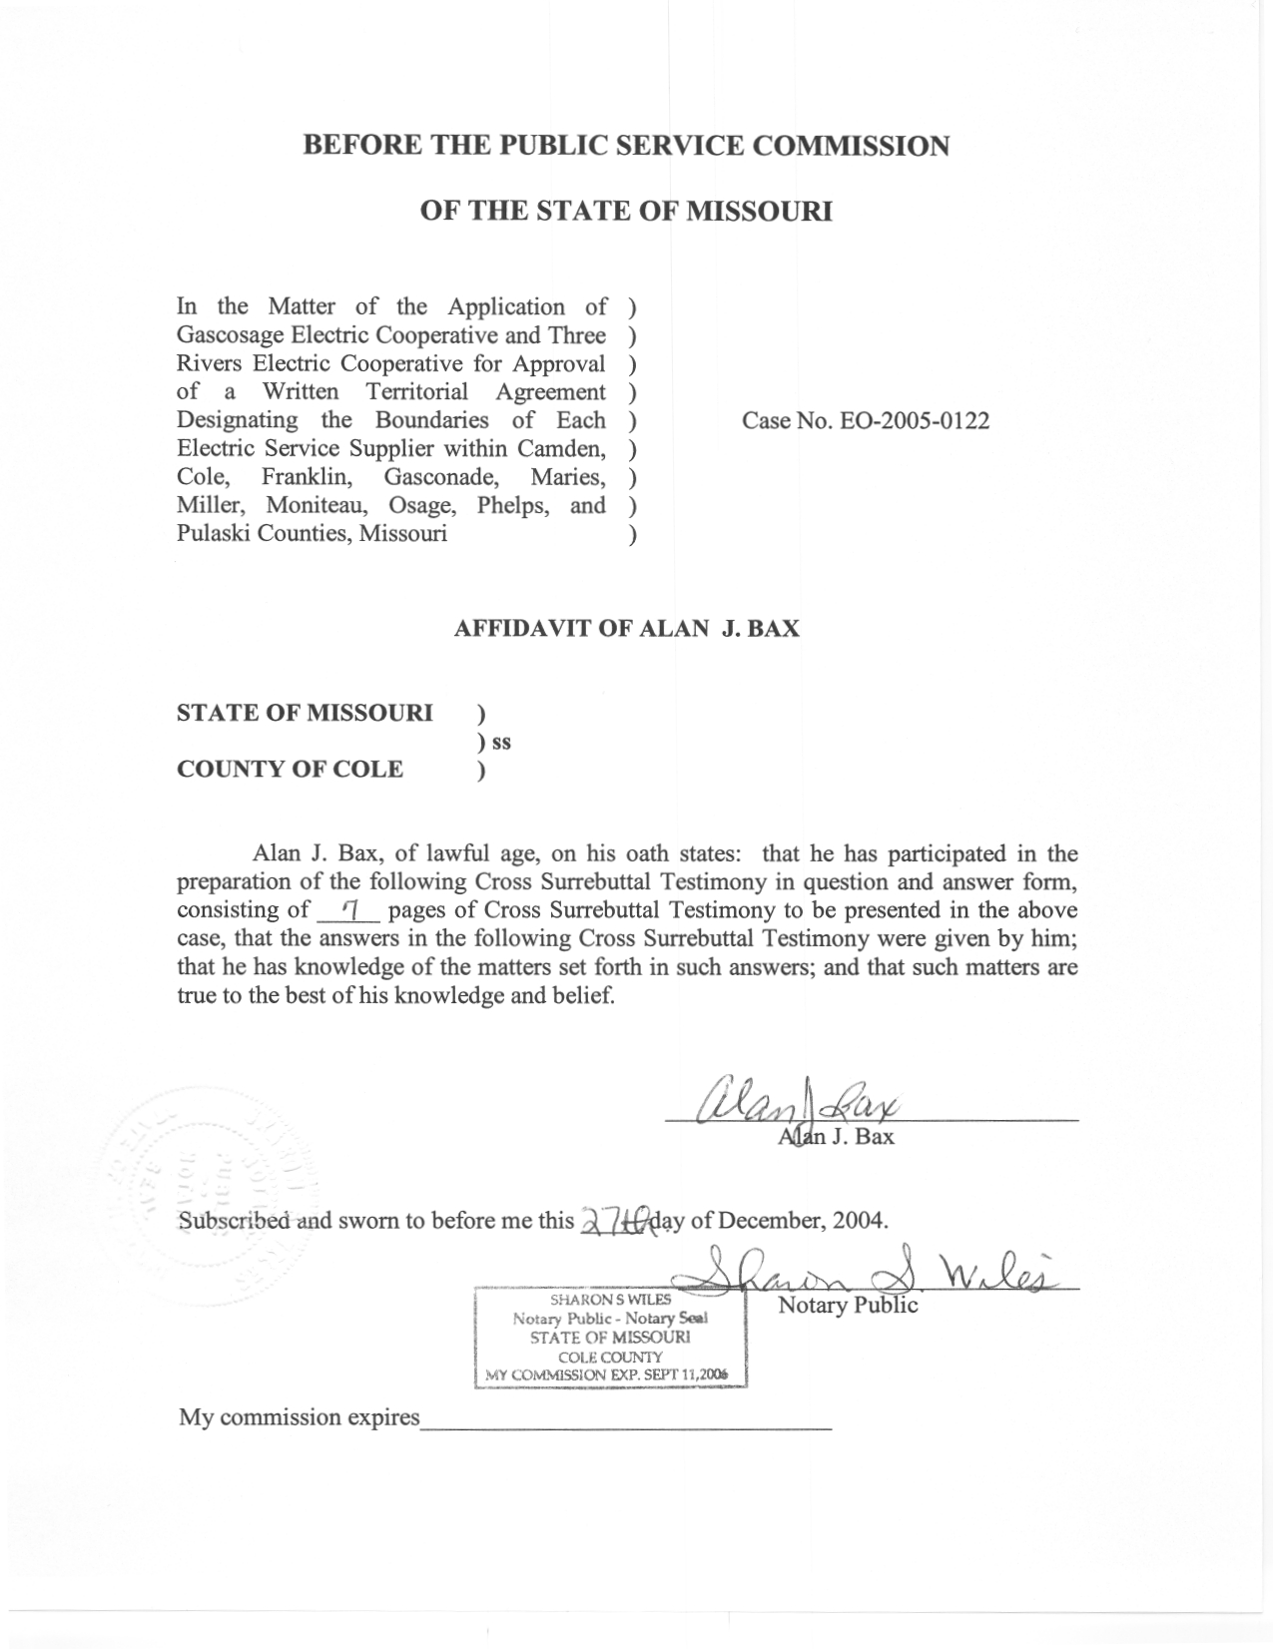

CROSS-SURREBUTTAL TESTIMONY

OF

ALAN J. BAX

GASCOSAGE ELECTRIC COOPERATIVE
AND THREE RIVERS ELECTRIC COOPERATIVE

CASE NO. EO-2005-0122

Q. Please state your name and business address?
A. Alan J. Bax, P.O. Box 360, Jefferson City, Missouri, 65102.
Q. By whom are you employed and in what capacity?
A. I am employed by the Missouri Public Service Commission (Commission) as a Utility Engineering Specialist III in the Energy Department of the Utility Operations Division.
Q. Are you the same Alan Bax who previously filed Rebuttal Testimony in this case (EO-2005-0122)?
- Yes.
- What is the purpose of your Cross-Surrebuttal Testimony in Case No. EO-2005-0122?
A. The purpose of this Cross-Surrebuttal Testimony is to address certain aspects of the Rebuttal Testimony of Union Electric Company, d/b/a AmerenUE (AmerenUE), Witness Mr. Larry Merry. Mr. Merry has recommended the Missouri Public Service Commission (Commission) not approve the Territorial Agreement as it is currently proposed, because of the language contained in Article 4 of the Territorial Agreement. As noted in my Rebuttal Testimony, a number of legal issues appear to be essential elements to this case. Although these items may be noted in my Cross-Surrebuttal Testimony, I will leave it to Staff counsel to provide Staff’s legal position.
Q. Is Mr. Merry’s concern similar to the ones you raised in your Rebuttal Testimony?
A. For the most part, yes, however, when comparing the matters raised in our Rebuttal Testimonies, there is not a total resemblance.
- What seems to be Mr. Merry’s concern?
A. His concern seems to be that Three Rivers Electric Cooperative (Three Rivers), one of the two rural electric cooperatives (RECs) that are the parties to the proposed Territorial Agreement, will be authorized, should the Commission approve the proposed Territorial Agreement, to provide retail electric service in non-rural areas within the exclusive service area defined for Three Rivers in the proposed Territorial Agreement.
Q. Does Mr. Merry have a similar concern with Gascosage Electric Cooperative (Gascosage), the other party to the proposed Territory Agreement?
A. No. Although the same contentious language that is contained in Article 4 regarding Three Rivers also appears in Article 3 of the proposed Territorial Agreement regarding Gascosage, Mr. Merry says there is not a similar concern because AmerenUE has a filed Territory Agreement with Gascosage that alleviates this concern.
- Please discuss the concern raised by Mr. Merry in his Rebuttal Testimony?
- In his Rebuttal Testimony, beginning on page 5, line 20 and ending on page 6, line 11, Mr. Merry describes a scenario involving a municipality with a population in excess of fifteen hundred inhabitants. There is an existing territorial agreement between AmerenUE and a REC, which serves an area adjoining this municipality. In his hypothetical, Mr. Merry has AmerenUE lawfully providing electric service to the municipality on the basis of both current Missouri law and the territorial agreement. Presumably, though not specifically mentioned by Mr. Merry, the area adjoining the municipality is within AmerenUE’s certificated area by virtue of a certificate of convenience and necessity (CCN) from the Commission. AmerenUE, by the terms contained in the territorial agreement, has apparently foregone its statutory rights to serve the adjoining area lying outside the city limits of said municipality, essentially creating a situation that the area immediately outside of the city limits is now an exclusive service territory of the REC per the terms of the territorial agreement.
Mr. Merry states in his Rebuttal Testimony that we are to assume that the municipality annexes a certain area outside of the city limits that is in the REC’s exclusive service territory given the terms of the territorial agreement between the REC and AmerenUE. In his description, Mr. Merry is concerned that, upon annexation, it would be a violation of the territorial agreement if AmerenUE were to serve new customers in the annexed area and the REC would be violating Missouri law if it served any new customers because the population of the municipality is in excess of fifteen hundred inhabitants. Mr. Merry states at page 6, lines 6-7, “the rural electric cooperative cannot serve the area without violating Missouri law.” In making this statement, presumably Mr. Merry is referring to Sections 394.020 (3) and 394.080 (2), RSMo 2000, which limit RECs to providing electric service to cities, towns, and villages with populations of less than fifteen hundred inhabitants. Mr. Merry cites these statutory sections in his Rebuttal Testimony at page 3, lines 9, 13, and 19 and at page 4, line 2.
Mr. Merry says at page 6, lines 7-11 of his Rebuttal Testimony that in order to remedy this situation, AmerenUE includes language in its territorial agreements that mirrors the language contained in Article 4 of the proposed Territorial Agreement. This language would allow the REC, in this specific situation, to lawfully serve load in the annexed area.
On page 5, lines 11-13 and 19-21, page 6, lines 8-11, and page 7, lines 1-2 of his Rebuttal Testimony, Mr. Merry references AmerenUE giving additional rights to the REC that is a party to the territorial agreement. These additional rights include allowing the REC to serve within the municipal boundaries within AmerenUE’s exclusive service area, i.e., rights that the REC would not otherwise have. Mr. Merry seems to be addressing Sections 394.080.1 (4) and 394.315 RSMo 2000 and various Missouri judicial decisions, including Missouri Public Service Commission v. Platte-Clay Cooperative, Inc., 407 S.W.2d 883 (Mo. 1966). Staff counsel will speak to these statutory provisions and cases. However, after reviewing the aforementioned references and other statutes and judicial decisions and following discussions with Staff counsel, I would note the following excerpt from Section 394.315.2 RSMo 2000, with particular attention to the portion in italics:
Once a rural electric cooperative, or its predecessor in interest, lawfully commences supplying retail electric energy to a structure through permanent service facilities, it shall have the right to continue serving such structure, and other suppliers of electrical energy shall not have the right to provide service to the structure except as might be otherwise permitted in the context of municipal annexation, pursuant to section 386.800, RSMo, and section 394.080, or pursuant to a territorial agreement approved under section 394.312. The public service commission, upon application made by an affected party, may order a change of suppliers on the basis that it is in the public interest for a reason other than a rate differential, and the commission is hereby given jurisdiction over rural electric cooperatives to accomplish to the purpose of this section. The commission’s jurisdiction under this section is limited to public interest determinations and excludes questions as to the lawfulness of the provision of service, such questions being reserved to courts of competent jurisdiction…
(Emphasis added.).

Mr. Merry continues, beginning on page 6, line 14 and ending on page 7, line 14, to address why the language in question used in Article 4 of the present Territorial Agreement alleviates the concern in his hypothetical scenario, when the territorial agreement is between AmerenUE and a REC, but is problematic when used in a situation where a territorial agreement is between two or more RECs and does not include AmerenUE, such as with the current Territorial Agreement. Mr. Merry indicates that in the territorial agreements that AmerenUE has entered into with individual RECs, often other RECs have operated in the same area covered by the territorial agreement but “[i]n general there was little duplication of service areas among these cooperatives because cooperatives tended to remain in their respective ‘historical service areas’ and they were not competing to serve new structures within municipalities with populations in excess of fifteen hundred inhabitants…[Thus,] there was little or no risk of destructive competition among cooperatives inside a municipality with populations in excess of fifteen hundred inhabitants as a result of these older territorial agreements…”
In the present case, however, Mr. Merry at page 7, lines 6-11 of his Rebuttal Testimony, envisions that Three Rivers would be able to utilize the proposed Territorial Agreement, in its present form, to, in effect, go around current statutory limitations. That is, whereas Three Rivers is generally barred by current Missouri law from competing in municipalities having a population of greater than fifteen hundred inhabitants, the proposed Territorial Agreement, if approved by the Commission absent some alteration to the language in Article 4, would authorize Three Rivers to compete with AmerenUE in all areas covered by the Territorial Agreement, including within municipalities with populations greater than fifteen hundred inhabitants. Mr. Merry states at page 7, lines 12-14, and at page 8, lines 2-9 of his Rebuttal Testimony that all of this would then lead to unnecessary duplication of electric facilities in municipalities with populations in excess of 1500 inhabitants, and would adversely impact AmerenUE’s ability to plan its system and optimally utilize its facilities in these municipalities. Moreover, this would ultimately result in congested lines in urban areas, increased unsafe conditions and higher costs to Three Rivers and AmerenUE. He asserts at page 8, lines 9-10 of his Rebuttal Testimony that this would not be in the public interest and therefore the Commission should reject the Joint Application in its current form respecting Article 4.
Finally, on page 8, line 13 to page 9, line 4 of his Rebuttal Testimony, Mr. Merry proposes language for Article 4 that would permit Three Rivers to serve in municipalities regardless of the number of inhabitants if AmerenUE and all other electric service providers cannot serve the municipality as a result of Missouri law or an approved territorial agreement. In addition, this proposed language would permit both Three Rivers and Gascosage (Applicants) to continue to serve in municipalities upon its population exceeding fifteen hundred inhabitants so long as the said municipalities were historically receiving electric service from the Applicants.
Q. Do you agree with Mr. Merry that the Territorial Agreement is not in the public interest in its current form?
A. I maintain that the Territory Agreement should be approved as being in the public interest subject to the Applicants clarifying the outstanding questions raised in my Rebuttal Testimony, as well as those further addressed in my Cross-Surrebuttal Testimony and by Staff counsel.
Q. Does this conclude your Cross-Surrebuttal Testimony?

A. Yes.

