Exhibit No.:
Issues: Purchased Power

Witness: Leon C. Bender
Sponsoring Party: MO PSC Staff
Type of Exhibit: Direct Testimony
Case Nos.: ER-2004-0034
& HR-2004-024
Date Testimony Prepared: December 9, 2003

MISSOURI PUBLIC SERVICE COMMISSION

Utility Operations DIVISION

Direct Testimony

OF

Leon C. Bender

Aquila, Inc.
d/b/a Aquila Networks -- mps
and Aquila Networks -- l&p

CASE NOS. ER-2004-0034 & HR-2004-024

Jefferson City, Missouri
December 2003

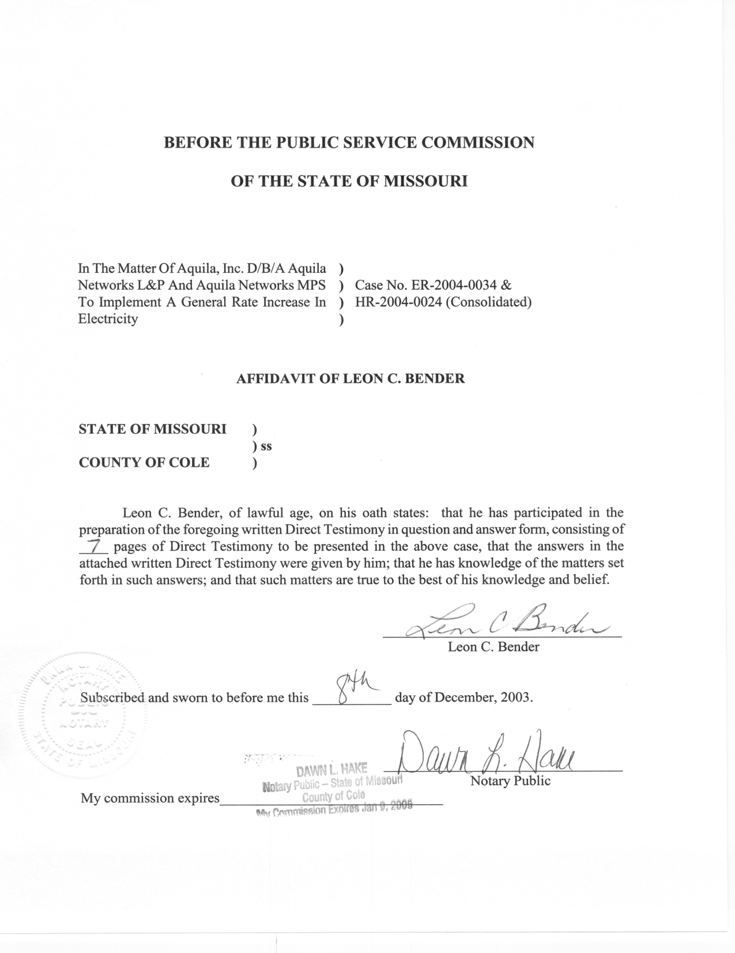

DIRECT TESTIMONY

OF

LEON C. BENDER
AQUILA, Inc.
D/B/A AQUILA NETWORKS-MPS
AND AQUILA NETWORKS-L&P
CASE NOs. ER-2004-0034 and HR-2004-024
(CONSOLIDATED)

Q. Please state your name and business address.
A. Leon C. Bender, P.O. Box 360, Jefferson City, Missouri, 65102.
Q. By whom are you employed and in what capacity?
A. I am employed by the Missouri Public Service Commission Staff (Staff) as a Regulatory Engineer in the Energy Department of the Utility Operations Division.
Q. Please describe your educational and work background.
A. I received a Bachelor of Science degree in Mechanical Engineering in August 1978 from Texas Tech University. I became employed by Southwestern Public Service Company (SPS) as a Power Generation Plant Design Engineer in September 1978. While employed by SPS, I was lead engineer on many projects involving design and construction of new power generating stations and the upgrading of their older plants. In 1983, I became a registered Professional Engineer in the state of Texas. In 1986, I transferred to SPS’s newly formed subsidiary company, Utility Engineering Corporation, and was responsible for various projects at various other clients’ power generation plants. In June 1990, I accepted employment as a Systems Engineer with Entergy Operations, Inc. at the nuclear powered generating station, Arkansas Nuclear One. In December 1995, I joined the Missouri Public Service Commission (Commission).
Q. Have you filed testimony in previous cases before this Commission?
A. Yes, I filed testimony in Case Nos. EC-2001-001, ER-2001-299, ER-97-394, EC-97-362 and EM-97-515.
Q. What is the purpose of your testimony in this case, Aquila, Inc. (Aquila) D/B/A Aquila Networks-MPS (MPS) and Aquila Networks-L&P (L&P) Case No. ER-2004-0034?
A. The purpose of my testimony is to support purchase prices, and associated energy, used by Staff Witness David Elliott as input into the Staff’s electric and steam production cost model simulation, which is used to establish a normalized fuel and purchased power cost for Aquila. For a discussion of the production cost model, please refer the Mr. Elliott’s Direct Testimony.
Q. What test year did Staff use to annualize fuel and purchased power cost?
A. The 12 months ending December 31, 2002, updated to September 30, 2003.

Q. What is purchased power?
A. Purchased power is the hourly energy which is purchased in the market place from another electric supplier and which is used to help meet the load of the electric utility company.
Q. Does Aquila use purchased power to serve native load?
A. Yes. Aquila purchases power from other sources during times of plant forced or planned outages and during times when it is more economical to purchase power rather than generate power.
Q. What were the sources of data used to calculate purchased power prices and to determine the amount of energy available?
A. The data used to calculate purchased power prices and to determine the amount of energy available was submitted to Staff by Aquila, as required by Commission Rule 4 CSR 240-3.190 formally Rule 4 CSR 240-20.080 (3.190 data). Data for September 2003 was not used in the update, as it was not received in time for the update.
Q. When should have the 3.190 data for September 2003 been received?
A. The 4 CSR 240-3.190 rule requires the company is to send the 3.190 data on last business day of the following month. That date corresponds to October 31, 2003. The 3.190 data was not received until the afternoon of November 26, 2003.
Q. What different kinds of purchased power were used in the production cost model?
A. Four kinds of purchased power were used in the production cost model: capacity purchases, spot purchased energy, peak purchased energy, and emergency energy.
Q. Please explain what is meant by capacity purchases.
A. Capacity purchases are made through firm capacity contracts for the purchase of power. Under these contracts, the purchaser pays a fixed cost for the ability to receive a maximum number of megawatts per hour and also pays a variable cost for the amount of megawatt-hours that is actually being purchased in any given hour. The purchasing company can obtain a quantity of hourly energy up to the maximum amount shown in the capacity contract.
Q. What capacity purchase contracts were used in the production cost model?
A. The capacity purchase contracts used in the production cost model are the Nebraska Public Power District Gentlemen Purchase (NPPD), Gray County Wind Energy LLP (Wind), Merchant Energy Partners Pleasant Hill Participation (MEP) and the Sunflower Electric Unit Participation (SEC) contracts.
Q. How did you calculate the hourly energy prices for each capacity contract?
A. I used historical prices for energy obtained from 3.190 data for the NPPD and the Wind contracts. The prices were fixed for each hour of every month regardless of amount of energy purchased up to the contract maximum. The MEP capacity contract is a unit participation purchase from the Aries gas fired generating station and the SEC capacity contract is a unit participation purchase from the Sunflower Electric gas fired generating station, thus both were modeled in Staff’s production cost model as gas units whose energy cost varies depending upon the price of gas used in the model.
Q. What is spot purchased energy?
A. Spot energy is energy purchased on an hourly basis rather than through a longer-term contract. The purchasing company decides to buy spot energy from one or more suppliers based on the economics and availability of its generating units and capacity purchases. Purchases of spot energy are made in order to lower costs when the spot market price is below both the marginal cost of providing that energy from the company’s generating units and the cost of capacity purchases. Since the spot market depends on energy supply and demand, the prices tend to be much more volatile than capacity purchases.
Q. What methodology did you use to determine the spot purchased energy prices?
A. I used a procedure developed by the Commission’s Energy Department-Engineering Section described in the document entitled A Methodology to Calculate Representative Prices for Purchased Energy in the Spot Market (March 18, 1996). The method uses a statistical calculation based on the truncated normal distribution curve to represent the hourly purchased power prices in the spot market. Aquila’s actual hourly non-contract transaction prices, obtained from Aquila’s 3.190 data, are used as price inputs in the calculation. The calculation yields a spot energy price for each hour of the year.
Q. How did you determine spot purchased energy available?
A. I limited the hourly spot purchased energy available to the maximum that was actually purchased in the same hours of days for each month as shown by the 3.190 data. A spot energy available for each stand-alone case was determined. The amount of spot energy available for MPS was added to the amount of spot energy available for L&P to produce a combined amount of spot energy available for the joint dispatch scenario. After the amount of spot purchased energy available was determined, the amount was given to Staff Witness Dave Elliott to input into Staff’s production cost model to calculate the amount of spot energy purchased to meet load in a least cost manner.
Q. What is peak purchased energy?
A. Peak purchased energy is energy purchased on a short-term hourly basis rather than through a longer-term contract during periods of high demand. The cost of peak energy is higher than spot, as it is purchased when less costly resources become unavailable.
Q. How did you determine the price of peak purchased energy available?
A. I used the highest price actually paid for spot purchase power in a given month plus 10%. This monthly peak energy price was then assigned to every hour in the month.
Q. How did you determine the amount of peak purchased energy available?
A. I estimated the hourly peak purchased energy available to be approximately equal to the amount required to replace the capacity of the largest of the regulated generating units in this case; namely, Sibley Unit 3.
Q. What is emergency purchased energy?
A. Emergency energy is energy purchased on a short-term hourly basis rather than through a longer-term contract during periods of high demand. The cost of emergency energy is higher than peak as it is purchased only when all other less costly resources become unavailable. For example, a sudden loss of generation source or transmission ability could require the purchase of energy at a substantially higher price on a short-term basis when other sources become unavailable.
Q. How did you determine the price of emergency purchased energy?
A. I used a price 10% higher than the price of any other resource that was made available. This ensured that emergency purchased energy was purchased only after all other resources were exhausted. This monthly emergency energy price was then assigned to every hour in the month.
Q. How did you determine the amount of emergency purchased energy available?
A. Based on preliminary production cost model runs, I estimated the hourly emergency purchased energy available to be approximately 10 % of Aquila’s total generation capacity in the non-summer months. For the summer months (June through August), the amount of emergency purchased energy made available is approximately 15% of total generation capacity. This was done on an hourly basis for each month.
Q. How were these purchased energy prices and the associated energy including capacity, spot, peaking and emergency purchased power used?
A. The purchased energy prices and the associated energy including capacity, spot, peaking, and emergency purchased power were part of the input data which was used by Staff Witness Dave Elliott for the Staff’s production cost model simulations. For further discussion of the production cost model and how the Staff used the production cost model in this case, please see Staff witness Dave Elliott’s Direct Testimony.
Q. Does this conclude your Direct Testimony?
A. Yes, it does.

