DR 4 -
Please provide examples of customer communication regarding changes in collection practices related to accounts subject to discontinuance.
Response –
During this unprecedented time, Spire has remained focused on supporting our customers and communities while continuing to operate safely for the health of our employees and those we come into contact with. Communicating with our customers and assisting our communities has been a primary focus. To make sure the messages reached as many customers as possible, Spire used social media, our customer-facing website, email, IVR, and various media channels to communicate with customers regarding assistance options and the suspension of disconnections.
NOTE: Some of the communications have the original timeframe of the suspension of disconnections which was mid-March through May 31. Before the end of May, Spire made the decision to extend the suspension until July.
Social Media posts:
Spire communicated the suspension of disconnections, as well as promoted our assistance programs, through various social media channels including Facebook, Twitter, Instagram and media interviews. Please see the CLIPS pdf file for details of customer communications through social media from mid-March through mid-June.

Spireenergy.com website:
Details regarding the suspension of disconnections can also be found on our website.
https://spireenergy.com/coronavirus
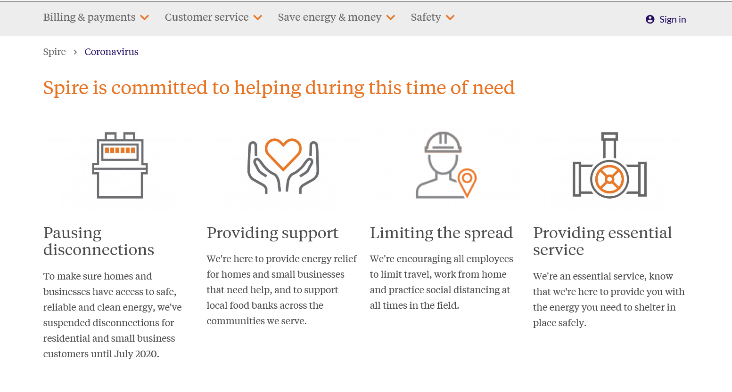

Email message to customers:
In March 2020, an email was sent from Suzanne Sitherwood, CEO, to all customers. This email was sent to assure customers that the essential service we provide would continue while keeping customers and employees’ safety in mind. The full email can be viewed below.

https://spireenergy.com/ceo-suzanne-sitherwood-message-coronavirus

A letter from Spire CEO Suzanne Sitherwood regarding coronavirus

To all those we serve,
As your local natural gas provider, we've been closely monitoring the evolving coronavirus events across the communities we serve—because we believe nothing is more important than your safety and the safety of Spire employees. This holds true whether we're delivering energy to homes and businesses or doing our part in preventing the spread of the virus.
And that balance of delivering reliable energy while helping our communities stay safe is incredibly important right now, because we're considered an essential utility and part of our nation's vital energy infrastructure.
As an "essential service" designated by government authorities, we'll continue to operate even under a state of emergency and any shelter in place orders.
So, when you see our field technicians working, know that we're there to provide you with the energy you need to cook homemade dinners and warm your homes while our communities shelter in place.
Simply put, these are uncertain times. And as we face them together, your trust in us is important. So, I'd like to share with you what we've been doing to take action and care for each other and all those we serve.
For you, our customers
We've adjusted the services we provide, performing only essential work. This will help protect both you and our team members as we continue to closely monitor developments. The CDC is regularly updating their guidelines and best practices, and we are following these guidelines carefully.
We've officially suspended late fees, disconnection notices and disconnections until at least May 1. If you're worried about your natural gas bill, please give us a call. We're always here for you, ready to work with you on finding the best solution for your situation.
We've provided field employees with the tools they need to do their jobs, requiring everyone to maintain social distancing and safety guidelines provided by the CDC. And, we've increased the frequency of deep cleanings of our equipment and at our facilities.
For our employees
Because we live and work in the communities we serve, caring for our employees has an impact on our communities at large. That's why we:
- Enacted our preparedness response plan, which defines how we adjust the services we provide in response to the changing situation
- Canceled all travel and events
- Provided emergency leave for employees who are unable to work from home and are quarantined, caring for a loved one who is quarantined or taking care of a child or family member because of coronavirus-related school and care facility closures
- Ensured all employees who can work from home do so
As an essential service you depend on, we'll continue to monitor our processes as the situation evolves. And, if you'd like more information about all we're doing to keep Spire employees and communities safe, visit us 24/7 at SpireEnergy.com/Coronavirus.
Through it all, our promise to you is that we're focused on the safety and well-being of those we serve.
We're in this together.
Stay safe and healthy,
Suzanne Sitherwood
President and CEO
Spire Inc.

Energy Efficiency Committee presentation:
The attached Presentation for Energy Efficiency PDF contains additional details related to Spire’s customer communication efforts related to the suspension of disconnections and promotion of our coronavirus assistance program.

Disconnect Notice Changes
Our disconnect notices were recently modified to include options for payment arrangements.

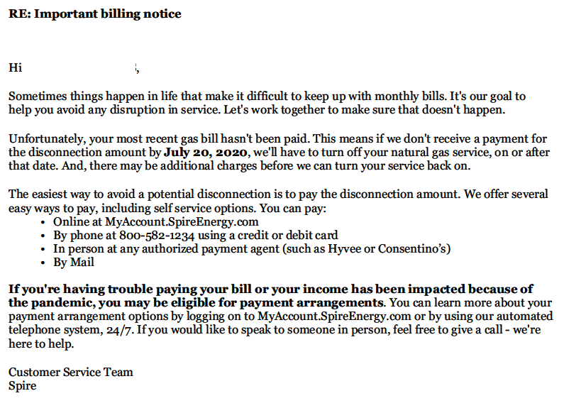

Letter to Legislators:
Hello XXX,
To help customers maintain access to safe, reliable natural gas service during the coronavirus pandemic, we worked with the United Way to reimagine how to assist struggling, limited-income residential and small business customers impacted by the pandemic. And we suspended late fees from mid-March through May and customer disconnects from mid-March through June.
In June, the Missouri Public Service Commission approved an order to decide how utility companies will collect past-due payments after delays due to COVID-19.
As we observe the direction of the Commission and slowly return to normal business operations, Spire will begin disconnecting accounts that are past due on Monday, July 6. To help prepare our customers, we have adjusted our customer communications for disconnections —both written and outbound call messages—to include information on energy assistance available to them.
If your constituents contact you regarding a disconnect notice or a past due bill, please encourage them to contact us. We’re here to help them find the best solution to meet their needs. We have assistance programs, payment arrangements and other offerings for which they may be eligible.
Below, I have included a list of Spire’s assistance programs.
Relief Assistance for Residential Customers
Spire is providing funds to assist active Missouri residential customers who are struggling to pay their natural gas bill due to the coronavirus pandemic.
To learn if you qualify, visit www.spireenergy.com/relief.
The maximum assistance is $100 per household.
Spire’s COVID19 Small Business Relief Program
If a business owner needs assistance with their natural gas bill due to the pandemic, support is available.
The application process is simple. To learn if your business qualifies, visit spireenergy.com/relief.
The maximum assistance available is $200 per small business.
Grant Funding
Nonprofit organizations (501c3 or 501c4 social welfare organizations) in good standing with the IRS are eligible to apply for Spire grant funding. The program funds organizations in the following categories:
1. Health & Human Services
2. Civic and Community Development
3. Education
4. Environment
Apply for a Spire grant here.

