BEFORE THE PUBLIC SERVICE COMMISSION
OF THE STATE OF MISSOURI
In the Matter of the Tariff Filings of  Union Electric Company, d/b/a AmerenUE, to Increase Its Revenues for Retail Electric Service. | )))) | Case No. ER-2010-0036

STIPULATION AND AGREEMENT
COME NOW the Office of the Public Counsel, the Missouri Industrial Energy Consumers, AARP, the Consumers Council of Missouri and the Missouri Retailers Association (collectively, the Signatories) and respectfully state to the Missouri Public Service Commission (Commission) that, as a result of negotiations, they have reached the stipulations and agreements contained herein in order to settle the class cost of service allocation and rate design issues in this rate case in the event the Commission finds that AmerenUE’s rates should be increased.

This Stipulation and Agreement will specify the agreement of the Signatories on the rate design and the spread of any revenue increase among the customer classes. An illustration of the Signatories’ agreement is attached hereto as Attachment 1, which shows the allocation of revenue increases from $100 million to $325 million, in $25 million increments, pursuant to the agreement of the Signatory parties. If the rate increase is within this range, the specific increase to each customer class will be determined by linear interpolation between the two closest revenue increase allocation illustrations. For example, if the increase is $130 million, the increase for each class would be the revenue increase shown on the $125 million illustration, plus 20% ($5 million ÷ $25 million) of the difference between the revenue increase illustration at $125 million and the revenue increase illustration at $150 million. If the revenue increase is less than $100 million, the difference between the awarded increase and $100 million would be spread to rate classes in proportion to the numbers appearing in the “percent of total revenues” column on the $100 million illustration. This dollar difference would be subtracted from the amounts appearing in the “increased revenues” column of the $100 million illustration in order to determine the allocation based on the awarded increase. If the awarded increase is greater than $325 million, the additional amount above $325 million would be allocated to classes in proportion to the “percent of total revenues” column shown on the $325 million illustration page. This additional amount would be added to the amount shown in the “increased revenues” column of the $325 million illustration in order to determine the allocation based on the awarded increase.

The Signatories have also reached agreement regarding certain issues pertaining to customer charges. The Signatories agree that the residential customer charge should be set at $8.00, with the remaining revenue assigned to the residential class to be allocated to volumetric charges. The Signatories agree the Small Power Service (SPS), Large Primary Service (LPS) and Large Transmission Service (LTS) customer charges should be set to $234.33, then those customer charges should be increased by the same percentage as the system average percentage increase, i.e., each will be increased by the same percentage and each will be the same. The Signatories agree the rates for Rider B voltage credits (Tariff Sheet 99) should remain the same for all applicable rate schedules. The existing Rider B voltage credits should be increased by the same percentage as the system average percentage increase. The particular Rider B voltage credits as they now exist follow:
- A monthly credit of $0.90/kW of billing demand for customers taking service at 34.5 or 69kV.

- A monthly credit of $1.06/kW of billing demand for customers taking service at 115kV or higher.

The Signatories agree the rate for the Reactive Charge should be the same for all applicable rate schedules and that the existing Reactive Charge should be increased by the same percentage as the system average percentage increase. The current Reactive Charge for SPS (Tariff Sheet 37), LPS (Tariff Sheet 67.1) and LTS (Tariff Sheet 68) classes are $0.27 per kVar. The Signatories agree the customer charge associated with Time-of-Day rates should be the same for all applicable non-residential rate schedules and that the existing Time-of-Day customer charge should be increased by the same percentage as the system average percentage increase. The current Time-of-Day customer charge for the Large General Service class (LGS) (Tariff Sheet 34), SPS (Tariff Sheet 37), LPS (Tariff Sheet 67.1) and LTS (Tariff Sheet 68) is $15.25. The Signatories agree the Small General Service class (SGS) customer charge should be $9.28 for single-phase service and $18.56 for three-phase service (Tariff Sheet 32). With the foregoing exceptions, all other rate elements within each rate schedule shall be increased by an equal percentage basis so that collectively all rate elements on that schedule are designed to collect the revenue assigned to the class to which that rate schedule applies.

3. The Signatories agree that the rate schedule relationships to be observed in the design of Rates SPS, LPS and LTS are those set forth in the January 6, 2010 “Missouri Public Service Commission Staff’s Class Cost-of-Service and Rate Design Report” in the first numbered paragraph in Section III entitled “Rate Design,” which appears on pages 23 and 24 of the Staff Report. That provision is as follows:
- That AmerenUE’s rate schedules should be uniform for certain interrelationships among the non-residential rate schedules that are integral to AmerenUE’s rate design. The following features were uniform until implementation of the rate design in AmerenUE’s last rate case (Case No. ER-2008-0318). Staff recommends returning these features to uniformity.

• The value of the customer charge be uniform across rate schedules, with the customer charges on the SPS, LPS, and LTS rate schedules being the same.

• The rates for Rider B voltage credits be the same under all applicable rate schedules.

- The rate for the Reactive Charge be the same for all applicable rate schedules.
- The rate associated with Time-of-Day meter charge be the same for all applicable non-residential rate schedules.

4. Unless otherwise explicitly provided herein, none of the Signatories to this Stipulation and Agreement shall be deemed to have approved or acquiesced in any ratemaking or procedural principle, including, without limitation to, any other method of cost determination or cost allocation or revenue-related methodology. Other than as explicitly provided herein, none of the Signatories shall be prejudiced or bound in any manner in this or any other proceeding by the terms of this Stipulation and Agreement regardless of whether this Stipulation and Agreement is approved.

5. This Stipulation and Agreement has resulted from extensive negotiations among the Signatories and the terms hereof are interdependent. If the Commission does not approve this Stipulation and Agreement unconditionally and without modification, then this Stipulation and Agreement shall be void and no Signatory shall be bound by any of the agreements or provisions hereof, except as explicitly provided herein.

6. If the Commission does not unconditionally approve this Stipulation and Agreement without modification, and notwithstanding the provision herein that it shall become void, neither this Stipulation and Agreement nor any matters associated with its consideration by the Commission shall be considered or argued to be a waiver of the rights that any Party has for a decision in accordance with §536.080 RSMo 2000 or Article V, Section 18 of the Missouri Constitution, and the Signatories shall retain all procedural and due process rights as fully as though this Stipulation and Agreement had not been presented for approval, and any suggestions, memoranda, testimony, or exhibits that have been offered or received in support of this Stipulation and Agreement shall become privileged as reflecting the substantive content of settlement discussions and shall be stricken from and not be considered as part of the administrative or evidentiary record before the Commission for any purpose whatsoever.

7. In the event the Commission unconditionally accepts the specific terms of this Stipulation and Agreement without modification, the Signatories waive the following rights only as to the issues resolved herein: 1) their respective rights to present oral argument and written briefs pursuant to §536.080.1 RSMo 2000; 2) their respective rights to seek rehearing, pursuant to §536.500 RSMo 2000; and 3) their respective rights to judicial review pursuant to §386.510 RSMo 2000. This waiver applies only to a final unappealed Commission order unconditionally approving this Stipulation and Agreement issued in this proceeding and only to the issues that are resolved hereby. It does not apply to any matters raised in any prior or subsequent Commission proceeding or any matters not explicitly addressed by this Stipulation and Agreement.
WHEREFORE, for the foregoing reasons, the undersigned Signatories respectfully request that the Commission issue its Order approving all of the specific terms and conditions of this Stipulation and Agreement.
Respectfully submitted,

/s/Lewis Mills /s/Diana Vuylsteke
Lewis R. Mills, Jr. #35275 Diana Vuylsteke #42419
Public Counsel BRYAN CAVE LLP
PO Box 2230 211 North Broadway
Jefferson City MO 65102 Suite 3600
(573) 751-1304 St. Louis Missouri 63102
Facsimile (573) 751-5562 (314) 259-2543
E-mail: lewis.mills@ded.mo.gov Facsimile: (314) 259-2020
ATTORNEY FOR THE OFFICE OF E-mail: dmvuylsteke@bryancave.com
THE PUBLIC COUNSEL ATTORNEY FOR THE MISSOURI
INDUSTRIAL ENERGY CONSUMERS

/s/Tim Schwarz /s/John Coffman___________________
Thomas Schwarz #29645 John B. Coffman #36591
BLITZ, BARDGETT & DEUTSCH JOHN B. COFFMAN, LLC
308 East High Street, Ste 301 871 Tuxedo Blvd.
Jefferson City MO 65101 St. Louis MO 63119-2044
(573) 634-2500 (573) 424-6779
Facsimile (573) 634-3358 E-mail: john@johncoffman.net
E-mail: tschwarz@blitzbardgett.com ATTORNEY FOR AARP
ATTORNEY FOR THE MISSOURI
RETAILERS ASSOCIATION

/s/ John Coffman_____________________
John B. Coffman #36591
JOHN B. COFFMAN, LLC
871 Tuxedo Blvd.
St. Louis MO 63119-2044
(573) 424-6779
E-mail: john@johncoffman.net
ATTORNEY FOR THE CONSUMERS
COUNCIL OF MISSOURI

CERTIFICATE OF SERVICE
I hereby certify that copies of the foregoing have been emailed on this 17th day of March 2010 to all parties on the Commission’s service list in this case.

/s/ Diana Vuylsteke___

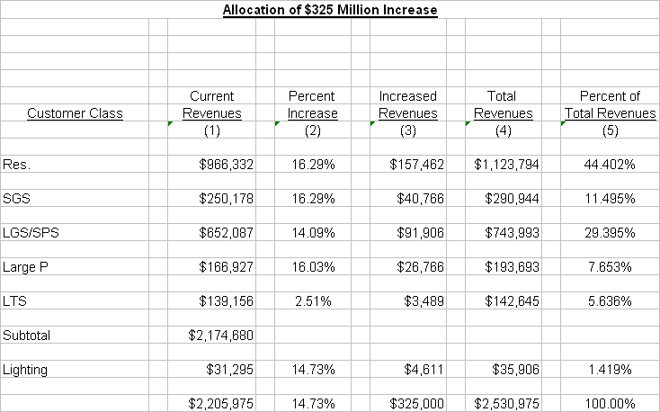
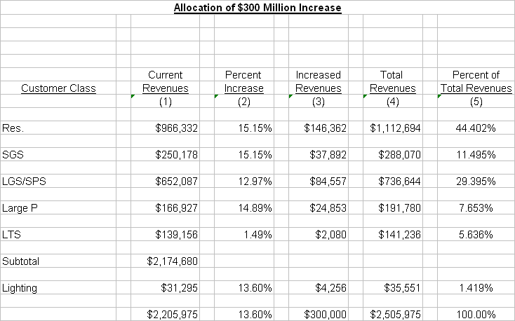
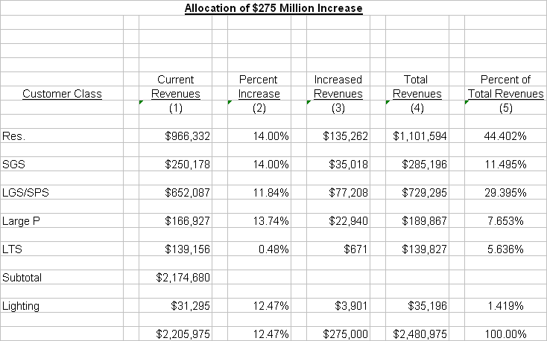
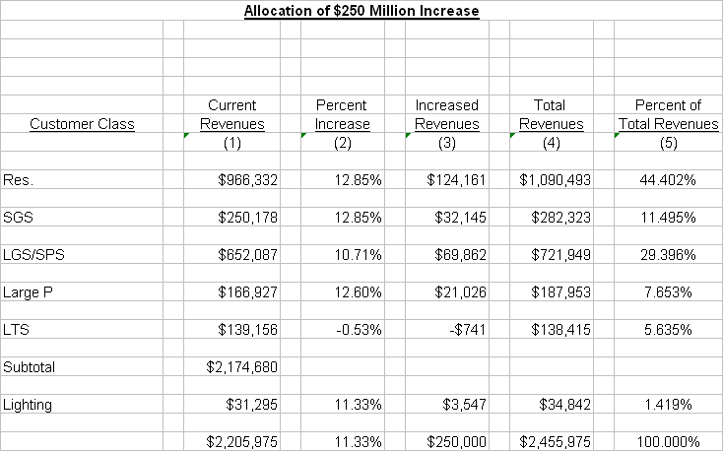
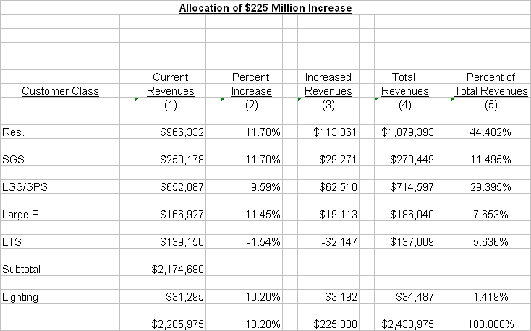
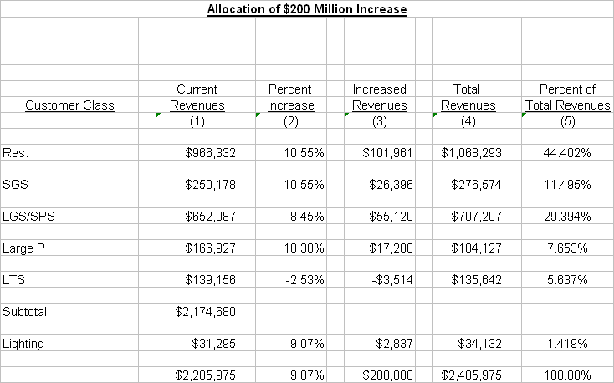
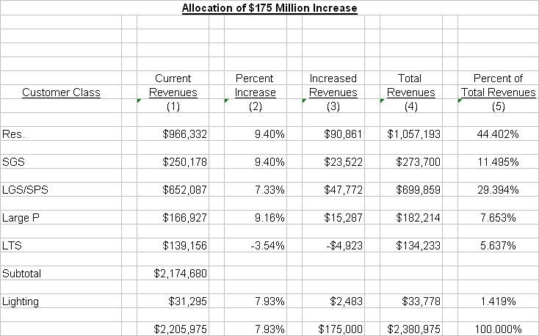
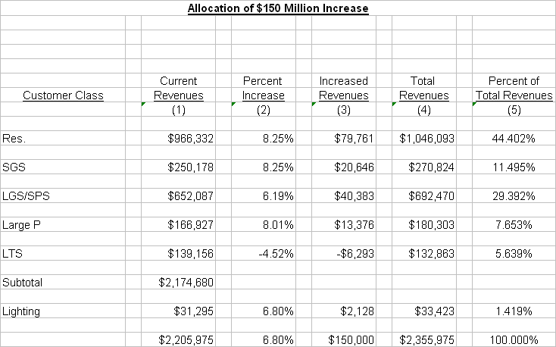
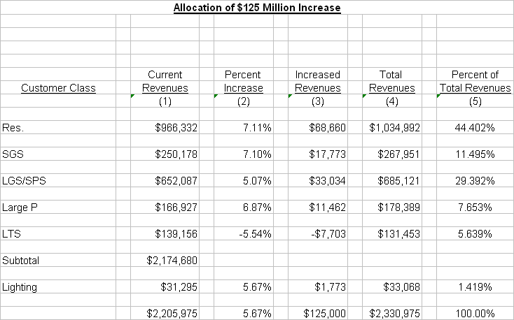
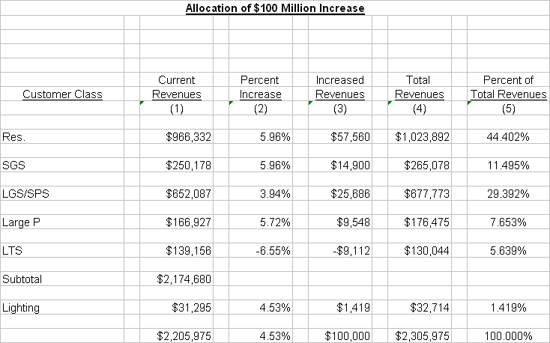

Anheuser-Busch Companies, Inc., BioKyowa, Inc., The Boeing Company, Doe Run, Enbridge, GKN Aerospace, General Motors Corporation, Hussmann Corporation, JW Aluminum, Monsanto, Noranda, Pfizer, Precoat Metals, Procter & Gamble Company, Nestle Purina PetCare, Solutia and U.S. Silica Company.

