Exhibit No.:
Issues: Weather
Normalization

Witness: Richard J. Campbell
Sponsoring Party: MO PSC Staff
Type of Exhibit: Direct Testimony
Case Nos.: ER-2004-0034 &
HR-2004-0024
(Consolidated)
Date Testimony Prepared: December 9, 2003

MISSOURI PUBLIC SERVICE COMMISSION

Utility Operations DIVISION

Direct testimony

OF

Richard J. Campbell

AQUILA, INC.
D/B/A AQUILA NETWORKS – MPS
AND AQUILA NETWORKS – L&P

CASE NOS. ER-2004-0034 & HR-2004-0024
(CONSOLIDATED)

Jefferson City, Missouri
December 2003
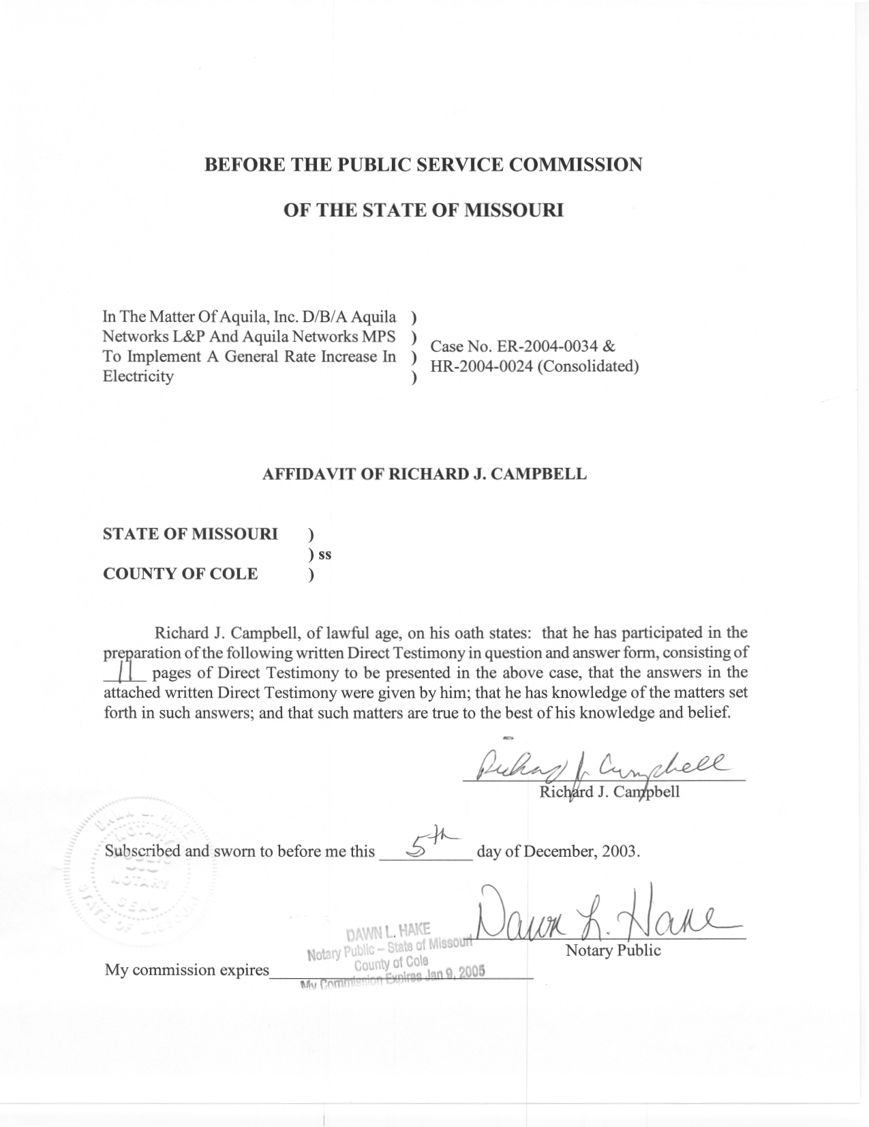

TABLE OF CONTENTS

NORMALIZATION OF USAGE 2
HOURLY NET SYSTEM LOADS 6
NORMAL WEATHER VARIABLES 9

DIRECT TESTIMONY
OF
RICHARD J. CAMPBELL
AQUILA, INC.
D/B/A AQUILA NETWORKS – MPS
AND AQUILA NETWORKS – L&P
CASE NOS. ER-2004-0034 AND HR-2004-0024
(CONSOLIDATED)

- Please state your name and business address.
A. My name is Richard J. Campbell and my business address is Missouri Public Service Commission, P.O. Box 360, Jefferson City, MO 65102.
Q. What is your present position with the Missouri Public Service Commission (Commission)?
A. I am a Utility Regulatory Engineer I in the Engineering Analysis Section, Energy Department, Utility Operations Division.
Q. Would you please review your educational background and work experience.
A. In May of 1995, I received a Bachelor of Science Degree in Chemical Engineering from the University of Missouri in Columbia. In July of 1995, I began working for the Missouri Department of Natural Resource Air Pollution Control Program as an environmental engineer. I was employed with the Air Pollution Control Program from July 1995 until November 2001. I joined the Commission Staff (Staff) in November 2001. I am a registered Professional Engineer in the State of Missouri.
Q. Have you filed testimony before this Commission before?
A. Yes, I filed direct testimony in Case No. ER 2002-424.
Q. What is the purpose of your direct testimony?
A. The purpose of my testimony is to recommend that the Commission adopt the weather and days adjustments to class usage for the weather sensitive rate classes of Aquila Networks - MPS (MPS) and Aquila Networks - L&P (L&P). These adjustments are given in Schedule 1 by rate class. Staff witnesses Janice Pyatte and Hong Hu calculated adjustments to revenues based on these weather adjustments to class usage. These adjustments to class usage were also included in the calculation of hourly generation requirements.
I also recommend that the Commission adopt the hourly net system load that I calculated. Staff witness David W. Elliott used these hourly loads in estimating the normalized fuel and purchase power expenses for the test year. A monthly summary of the normalized net system load for L&P is shown on Schedules 2 and for MPS on Schedule 3.
Q. To which of the Aquila, Inc. (Aquila) operations are you directing your testimony?
A. This testimony only addresses the electric operations of Aquila in Missouri.

NORMALIZATION OF USAGE
Q. Why is it necessary to weather normalize electricity usage?
A. Electricity use is very sensitive to weather conditions. Because of the high saturation of air conditioning and the presence of some electric space heating in Aquila Networks (Aquila) Missouri territories, the magnitude of Aquila’s load is directly related to daily temperatures. The weather during the test year differed from normal conditions. The winter months of January, February, and December 2002 were warmer than normal. The warmer than normal temperatures resulted in decreased energy consumption and lower than normal usage. The months of June through September 2002 were also warmer than normal. The warmer temperatures caused added cooling demand and energy usage that were higher than what is normally experienced.
Q. What method did you use to calculate the weather adjustments to class usage?
A. I used the Electric Power Research Institute (EPRI) Hourly Electric Load Model (HELM) to calculate the weather adjustments to class usage. In this model, the response to daily weather is first estimated for each of the rate classes from hourly class level load data. Weather normalized usage is then calculated for each month for each of the weather sensitive classes, given normal weather variables based on the estimated response. The weather variables are carefully matched to correspond to the usage in the time period over which usage was recorded. The weather adjustment to class usage is calculated as the difference between the weather normalized usage and the actual usage.
Q. How did you calculate the days adjustment?
A. HELM’s output provides weather-normalized usage on both a billing month and a calendar month basis. The difference between billing month and calendar month usage is referred to as the days adjustment.
Q. What are the inputs to this model?
A. There are four data inputs into the model – monthly class usage, hourly class load data, and actual and normal daily weather variables. The monthly class usage and the hourly class loads were supplied by Aquila. Staff witness Dennis Patterson supplied the actual high and low temperatures for the test year and the history of high and low temperatures that I used to calculate daily normal weather.
Q. Did you independently perform a weather impact analysis on hourly class load data to determine the appropriate weather response functions?
A. Yes, Aquila supplied hourly class load data for the time period dating June 1, 2002 through May 31, 2003. The hourly loads were plotted against mean daily temperature to ascertain the weather sensitivity of each class. The hourly loads from the classes that were found to be weather sensitive were then used to develop weather response functions in the HELM model.
Q. Which classes were deemed to be weather sensitive?
A. For L&P, the classes that were found to be weather sensitive were the residential classes, with the exception of the residential general class (MO915), and the small and large general service classes. The large power class was not weather sensitive with respect to daily weather. There is a seasonal response to load for the large power class, but not a clear daily weather response. For the MPS, the residential, small general service secondary, large general service secondary, and Schools & Churches secondary classes were found to be weather sensitive. The small general service primary, large general service primary, schools & churches primary, and large power primary and secondary were found to not be sensitive to daily weather. These classes do show sensitivity to seasonal changes and day-type changes.
Q. Did the dates of the hourly class load data coincide with the test year for this case?
A. No. The test year for this rate case is the calendar year 2002. However, Aquila’s hourly class loads for MPS prior to June 2002 were developed using a sample that was over a decade old. Aquila began collecting data from a new sample on June 1, 2002. Therefore, the hourly class load data used in my analysis was from the year June 1, 2002 through May 31, 2003.
Q. Does the difference in timeframes cause a problem? Explain why or why not?
A. No. The HELM model develops load response functions based on day types and seasons. Therefore, we are able to develop a load shape for January weekdays, for example, that can be used in different time periods for a given rate class. However, it is important that the hourly class load data be representative of the class and that the class load data is recent. The class load data used in this analysis meets both of those criteria.
Q. Did you make any adjustments or corrections to the billing cycle usage data?
A. Yes. The billing cycle data, provided by Aquila, was disaggregated by billing cycle. While reviewing the billing cycle data provided by Aquila, I notice that the usage in some billing cycles was negative. I used information provided by Aquila to adjust this data to remove these negative values.
Q. Do any Missouri electric utilities use HELM?
A. Yes. Kansas City Power and Light Company, Aquila, AmerenUE, and Empire have all used HELM to analyze loads in their Missouri resource planning process. Kansas City Power and Light Company and the Empire District Electric Company (Empire) both used HELM to weather normalize billing month usage and hourly loads in their most recent rate design cases. Empire also used HELM to weather normalize sales in its most recent rate case.
Q. Has Staff previously used HELM?
A. Yes, Staff has used HELM in rate cases involving Empire and MPS.
Q. Which Staff witnesses relied on the adjustments to usage that you calculated?
A. Staff witnesses Janice Pyatte and Hong Hu calculated the corresponding adjustments to Missouri retail revenues. These adjustments to class usage were also included in the net system load and total test year usage that was used by David W. Elliott in the normalization of fuel costs.

HOURLY NET SYSTEM LOADS
- What are hourly net system loads?
A. Hourly net system load is the hourly electric supply necessary to meet the energy demands of company’s customers and the company’s own internal needs. It is net of (i.e., does not include) station use, which is the electricity requirement of the company’s generating plants. The hourly loads used in my analysis of the test year January 2002 through December 2002 were provided to Staff in response to Data Request numbers 44 and 45 and the respective supplements to these requests. I also used hourly load data submitted by Aquila in response to the Commission’s monthly
4 CSR 240-3.190 requirements to cross check and correct errors that were found in the data request response.
Q. What method did Staff use to weather normalize net system hourly loads?
A. The Staff’s weather normalization procedure was developed by the Economic Analysis Department of the Commission in 1988. The process is described in detail in the document Weather Normalization of Electric Loads, Part A: Hourly Net System Loads (November 28, 1990), written by Dr. Michael Proctor, Manager of the Economic Analysis Department.
Q. Briefly summarize the process you use.
A. In order to reflect normal weather, daily peak and average loads are adjusted independently, but using the same methodology. Independent adjustments are necessary because average loads respond differently to weather than peak loads.
Daily average load is calculated as the daily energy divided by twenty-four hours and the daily peak is the maximum hourly load for the day. Separate regression models estimate both a base component, which is allowed to fluctuate across time, and a weather sensitive component, which measures the response to daily fluctuations in weather for daily average loads and peak loads. The regression parameters, along with the difference between normal and actual cooling and heating measures, are used to calculate weather adjustments to both the average and peak loads for each day. The adjustments for each day are added respectively to the actual average and peak loads for each day. The starting point for allocating the weather normalized daily peak and average loads to the hours is the actual hourly loads. A unitized load curve is calculated for each day as a function of the actual peak and average loads for that day. The corresponding weather normalized daily peak and average loads, along with the unitized load curves, are used to calculate weather normalized hourly loads.
This process includes many checks and balances, which are included in the spreadsheets that are used. In addition, the analyst is required to examine the data at several points in the process.
Q. Has this method been used in other rate cases?
A. Yes, this method has been used in several cases before this Commission. Please refer to Schedule 4 for a list of these cases.
Q. Did you make any adjustments to the procedure referenced above?
A. Yes, the Kansas City area experienced an ice storm in January of 2002. This storm cause significant outages that affected MPS’s generation requirements. Also, April of 2002 had some days with abnormally high temperatures. I added a linear spline, similar to that used for heating and cooling degree days, then preformed a regression analysis on both the ice storm dates and the abnormal high temperature dates, for MPS. I also used the results of the regression to adjust the usage for the time period that the ice storm affected generation. This was done to ensure that MPS’s load during this timeframe represents the load that would have occurred absent the ice storm. L&P did not require any adjustments.
Q. What data was used in this process?
A. Actual hourly net system loads for the time period from October 1, 2001 through March 31, 2003 were provided by Aquila. The actual daily weather variables were supplied to me by Mr. Patterson. I calculated the normal weather variables using a method developed by the staff in 1991. The process is described in the document Weather Normalization of Electric Loads, Demonstration: Calculation of Weather Normals, October 25, 1991.
Q. Were modifications made to the test year weather normalized hourly net system loads to account for Staff adjustments to test year usage?
A. Yes. I adjusted the weather-normalized hourly net system loads to be consistent with the Staff’s weather-normalized, annualized test year usage.
Q. How were the hourly loads adjusted to account for the annual adjustments to usage?
A. I added wholesale sales and company usage to the Staff’s weather-normalized, annualized test year usage. Then, I increased the annual usage adjustment by the loss factor supplied to me by Staff witness Alan J. Bax in order to obtain the additional amount of generation (net system input) necessary to serve this additional usage. A factor was applied to each hour of the weather-normalized loads to produce an annual sum of the hourly net-system loads that equals the adjusted test year usage, consistent with normalized revenues, plus losses. A monthly summary of the adjusted loads is shown on Schedule 2.
Q. Which Staff witness used your hourly-normalized net system loads?
A. Staff witness David W. Elliott used the test year hourly normalized system loads in developing test year fuel and purchase power expense.

NORMAL WEATHER VARIABLES
Q. What did you use to represent normal weather in these calculations?
A. The normal weather used in both the normalization of class usage and hourly net system loads was calculated using Staff’s ranking method and daily weather values for the time period January 1, 1971 through December 31, 2000. Staff’s ranking method estimates daily normal values for the test year, which range from the temperature value that is “normally” the hottest to the temperature value that is “normally” the coldest.
Using ranked normals to estimate the weather adjustment to usage is important because electricity use does not respond to temperature by a constant factor. Customer response to a change in temperature of one degree from 70 to 71 is very different from a change in temperature of one degree from 90 to 91. The ranking method of calculating normals allows for a more accurate estimate of changes in usage due to deviations from normal weather.
Using ranked normals is also important in estimating fuel and purchased power expense because these expenses are greatly impacted by daily weather extremes. Since every year has days with extreme temperatures, the daily normals should also contain extremes. The ranking method that was used estimates normal extremes.
Q. How are the daily normals derived?
A. The daily normal variables are calculated by ranking the temperatures in each year of the history. These temperatures are then averaged by rank, not by the day of the year. This results in the normal extreme being the average of the most extreme temperatures in each year of the history. The second extreme normal variable is based on the average of the second most extreme day of each year and so forth. The normal variables calculated from this ranking are then assigned to the days in the test year based on the rankings of the actual temperatures in the year. This assignment results in as little weather normalization occurring on each day as is possible.
Q. Who supplied the history of daily temperatures used in your calculation of daily normals?
A. Staff witness Dennis Patterson supplied the history of daily temperatures that I used in calculating the daily normal weather values.
Q. Does this conclude your direct testimony?
A. Yes, it does.

