Exhibit No.:
Issues: Joint Application of
Aquila Networks-MPS and Osage Valley Electric Cooperative

Witness: Alan Bax
Sponsoring Party: MO PSC Staff
Type of Exhibit: Rebuttal Testimony
Case No.: EO-2004-0603
Date Testimony Prepared: August 13, 2004

MISSOURI PUBLIC SERVICE COMMISSION

UTILITY OPERATIONS DIVISION

REBUTTAL TESTIMONY

OF

ALAN BAX

AQUILA, INC., D/B/A AQUILA NETWORKS-MPS
AND OSAGE VALLEY ELECTRIC COOPERATIVE

CASE NO. EO-2004-0603

Jefferson City, Missouri
August 2004
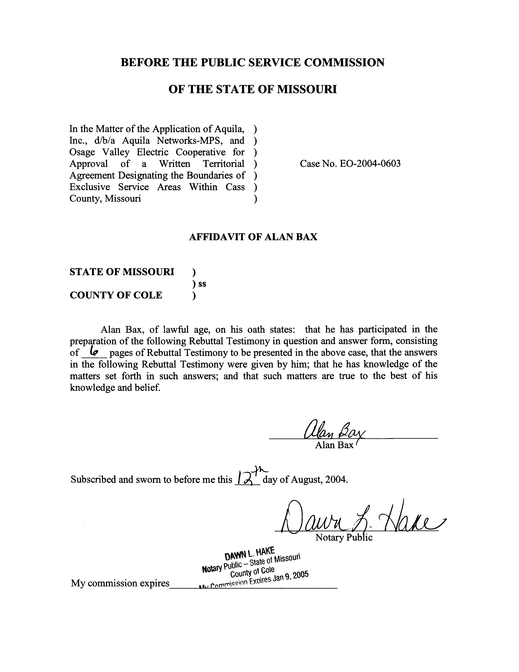
REBUTTAL TESTIMONY
OF
ALAN J. BAX
CASE NO. EO-2004-0603
Q. Please state your name and business address?
A. Alan J. Bax, P.O. Box 360, Jefferson City, Missouri, 65102.
Q. By whom are you employed and in what capacity?
A. I am employed by the Missouri Public Service Commission (Commission) as a Utility Engineering Specialist III in the Energy Department of the Utility Operations Division.
Q. Please describe your educational and work background.
A. I graduated from the University of Missouri - Columbia with a Bachelor of Science degree in Electrical Engineering in December 1995. Concurrent with my studies, I was employed as an Engineering Assistant in the Energy Management Department of the University of Missouri – Columbia from the Fall of 1992 through the Fall of 1995. Prior to this, I completed a tour of duty in the United States Navy, completing a course of study at the Navy Nuclear Power School and a Navy Nuclear Propulsion Plant. Following my graduation from the University of Missouri - Columbia, I was employed by The Empire District Electric Company as a Staff Engineer until August 1999, at which time I began my employment with the Staff of the Public Service Commission (Staff).
Q. Are you a member of any professional organizations?
A. Yes, I am a member of the Institute of Electrical and Electronic Engineers (IEEE).
Q. What is the purpose of your testimony?
A. The purpose of this testimony is to discuss the proposed territorial agreement filed between Aquila Networks – MPS (Aquila) and Osage Valley Electric Cooperative (Osage), referred to together as the Applicants. The Applicants are asking that three parcels of land, located inside the city limits of Peculiar, Missouri, a city within a portion of Cass County, Missouri, be designated as areas within the exclusive electric service territory of Osage.
Q. Have Osage and Aquila filed testimony in this proceeding?
A. Yes. Mr. Jon McClure, General Manager of Osage and Mr. Steve Yates, Operations Manager-West District of Aquila have filed Direct Testimony.
Q. Why is a territorial agreement necessary?
A. A territorial agreement is necessary because electric cooperatives may not provide new services within a city, town, or village upon its population reaching 1500, except for reasons provided in sections 394.080 and 394.312, RSMo. 2000. Since Osage was not the predominant supplier of retail electric energy in Peculiar at the time the official U.S. Census Bureau “decennial census report” declared the population of Peculiar to be in excess of 1500 inhabitants, a territorial agreement is necessary. The City of Peculiar has signed a franchise agreement with Aquila, which stipulates Aquila as owning the rights of providing electric service within the city limits of Peculiar. In addition, Mr. McClure noted in his Direct Testimony that Osage does not need to obtain a franchise agreement with Peculiar as Osage has an existing franchise agreement and has been serving customers within Peculiar for years. Nonetheless, in order to allow an alternate electric service provider in this situation, approval from the Commission is necessary.
Q. Does Osage provide electrical service to any other customers currently within the city limits of Peculiar?
A. Yes. The City of Peculiar has grown in size through annexation, and customers who historically received electric service from Osage maintained this relationship upon being annexed into the city limits. Osage presently provides electric service to approximately 100 customers within the city limits of Peculiar.
Q. Are there any electric service providers in this case other than Osage and Aquila?
A. No.
Q. Did Staff conduct a visit to the area in question?
A. Yes. Rick Campbell of the Staff and I made a visit to the area on August 9, 2004.
Q. Please describe the three parcels of land sought to be designated as within the exclusive service territory of Osage?
A. A metes and bounds description of the three parcels is offered in Exhibit A of the Territorial Agreement attached to the joint filing of the Applicants. All properties are within the city limits of Peculiar. I will summarize these descriptions below:
Parcel A: Harvest Hill Subdivision – a proposed subdivision located on the South side of 211th Street.
Parcel B: Arnall Property - located on the East side of Old Town Road.
Parcel C: Peculiar Industrial Park - Property owned by the City of Peculiar located on the East Outer Road of Hwy 71.
Q. Briefly describe the electric facilities near each of these parcels.
A. Parcel A – Harvest Hills Subdivision:
Osage has a single-phase line on the North side of 211th Street as well as a line running behind the homes on the South side of 211th Street. A tap off of these facilities will be sufficient to serve the anticipated load in the proposed subdivision. Aquila’s nearest facilities to this parcel are greater than a half-mile away. Building a new extension in order to serve this parcel would require such items as new right-of-way acquisitions, and conducting necessary tree trimming in addition to the greater cost of an Aquila line extension as compared to utilizing Osage’s facilities.
Parcel B – Arnall Property:
Osage has an existing three-phase line located directly in front of this property, running along the East side of Old Town Road. Aquila’s nearest facilities are approximately 1500 feet away and the necessary extension to serve any load on this property would require crossing Osage’s facilities and necessitate tree trimming as well.
Parcel C – The Peculiar Industrial Park:
Osage has an existing three phase line that runs in front of this property along the outer road on the East side of Highway 71. Aquila’s nearest facilities are over a mile away, an extension of which would require crossing Highway 71 and necessarily result in a significantly greater cost to provide electric service to this site compared to service from Osage’s facilities.
Q. Are all parties in favor of allowing Osage to be the exclusive electric service provider to these defined areas?
A. Yes. Not only the Applicants, but also the landowners, including the City of Peculiar, support Osage being the electric service provider.
Q. Have the parties considered how to handle any exceptions to this Territorial Agreement, such as a change in electric service providers, other than by amendment of the Territorial Agreement, should the Territorial Agreement receive approval?
A. Yes. Article 7 of the Territorial Agreement contains a procedure to handle, by addendum to the Territorial Agreement rather than by amendment, any exceptions, should they arise, on a case-by-case basis. It is significant that Article 7 of this proposed Territorial Agreement states, in part, as follows: “If the Commission Staff or the Office of the Public Council does not submit a pleading objecting to the Addendum within forty-five (45) days of the filing thereof, the Addendum shall be deemed approved by the aforesaid parties”. It is very important that this sentence be limited to the Staff and Office of the Public Council. The Commission itself is not named in this sentence and Staff cannot agree to a procedure where approval by the Commission is assumed. The Commission should specifically approve the addendum by the issuance of an Order approving the addendum. The burden in the case should not be shifted to the Commission, as Mr. McClure’s Direct Testimony seems to indicate should occur.
Q. Does Mr. McClure read Article 7 in the Territorial Agreement differently than the Staff?
A. Yes. Mr. McClure states as follows at page 8, lines 13-16 of his Direct Testimony: “The Agreement provides that if neither the Commission, Staff, nor Public Counsel opposes that addendum within forty-five (45) days, it will be deemed effective. If there is opposition, the Commission will determine whether to approve or reject that addendum under its normal proceedings.” Again, the Staff takes the position that approval by the Commission must not be assumed and the burden in the case must not be shifted to the Commission. Therefore, Osage’s and Aquila’s Joint Application should be denied by the Commission, given Mr. McClure’s Direct Testimony.
Q. What is your recommendation in this case?
A. I recommend that the Commission not approve this Territorial Agreement based upon Mr. McClure’s Direct Testimony. As required by section 394.312.4 RSMo 2000, this Territorial Agreement must be not detrimental to the public interest. (The Staff would note that 4 CSR 240-3.130(1)(c) states that an application for Commission approval of a territorial agreement should include an explanation as to why the territorial agreement is in the public interest.) Given proper application, this Territorial Agreement would prevent the otherwise necessary duplication of facilities in this area. In addition, this Territorial Agreement would limit tree-trimming that otherwise would be necessary if Aquila were to extend its facilities to serve the anticipated new load in the three parcels of land covered by the Territorial Agreement. The cost of the extensions would be unnecessarily burdensome to the customers absent this agreement to allow Osage to be the exclusive electric service provider to these three specific areas.
- Will Osage’s nearby facilities be adequate to serve the additional load?
- Yes.
Q. Does this conclude your prepared Rebuttal Testimony?
A. Yes, it does.

