Exhibit No.:
Issue: Quality of Service
Witness: Deborah Ann Bernsen
Sponsoring Party: MoPSC Staff
Type of Exhibit: Rebuttal Testimony
Case No.: GM-2003-0238
Date Testimony Prepared: March 17, 2003

MISSOURI PUBLIC SERVICE COMMISSION

UTILITY SERVICES DIVISION

REBUTTAL TESTIMONY

OF

DEBORAH ANN BERNSEN

SOUTHERN UNION COMPANY
d/b/a MISSOURI GAS ENERGY
CASE NO. GM-2003-0238

Jefferson City, Missouri
March 2003
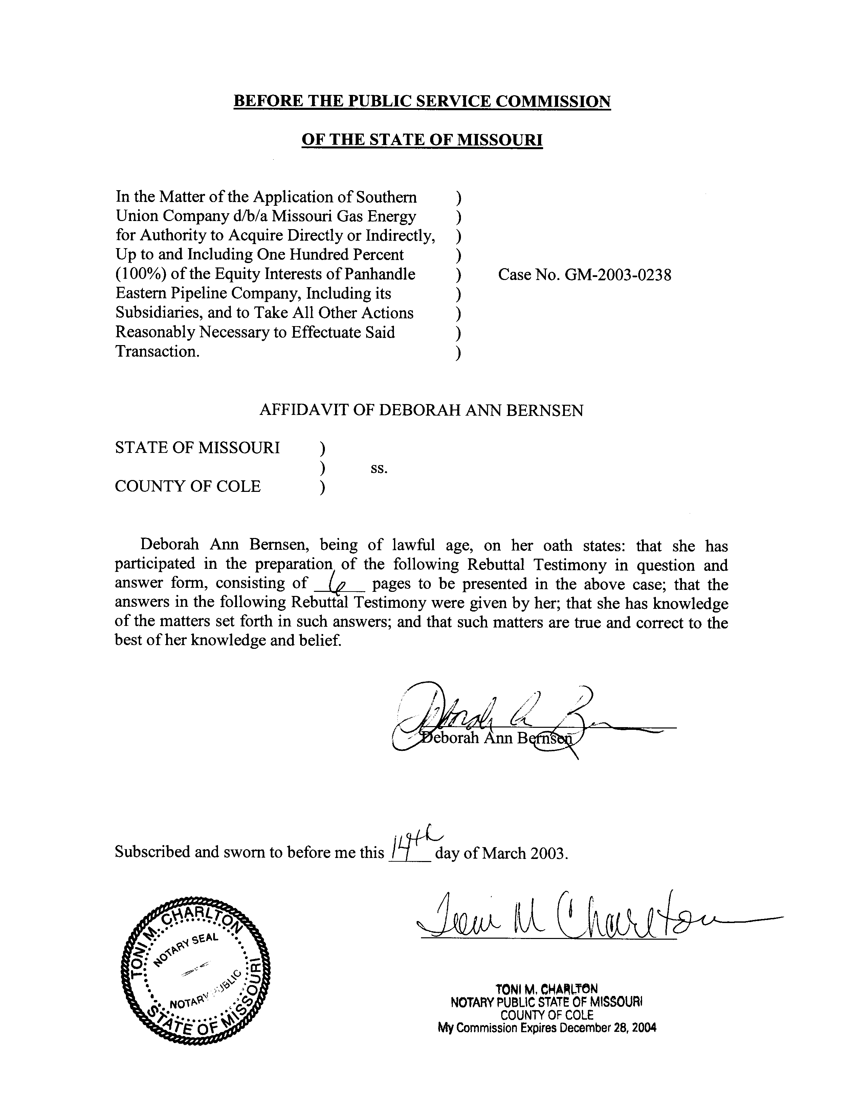

REBUTTAL TESTIMONY
OF
DEBORAH ANN BERNSEN

SOUTHERN UNION COMPANY
d/b/a MISSOURI GAS ENERGY
CASE NO. GM-2003-0238
Please state your name and business address.
My name is Deborah Ann Bernsen and my business address is P.O. Box 360, Jefferson City, Missouri 65102.
By whom are you employed and in what capacity?
I am employed as a Management Analyst for the Missouri Public Service Commission (Commission or PSC).
Please describe your educational background.
I graduated from the University of Missouri-Columbia in 1975 with a Bachelor of Science degree in Business Administration. I completed a Masters degree in Public Administration in 1990 from the same university. I have passed three of the four parts of the Certified Internal Auditor (CIA) exam.
Please describe your work background.
I have been employed by the Commission since 1976 when I began a graduate internship. I subsequently entered the Consumer Services Department of the PSC as a Consumer Services Specialist responding to consumer complaints and inquiries. I entered the Management Services Department in 1978 as a Management Analyst and since that time have had responsibility for conducting and directing reviews of management operating and control systems at utility companies under the Commission’s jurisdiction. The name of the Management Services Department was changed to the Engineering and Management Services Department in 2000.
Have you previously filed testimony before the Commission?
Yes. Schedule 1 presents the cases in which I filed testimony and notes which issues were covered in the testimony.
What matters will you address in your testimony?
I will address matters related to the quality of service provided to the Missouri customers of Southern Union Company.
What is the purpose of your testimony?
The purpose of my testimony is to present an overview of the Staff’s position regarding the quality of service issues. These issues are important in assessing the “not detrimental to the public interest standard” in the consideration of the proposed acquisition of Panhandle Eastern Pipeline Company (Panhandle).
Why are quality of service issues of particular concern in the consideration of a merger or acquisition request by utility companies?
The quality of service received by customers becomes particularly vulnerable given the events which normally occur during or shortly after a merger or acquisition. The financial pressures associated with an acquisition may encourage a company to engage in expense reduction efforts that may impact service quality. Service quality may be impacted by changes in company personnel, systems and by the relationships that the company develops with affiliates.
Computerized systems, such as customer information systems, may be changed at the acquired company to make for compatible methods of combining customer records and responding to inquiries. Operating functions are frequently consolidated and local offices closed which can lead to staffing reductions. The acquiring company may significantly reduce the presence of the company in the communities.
Functions normally performed by one company may be reassigned to a separate entity. Changes in responsibilities may shift experienced and knowledgeable company employees from the regulated business into other regulated or unregulated companies within the new organization. Relationships with unregulated affiliates can present situations in which the regulated entity can potentially be utilized to increase the earnings of the unregulated side of the business.
Another potential concern involves the economics of the transaction and assumptions regarding savings and synergies. If these expectations do not occur, financial pressures may dictate the initiation of additional cost savings measures that could affect the provision of service quality. These situations and others may occur in the name of taking advantage of synergies and efficiencies. However, focus needs to be retained on the level of service being provided to the customer. All of these factors can contribute to a reduction in the level of service experienced by the customer of either company involved in the merger.
Why should this be a concern in merger or acquisition cases?
There is clear direction by the Commission in the Missouri Code of State Regulations 4 CSR 240-2.060 that applications for authority to merge or acquire companies must include reasons why the proposal is not detrimental to the public interest. Mergers and acquisitions, therefore, in the Staff’s view, should not result in a deterioration of customer service because a deterioration in customer service is not in the public interest.
Has the Staff expressed concern with quality of service issues in prior merger applications?
Yes. The Staff has expressed this concern in several prior merger cases where stipulations and agreements were subsequently reached by the parties and approved by the Commission. The first instance was in the Stipulation and Agreement in Case No. EM-97-515, the Western Resources, Inc. and Kansas City Power & Light Company merger. The second instance was in the Stipulation and Agreement in Case No. GM-2000-43, respecting Southern Union and Pennsylvania Enterprises, Inc. In both of these cases, indicators to measure significant customer service components in a
post-merger environment were jointly developed and agreed to by the Staff, the Companies and the Office of the Public Counsel in a Stipulation and Agreement. These indicators included customer call center measurements, as well as technical indicators for distribution system reliability.
The Staff filed testimony in Case No. GM-2000-312, concerning the merger of Atmos Energy Company and Associated Natural Gas Company. A Unanimous Stipulation and Agreement was filed in that case on March 29, 2000, which also contained proposed customer service indicators. The Stipulation and Agreement was approved on April 20, 2000. The Staff also filed rebuttal testimony in Case No. EM-2000-292, regarding the Joint Application of UtiliCorp United Inc. and St. Joseph Light & Power Company for authority to merge St. Joseph Light & Power into UtiliCorp United Inc. In this case, the Commission ordered the reporting of information on call center performance and distribution reliability. These same issues were addressed by Staff in testimony filed in Case No. EM-2000-369, the proposed merger of UtiliCorp United Inc. and Empire District Electric Company. This merger request was eventually withdrawn by UtiliCorp United Inc. In Case No. WM-2001-309, a request by Missouri-American Water to merge St. Louis County Water and Jefferson City Water Works into Missouri-American Water, the Stipulation and Agreement reached in the case included the reporting of performance indicators for the Company’s consolidated Call Center.
What has the Staff supported in previous cases regarding methods to ensure that the level of customer service is maintained in a post-merger environment?
In the past, the Staff has recommended the utilization of several indicators designed to assist in assessing the level of service being provided to the customer. Once developed, these indicators provide a benchmark over time to determine any changes or trends in service received by the customer. Formal monitoring and reporting systems also have been included to track these indicators.
In your opinion, can the use of such indicators provide complete assurance that customers are receiving the same level of service as before a merger?
No. While the use of indicators can provide a useful management tool and can be used to help direct further inquiry, they cannot provide assurance that deficiencies are not present in other facets of customer service. However, indicators do provide useful tools to monitor changes and trends in specific areas and alert the company and Staff to deviations from the intended or required level of customer service and the identification of potential problems.
Does the Company presently provide any information to the Staff regarding the quality of service it provides to the Missouri customers?
Yes. Under the provisions of the Stipulation and Agreement in Case No. GM-2000-43, Missouri Gas Energy provides quarterly data and a yearly summary on several indicators relating to the service provided by its call center. In addition, the Company also provides information on a number of operating procedures in the customer service area. This information assists Staff in determining if unfavorable trends are developing in the customer services area.
What does Staff propose in this case regarding the maintenance and reporting of customer service data?
The Staff proposes that the Company maintain a reporting of the information required under Case No. GM-2000-43. In addition, the Staff is requesting the provision of two additional service level indicators. The first indicator pertains to the Company’s ability to meet its service appointments. The second indicator is the maintenance of the average response time that it takes for the Company to respond to Commission-forwarded complaints.
Does this conclude your rebuttal testimony?
Yes, it does.
Testimony Summary

Deborah A. Bernsen

Date Filed | Issue | Case Number | Exhibit | Case Name
10/07/1983 | Management Efficiency | TR83253 | Rebuttal | Southwestern Bell Telephone Company
1983 | Customer Service | GR83225 | Direct | Gas Service Company
07/03/1985 | Management Efficiency | ER85128  EO85185 | Direct | Kansas City Power & Light
11/17/1989 | Capital Deployment | TR89196 | Rebuttal | Contel of Missouri, Inc.
05/02/2000 | Customer Service | EM2000292 | Rebuttal | UtiliCorp United Inc./St. Joseph Light and Power
06/26/2001 | Customer Service | WM2001309 | Rebuttal | Missouri-American Water Company, et al
12/06/2001 | Customer Service Call Center Reporting | EC2002265 | Direct | UtiliCorp United Inc. d/b/a Missouri Public Service
12/06/2001 | Call Center Reporting | ER2001672 | Direct | UtiliCorp United Inc. d/b/a Missouri Public Service
06/24/2002 | Alternative Regulation Plan - Quality of Service | EC20021 | Surrebuttal | Union Electric Company d/b/a AmerenUE

