Exhibit No.:
Issues: Individual Electric
Meters - Variance &
Rate Application

Witness: James C. Watkins
Sponsoring Party: MO PSC Staff
Type of Exhibit: Rebuttal Testimony
Case Nos.: EE-2004-0267 &
EE-2004-0268
Date Testimony Prepared: August 16, 2004

MISSOURI PUBLIC SERVICE COMMISSION

Utility Operations DIVISION

REBUTTAL TESTIMONY

OF

JAMES C. WATKINS

UNION ELECTRIC COMPANY, d/b/a AMERENUE

CASE NOS. EE-2004-0267 & EE-2004-0268

Jefferson City, Missouri
August 2004
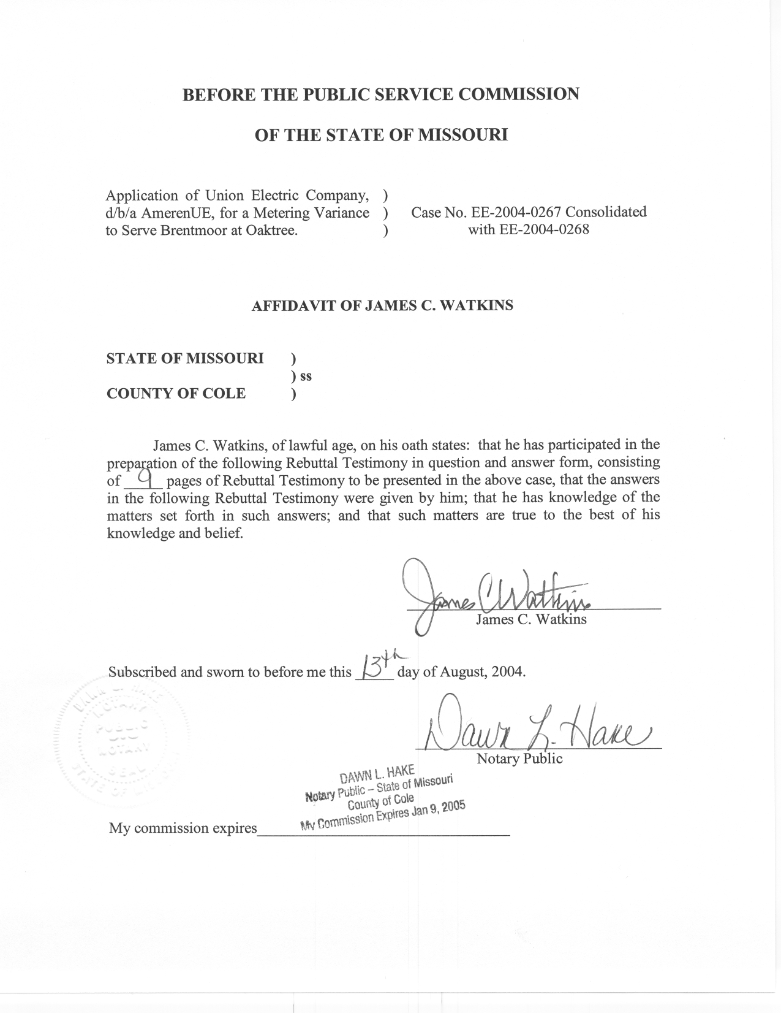
REBUTTAL TESTIMONY
OF
JAMES C. WATKINS
UNION ELECTRIC COMPANY, d/b/a AMERENUE
CASE NOS. EE-2004-0267 & EE-2004-0268
(Consolidated)

Q. Please state your name and business address.
A. My name is James C. Watkins and my business address is Missouri Public Service Commission, 200 Madison Street, P. O. Box 360, Jefferson City, Missouri 65102.
Q. What is your present position with the Missouri Public Service Commission (Commission)?
A. I am a Regulatory Economist in the Economic Analysis Section of the Energy Department, Utility Operations Division.
Q. Please review your educational background and work experience.
A. I have a Bachelor of Arts Degree in Economics from William Jewell College, a year of graduate study at the University of California at Los Angeles in the Masters Degree Program, and have completed all requirements except my dissertation for a Ph.D. in Economics from the University of Missouri-Columbia. My previous work experience has been as an Instructor of Economics at Columbia College, the University of Missouri-Rolla, and William Jewell College. I have been on the Staff of the Missouri Public Service Commission (Staff) since August 1, 1982. A list of the major cases in which I have filed testimony before the Commission is shown on Schedule 1.

Q. What is the purpose of your Rebuttal Testimony?
A. The purpose of my Rebuttal Testimony is to present the Staff’s position regarding whether Union Electric Company, d/b/a AmerenUE (“Company”) should (1) be granted the requested metering variances and (2) be authorized to bill the aggregate load of the individual residential apartments in each of these retirement communities under one of its non-residential rate schedules as if they were a single commercial customer. The Staff recommends that the Commission require that the individual residential apartments be individually metered and billed on the residential rate.
PURPA
Q. Why is individual metering of multiple occupancy buildings required?
A. Both the Commission’s Rules (4 CSR 240-20.050) and the Company’s tariff (Sheet 174, General Rules And Regulations, V. Billing Practices, L. Rent Inclusion) require individual metering. The Company’s tariff implements the Commission’s Rule. The Commission’s Rule is aimed at compliance with the Public Utility Regulatory Policies Act of 1978 (“PURPA”), PL 95-617, 16 USC 2601, which provides in pertinent part:
The Congress finds that the protection of the public health, safety, and welfare, the preservation of national security, and the proper exercise of congressional authority under the Constitution to regulate interstate commerce require –
(1) a program providing for increased conservation of electric energy, increased efficiency in the use of facilities and resources by electric utilities, and equitable retail rates for electric consumers.

Requiring individual metering promotes (1) energy conservation and (2) equitable retail rates. Other provisions of PURPA relate to efficient use of facilities and resources by electric utilities.
Q. How does individual metering and billing promote conservation?
A. Conservation does not simply mean using less. Conservation means eliminating waste. There is an economic incentive to eliminate waste when consumers must pay the full cost of what they consume. If consumers’ electric bills increase with usage, there is an economic incentive to turn off the lights when they leave the room and control the temperature with the thermostat instead of the window.
Metering
Q. Are there exceptions to the requirement to individually meter each residential or commercial unit in a multiple occupancy building?
A. Yes. The exceptions are listed in the Commission’s Rule (4 CSR 240-20.050(4)) and the Company’s tariff. The exceptions are rather lengthy, so I have attached the Commission’s Rule as Schedule 2 and Company’s tariff as Schedule 3. In general, these exceptions are for “transient” or “temporary” use and for central space heating, water heating, ventilating, and air-conditioning.
Q. Does either Brentmoor at Oaktree or River’s Edge Properties qualify for any of these exemptions?
A. No. While PURPA allows for an exemption when the long-run benefits to electric consumers in each unit of the multiple occupancy building do not exceed the costs of purchasing and installing separate meters in the building, the Commission’s Rule does not. Instead, the Commission’s Rule provides that variances may be granted for good cause shown and establishes a variance committee to consider all variance applications filed by utilities and make written recommendations to the Commission.
Q. Are you a member of the Electric Meter Variance Committee?
A. Yes. I have been a member since October 28, 1999.
Q. Has the general approach of the variance committee been to recommend that the Commission approve variances when the long-run benefits to electric consumers in each unit of the multiple occupancy building do not exceed the costs of purchasing and installing separate meters in the building?
A. Yes. The variance committee has also considered the degree of similarity in the proposed use of the building to those listed as exceptions in the Commission’s Rule.
Q. In the cases of Brentmoor at Oaktree and River’s Edge Properties, do the costs of purchasing and installing separate meters exceed the long-run benefits to electric consumers in each unit of the multiple occupancy building?
A. I do not know. Company witness Philip B. Difani, Jr. presented information in his direct testimony (page 6, beginning at line 5) that the estimated cost of installing individual meters would be $180 per unit. No witness presented any information on the long-run benefits to consumers, so a comparison is impossible to make.
Q. Did Mr. Difani provide any other cost information?
A. Yes. Mr. Difani also provided information that additional facilities and equipment installed by Company would add $170 per unit to its costs at River’s Edge (direct, page 6, lines 6-8) and that it would cost River’s Edge between $500,000 and $1,000,000 to rewire these units for individual metering (direct, page 6, lines 11-12).
Q. Should these additional costs be considered in determining whether the costs of purchasing and installing separate meters exceed the long-run benefits to electric consumers?
A. No. They are not costs of purchasing and installing meters. The Company’s additional costs are for facilities and equipment normally provided to new customers. Furthermore, the cost to rewire these units is a cost that would not be necessary if the units had been wired for individual meters in the first place.
Q. Is there any similarity between these independent living retirement communities and the listed exceptions in the Commission’s Rule?
A. No information was presented in direct testimony that these retirement communities were transient in nature. Mr. Difani testified (direct, page 4, lines 10-11) that the residents are all able to perform the activities of daily life. I can find no basis on which to distinguish these independent living retirement communities from other apartment buildings.
Q. If the Commission determines that master metering is appropriate for Brentmoor at Oaktree and River’s Edge Properties, is the appropriate remedy to grant the variance?
A. It would only be appropriate as a stop-gap measure. The long-term solution would be to modify the Commission’s Rule to include an exception for this type of multiple occupancy building so that the owners of all of the other “retirement communities” won’t have to file individually for a similar variance. The problem with this approach is that “retirement community” is not well defined. They require no special license and have no unique characteristics to distinguish them from any other apartment complex.
Billing
Q. Is the issue of the appropriate billing of retirement facilities and other multiple-occupancy buildings addressed by Union Electric Company in a tariff filing in July of 1995?
A. Yes. Attached as Schedule 4 is the Staff’s recommendation regarding that tariff, which is currently in effect. That recommendation indicates that the filing modifies the tariff language that was the subject of three complaint cases regarding the metering and billing of single-metered multiple-occupancy licensed retirement or nursing care facilities (Schedule 4, last paragraph on page 1) to more accurately define when a retirement facility will be billed from the Residential, General Service, or Primary Service Classification (Schedule 4, last paragraph on page2), as follows:
Language has been added stating that the Residential Classification is not available to a nursing home or retirement facilities [sic] that is licensed by the State of Missouri Department of Social Services Division of Aging (State). These types of facilities will receive service from the appropriate non-residential classification.

Normal apartment buildings or retirement facilities that are not licensed by the State will be individually metered and will receive service from the Residential Classification. However, Commission Rule 4 CSR 240-20.050 allows for a variance from the individual metering requirement. If a variance is requested by an applicant and ultimately granted by the Commission, the facility will then receive service from the appropriate General Service or Primary Service Classification.

Q. How were single-metered multiple-occupancy residential buildings constructed prior to June 1, 1981 billed prior to December 15, 1995?
A. The total monthly bill to each such building to which service was delivered and metered at one point was equal to the total number of dwelling units therein multiplied by the bill per dwelling unit, which bill per dwelling unit was calculated by applying the Residential Service Rate to the average kilowatthour use per dwelling unit (equal to the total building use divided by the number of dwelling units, rounded to the nearest kilowatthour). (Sheet No. 29, paragraph 4).
Q. How do the Company’s tariffs define a residential apartment?
A. A residential apartment is a housekeeping unit with space for eating, living and sleeping, and permanent provisions for cooking and sanitation. (Sheet No. 29).
Q. Do the apartments at Brentmoor at Oaktree and River’s Edge Properties meet this definition of a residential apartment?
A. Yes.
Q. What would be the rationale for granting a variance and authorizing Brentmoor at Oaktree and River’s Edge Properties to be billed as a single customer on a non-residential rate?
A. The rationale could be that the usage in the individual apartments was not primarily for residential purposes. Rather, it was primarily for some other commercial purpose. This is the situation with licensed nursing homes. The primary purpose is providing nursing care on a 24-hour basis. It is only incidental that patients live, eat, and sleep in the facility. This is not the case for unlicensed “retirement communities” like Brentmoor at Oaktree and River’s Edge Properties. While the common areas may be a commercial use, the individual apartments are clearly residential.
Q. Would granting a variance and authorizing Brentmoor at Oaktree and River’s Edge Properties to be billed as a single customer on a non-residential rate result in unduly preferential rates?
A. I believe that it would. Based on Mr. Difani’s calculations (direct, page 8, lines 3-6), if a variance is granted and for the same usage, the annual bill for a residential customer would be 65% higher than that for the tenants living at Brentmoor at Oaktree. In addition, other “worry-free” retirement communities that have not been granted variances would pay 65% more for their electricity and would be put at a competitive disadvantage. To me, this clearly affords Brentmoor at Oaktree and River’s Edge Properties unduly preferential rate treatment.
Q. Mr. Difani addresses how the Company has been billing these customers in his direct testimony from page 8, line 15 through page 9, line 2. Is this billing consistent with the Company’s approved tariffs?
A. No. Neither the Small General Service Rate nor the Large General Service Rate is available to unlicensed “retirement communities” that have not been granted a variance from the Commission’s Rule. The Residential Service Rate, however, would only be available if the individual residential apartments are separately metered.
Q. If variances are not granted for Brentmoor at Oaktree and River’s Edge Properties, what will need to be done in order for them to continue to receive electric service?
A. I believe the situations are different for Brentmoor at Oaktree and River’s Edge Properties. It is my understanding that the individual apartments at Brentmoor at Oaktree were previously served through individual meters, and that all that would be required is for the Company to reinstall the meters it removed when the master meter was installed.
In the case of River’s Edge Properties, which was constructed only for master metering, the building would have to be rewired (at an estimated cost between $500,000 and $1,000,000) and the Company would have to install additional facilities and equipment, as well as individual meters.
Q. Would the installation of separate meters interfere with the plastic covers or electronic mechanisms installed on the tenants’ thermostats to prevent them from setting the temperature at harmful levels, as suggested in the direct testimony of Ms. Julie Hess on behalf of River’s Edge Properties?
A. No. The metering configuration is totally unrelated to the thermostats and will have no effect on them.
Q. What is your recommendation to the Commission regarding whether it should grant these variances?
A. I recommend that the Commission deny the variances requested by Brentmoor at Oaktree and River’s Edge Properties.
In the case of Brentmoor at Oaktree, there is no reason that electric service should not be provided in strict compliance with the Commission’s Rules and the Company’s tariffs.
In the case of River’s Edge Properties, I recommend that the Commission consider the alternative of granting a variance to allow River’s Edge Properties to be billed in accordance with the aforementioned paragraph 4 on sheet 29 of Company’s Residential Service Rate, even though the provisions of that paragraph are no longer available to other customers. This would resolve the problems with improperly billing the residential usage in 166 separate residential apartments as if it were the usage of a single commercial customer, but would not require costly rewiring of the building.
Q. Does this conclude your prefiled rebuttal testimony in support of the Staff’s position on these issues?
A. Yes.
- The Empire District Electric Company Case No. ER-83-42
- Kansas City Power & Light Company Case No. ER-83-49
- Union Electric Company Case No. ER-83-163
- Arkansas Power & Light Company Case No. ER-83-206
- The Empire District Electric Company Case No. ER-83-364
- Kansas City Power & Light Company Case No. EO-84-4
- Union Electric Company Case No. EO-85-17
- Arkansas Power & Light Company Case No. ER-85-20
- Arkansas Power & Light Company Case No. EO-85-146
- Union Electric Company Case No. ER-85-160
- Kansas City Power & Light Company Case Nos. ER-85-128 & EO-85-185
- Arkansas Power & Light Company Case Nos. ER-85-265 & ER-86-4
- Union Electric Company Case Nos. EC-87-114 & EC-87-115
- St. Joseph Light & Power Company Case No. HR-88-116
- Union Electric Company Case No. EO-87-175
- Missouri Public Service Case No. ER-90-101
- The Empire District Electric Company Case No. ER-90-138
- Kansas City Power & Light Company Case No. EM-91-16
- St. Joseph Light & Power Company Case No. EO-88-158
- The Empire District Electric Company Case No. EO-91-74
- Missouri Public Service Case No. EO-91-245
- Missouri Public Service Case No. EO-93-37
- St. Joseph Light & Power Company Case No. ER-93-41
- St. Joseph Light & Power Company Case No. EO-93-351
- St. Joseph Light & Power Company Case No. ER-94-163
- The Empire District Electric Company Case No. ER-94-117
- Citizens’ Electric Corporation Case No. ER-97-286
- The Empire District Electric Company Case No. ER-97-81
- The Empire District Electric Company Case No. ER-97-491
- Missouri Public Service Case Nos. ER-97-394 & ET-98-103
- St. Joseph Light & Power Company Case Nos. EC-98-573 & ER-99-247
- Citizens’ Electric Corporation Case No. ET-99-113
- Union Electric Company Case No. EO-96-15
- Union Electric Company Case No. EO-2000-580
- The Empire District Electric Company Case No. ER-2001-299
- Missouri Public Service Case No. ER-2001-672 & EC-2002-265
- Union Electric Company Case No. EC-2002-1
- Citizens’ Electric Corporation Case No. ER-2002-217
- The Empire District Electric Company Case No. ER-2001-1074 (ER-2001-425)
- The Empire District Electric Company Case No. ER-2002-424
- Aquila, Inc. Case Nos. ER-2004-0024 & ER-2004-0034

