Exhibit No.:

Issues: Large Transmission Service Rate
Witness: James C. Watkins
Sponsoring Party: MoPSC Staff
Type of Exhibit: Rebuttal Testimony
Case No.: EA-2005-0180
Date Testimony Prepared: January 31, 2005

MISSOURI PUBLIC SERVICE COMMISSION

Utility Operations Division

Rebuttal TESTIMONY

OF

James c. watkins

UNION ELECTRIC COMPANY
D/B/A AMERENUE

CASE NO. EA-2005-0180

Jefferson City, Missouri

January, 2005

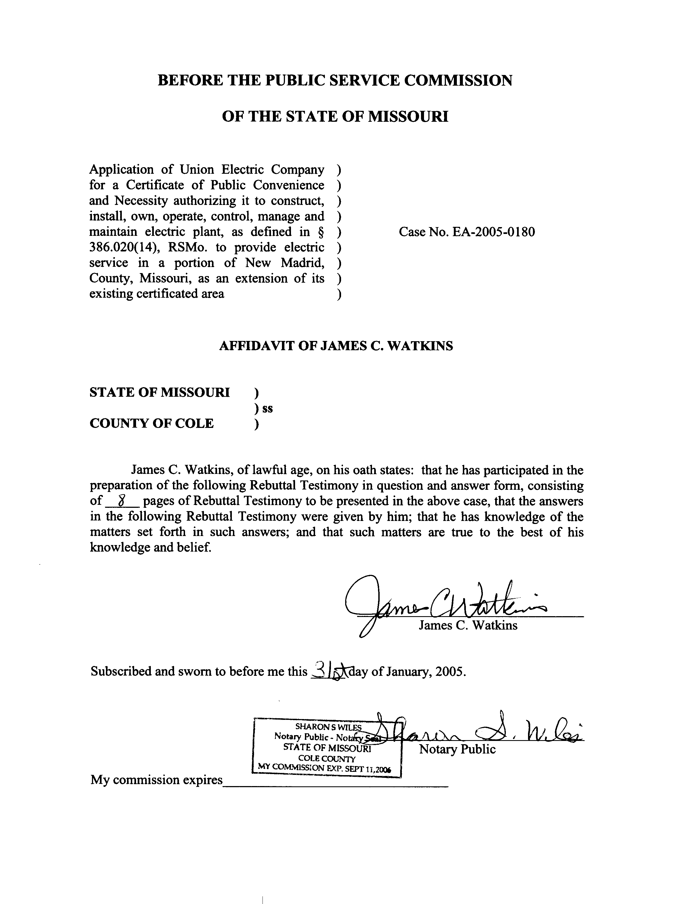
REBUTTAL TESTIMONY
OF
JAMES C. WATKINS
UNION ELECTRIC COMPANY
D/B/A AMERENUE
CASE NO. EA-2005-0180
Q. Please state your name and business address.
A. My name is James C. Watkins and my business address is Missouri Public Service Commission, 200 Madison Street, P. O. Box 360, Jefferson City, Missouri 65102.
Q. What is your present position with the Missouri Public Service Commission (Commission)?
A. My title is Manager, Economic Analysis, Energy Department, Operations Division.
Q. Please review your educational background and work experience.
A. I have a Bachelor of Arts Degree in Economics from William Jewell College, a year of graduate study at the University of California at Los Angeles in the Masters Degree Program, and have completed all requirements except my dissertation for a Ph.D. in Economics from the University of Missouri-Columbia. My previous work experience has been as an Instructor of Economics at Columbia College, the University of Missouri-Rolla, and William Jewell College. I have been on the Staff of the Missouri Public Service Commission (Staff) since August 1, 1982. A list of the major cases in which I have filed testimony before the Commission is shown on Schedule 1.
Q. What is the purpose of your rebuttal testimony in this case?
A. The purpose of my rebuttal testimony is to present my analysis of the Company’s proposed tariff sheets designed to create a Service Classification No. 12(M)-Large Transmission Service Rate (Large Transmission Service Rate Schedule) for providing service to Noranda Aluminum, Inc. (Noranda) and to address certain claims made by Union Electric Company, d/b/a AmerenUE (Company) witness Wilbon L. Cooper regarding the “very unique service characteristics” of Noranda’s load that are not addressed in the Company’s current Large Primary Service Rate Schedule.
Q. Which of the unique characteristics of Noranda’s load identified by Mr. Cooper will you address?
A. Mr. Cooper lists four (4) characteristics in his Direct Testimony, page 4, lines 3 - 12:
1) annual energy consumption of at least 3,000,000 megawatt hours;

2) annual load factor of 98%;
3) customer responsible for arranging and paying for third-party transmission service, including energy line losses;

4) customer does not require use of Company’s distribution system; and thus, as noted on page 6, lines 12 - 15 of Mr. Cooper’s Direct Testimony, customer has lower energy and demand losses than customers on the Large Primary Service Rate Schedule.

I will address characteristic 4) and the Company’s proposed adjustments from the Large Primary Service Rate Schedule. Mr. Cooper states that the Large Primary Service rate structure “equitably addresses conditions 1) and 2) above.” Characteristic 3) is unique to Noranda in that it is not connected directly to the Company’s transmission system. This characteristic has to be addressed whether Noranda is served on the Large Primary Service Rate Schedule, by adding a provision for third-party transmission service, or on a new Large Transmission Service Rate Schedule.
Q. Would Noranda be the only customer that takes service at 138,000 volts or higher?
A. No. There are other Large Primary Service customers that take service at 138,000 volts or higher.
Q. Is there a special rate for these customers?
A. The Company’s tariff contains riders that are applicable to and available to these customers. Rider B provides discounts for customer ownership or leasing of substations to transform all or part of the service from a delivery voltage of 34,500 volts or higher to a lower voltage. Large Primary Service customers receive a discount of $0.95 per kilowatt of billing demand if they take service at 138,000 volts or higher. Rider C provides adjustments to meter readings to account for the difference in losses, if a customer is metered at a voltage other than the standard delivery voltage. Both kilowatt and kilowatt-hour meter readings are reduced by 0.68% if metering is above 34,500 volts.
Q. What adjustments has the Company proposed in the Large Transmission Service Rate Schedule applicable to Noranda to account for taking service at 138,000 volts or higher?
A. Instead of the Rider B credit of $0.95 per kilowatt of billing demand, the Company proposes a discount of $1.64, which Mr. Cooper bases on the Rider RDC charges. In addition to the Rider C loss adjustment of 0.68%, the Company proposes an additional adjustment of 4.17%.
Q. Are you aware of anything unique to serving Noranda’s load that would warrant these adjustments only for Noranda, and not for other customers served at 138,000 volts or higher?
A. In order to serve its Large Primary Service customers at 138,000 volts or higher, the Company normally installs a radial drop (or radial line) from its transmission line to the customer’s substation. Because Noranda’s substation is connected to a third-party transmission provider, the Company will not be required to install a radial drop for Noranda.
Q. How does the Company classify these radial drops?
A. Because they are radial lines that terminate at a distribution substation, the Company classifies them as “distribution”, rather than “transmission”, even though they are at 138,000 volts or higher. Only looped lines that have no termination point would be classified as transmission.
Q. How are the Rider RDC charges related to serving Noranda?
A. They are not directly related. The purpose of Rider RDC is to provide reserve capacity on the Company’s distribution system to customers that request a reserve distribution connection for delivery of electricity from distribution facilities other than the standard or preferred distribution supply facilities designated by the Company. The customer pays for the additional facilities and is charged the Small Primary Service Total Billing Demand Charges, less any applicable Rider B ownership credits, each month. Mr. Cooper has suggested that the Rider RDC charges should be used as a proxy for the cost of a radial line from the Company’s transmission line to the Customer’s substation.
Q. Are the Rider RDC charges a reasonable proxy for a radial line?
A. I don’t know, but it seems unlikely. Mr. Cooper used a proxy because the Company had not performed a cost study to present in this case. He suggests that the reasonableness of this credit be examined in connection with the Company’s next rate proceeding, in which the Company will file a customer class cost-of-service study and comprehensive rate design. The Staff will make its recommendation as to what credit, if any, should be given for radial lines in the next rate proceeding respecting the Company, after it has had a chance to review the Company’s cost studies.
Q. On page 6, lines 13-15, of his Direct Testimony, Mr. Cooper states that the Company’s Energy Delivery personnel determined that the average energy and demand loss factor for a Large Transmission Service customer would be only 1.38%. What loss factor did Mr. Cooper design into the Large Transmission Service Rate Schedule?
A. The demand and energy charges on the Large Primary Service Rate Schedule were reduced by 4.17%, from 5.55% to 1.38%, as shown on lines 7 and 15 of Mr. Cooper’s schedule WLC-2. An additional Rider C adjustment is shown on line 24 and noted on line 28. This would make the loss factor 0.70% (1.38% - 0.68%), not 1.38%. The first section (Character of Service Supplied) on Sheet No. 68.4 of the proposed rate schedule (Schedule WLC-1, page 5 of 10) clearly indicates that Rider C will apply, even though the rates have already been reduced by 4.17%.
Q. Is a loss factor of 0.70% reasonable for service to Noranda?
A. Again, I don’t know, but it seems highly unlikely. A loss factor of 0.70% for service to Noranda implies that the line losses on the radial drops, serving Large Primary Service customers at 138,000 volts or higher, is 4.17%. If losses on the entire transmission system are only 1.38%, it seems highly unlikely that the additional losses on a short extension of that system would be over three times higher than the losses over the entire transmission system. The Staff will make its recommendation as to what a reasonable loss adjustment is for radial lines in the next rate proceeding respecting the Company, after it has had a chance to review the Company’s loss studies.
Q. What is the relationship between the Rider B credits, the Rider C adjustments, and the Company’s proposed Annual Contribution Factor in the proposed Large Transmission Service Rate Schedule?
A. As shown by comparison of Schedule WLC-2 to Schedule WLC-3, and as described by Mr. Cooper on page 7, lines 6-16, of his Direct Testimony, the only difference between the charges on the Large Primary Service Rate Schedule and the charges on the Large Transmission Service Rate Schedule are related to “utilization of distribution assets and average losses.” Thus, the Annual Contribution Factor accounts only for the difference between the Rider B ownership credits and the Rider RDC charges, to account for customer ownership of the radial line, plus the additional 4.17% reduction in the demand and energy charges to adjust for radial line losses.
Q. Is the Annual Contribution Factor a permanent provision of the Large Transmission Service Rate Schedule?
A. No. The rate schedule provides, “The AFC shall be eliminated effective upon a Missouri Public Service Commission (‘MoPSC’) order in a Complaint case, rate case proceeding, or any other regulatory proceeding where Company’s rates for its bundled Service Classifications are changed.” (See Mr. Cooper’s Schedule WLC-1, page 2 of 10). Furthermore, “In the event the ACF is eliminated or discontinued prior to the said anniversary date, no Customer payment is required.” (See Mr. Cooper’s Schedule WLC-1, page 2 of 10).
Q. What is the effect of the Annual Contribution Factor?
A. The Annual Contribution Factor is simply the difference between what Noranda would be charged on the existing Large Primary Service Rate Schedule, after applying Rider B and Rider C adjustments, and what Noranda would be charged on the proposed Large Transmission Service Rate Schedule, absent the Annual Contribution Factor. Thus, it makes the charges under the Large Primary Service and Large Transmission Service rate schedules equivalent, at Noranda’s assumed load factor.
Q. Will the two rates be equivalent if Noranda’s load factor is less than the load factor assumed in Mr. Cooper’s analysis?
A. No. Under the Large Primary Rate Schedule, a reduction in load factor would increase the average charge per kilowatt-hour because the fixed charges (customer charge and demand charge) are spread over fewer kilowatt-hours. Thus, the annual net bundled kilowatt-hour realization to the Company of $0.0325/kWh, after Rider C adjustments, specified in the Annual Contribution Factor section of the proposed Large Transmission Service Rate Schedule would be less than Noranda would be charged for service under the Large Primary Service Rate Schedule.
Q. Does the Commission need to determine the reasonableness of the Annual Contribution Factor (i.e., a demand credit based on Rider RDC and a 4.17% loss adjustment for radial lines) in this case?
A. No. If Noranda’s load factor remains as high as the assumed level, Noranda will be charged the same total amount whether it takes service under the existing Large Primary Service Rate Schedule or under the Company’s proposed new Large Transmission Service Rate Schedule.
Pursuant to the Commission’s approval of the Stipulation And Agreement in Case No. EC-2002-1, the Company will submit no later than January 1, 2006, a Missouri jurisdictional customer class cost-of-service study and a Missouri jurisdictional revenue requirement cost of service study covering the twelve months ending June 30, 2005. The reasonableness of any rate adjustments to serve Noranda should be determined by the Commission in the next general rate proceeding or Missouri jurisdictional customer class cost-of-service study and comprehensive rate design proceeding.
Q. What is the Staff’s recommendation?
A. The Staff’s recommendation is that if the Company’s application is approved, the proposed Large Transmission Service Rate Schedule should be rejected, and the Company should be ordered to (1) file revised tariff sheets to add provisions for third-party transmission to its Large Primary Service Rate Schedule and (2) serve Noranda under its Large Primary Service Rate Schedule.
Q. Does this complete your rebuttal testimony?
A. Yes, it does.
- The Empire District Electric Company Case No. ER-83-42
- Kansas City Power & Light Company Case No. ER-83-49
- Union Electric Company Case No. ER-83-163
- Arkansas Power & Light Company Case No. ER-83-206
- The Empire District Electric Company Case No. ER-83-364
- Kansas City Power & Light Company Case No. EO-84-4
- Union Electric Company Case No. EO-85-17
- Arkansas Power & Light Company Case No. ER-85-20
- Arkansas Power & Light Company Case No. EO-85-146
- Union Electric Company Case No. ER-85-160
- Kansas City Power & Light Company Case Nos. ER-85-128 & EO-85-185
- Arkansas Power & Light Company Case Nos. ER-85-265 & ER-86-4
- Union Electric Company Case Nos. EC-87-114 & EC-87-115
- St. Joseph Light & Power Company Case No. HR-88-116
- Union Electric Company Case No. EO-87-175
- Missouri Public Service Case No. ER-90-101
- The Empire District Electric Company Case No. ER-90-138
- Kansas City Power & Light Company Case No. EM-91-16
- St. Joseph Light & Power Company Case No. EO-88-158
- The Empire District Electric Company Case No. EO-91-74
- Missouri Public Service Case No. EO-91-245
- Missouri Public Service Case No. EO-93-37
- St. Joseph Light & Power Company Case No. ER-93-41
- St. Joseph Light & Power Company Case No. EO-93-351
- St. Joseph Light & Power Company Case No. ER-94-163
- The Empire District Electric Company Case No. ER-94-117
- Citizens’ Electric Corporation Case No. ER-97-286
- The Empire District Electric Company Case No. ER-97-81
- The Empire District Electric Company Case No. ER-97-491
- Missouri Public Service Case Nos. ER-97-394 & ET-98-103
- St. Joseph Light & Power Company Case Nos. EC-98-573 & ER-99-247
- Citizens’ Electric Corporation Case No. ET-99-113
- Union Electric Company Case No. EO-96-15
- Union Electric Company Case No. EO-2000-580
- The Empire District Electric Company Case No. ER-2001-299
- Missouri Public Service Case No. ER-2001-672 & EC-2002-265
- Union Electric Company Case No. EC-2002-1
- Citizens’ Electric Corporation Case No. ER-2002-217
- The Empire District Electric Company Case No. ER-2001-1074 (ER-2001-425)
- The Empire District Electric Company Case No. ER-2002-424
- Aquila, Inc. (MPS & L&P) Case Nos.ER-2004-0034 & HR-2004-0024
- The Empire District Electric Company Case No. ER-2004-0570

