Exhibit No.:
Issues: Weather Normalization

Witness: Richard J. Campbell
Sponsoring Party: Mo PSC Staff
Type of Exhibit: Direct Testimony
Case No.: ER-2002-424
Date Testimony Prepared: August 22, 2002

MISSOURI PUBLIC SERVICE COMMISSION

Utility Operations DIVISION

Direct Testimony

OF

Richard J. Campbell

The Empire District Electric Company

CASE NO. ER-2002-424

Jefferson City, Missouri
August, 2002

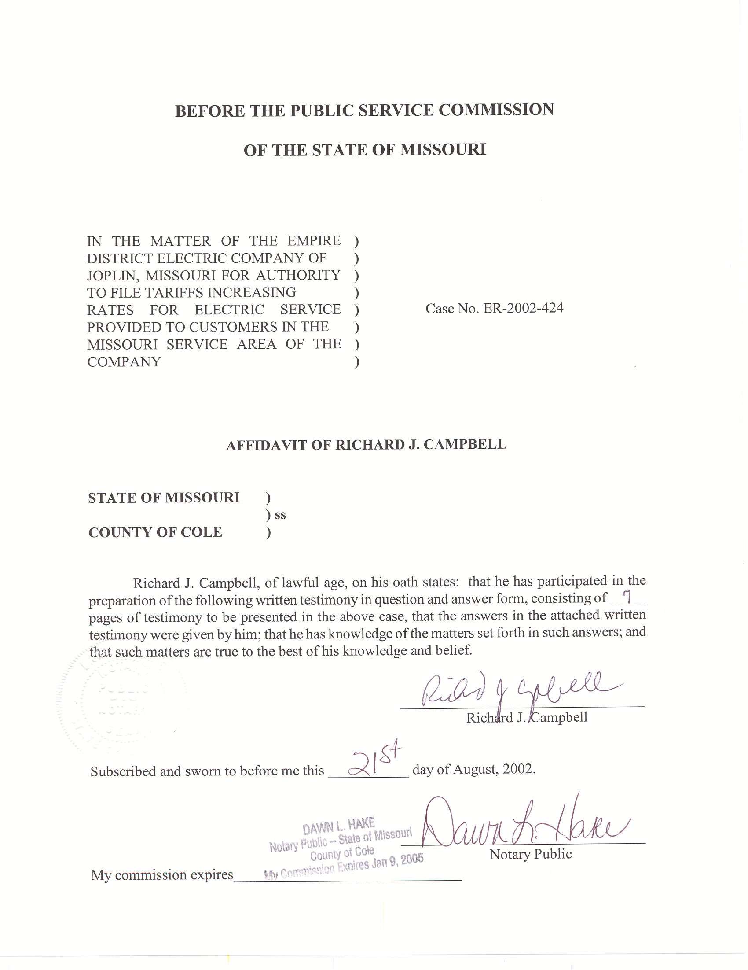
TABLE OF CONTENTS

NORMALIZATION OF USAGE 2

HOURLY NET SYSTEM LOADS 4

DIRECT TESTIMONY
OF
RICHARD J. CAMPBELL
THE EMPIRE DISTRICT ELECTRIC COMPANY
CASE NO. ER-2002-424
- Please state your name and business address.
A. My name is Richard J. Campbell and my business address is Missouri Public Service Commission, P.O. Box 360, Jefferson City, MO 65102.
Q. What is your present position with the Missouri Public Service Commission (Commission)?
A. I am a Utility Regulatory Engineer I in the Engineering Analysis Section, Energy Department, Utility Operations Division.
Q. Would you please review your educational background and work experience.
A. In May of 1995, I received a Bachelor of Science Degree in Chemical Engineering from the University of Missouri in Columbia. In July of 1995, I began working for the Missouri Department of Natural Resource Air Pollution Control Program as an environmental engineer. I was employed with the Air Pollution Control Program from July 1995 until November 2001. I joined the Commission Staff (Staff) in November 2001. I am a registered Professional Engineer in the State of Missouri.
Q. What is the purpose of your direct testimony?
A. The purpose of my testimony is to recommend that the Commission adopt the weather and days adjustments to class usage for the Missouri weather sensitive rate classes of The Empire District Electric Company (EDE) shown in Schedule 1. Staff witness Janice Pyatte calculated an adjustment to revenues based on these weather adjustments to class usage. These adjustments to class usage were also included in the calculation of hourly generation requirements.
I also recommend that the Commission adopt the hourly net system load that I calculated. Staff witness David W. Elliot used these hourly loads in estimating the normalized fuel and purchase power costs for the test year. A monthly summary of the normalized net system load is shown on Schedule 2.

NORMALIZATION OF USAGE
Q. Why is it necessary to weather-normalize electricity usage?
A. Electricity use is very sensitive to weather conditions. Because of the high saturation of air conditioning and electric space heating in EDE’s territory, the magnitude of EDE’s load is directly related to daily temperatures. The weather during the test year differed from normal conditions. December 2000 was very cold, resulting in higher than normal billed usage in the first billing month of the test year, January 2001. The month of March was much colder than normal resulting in higher than normal usage. The months of June, August, September, and October were all cooler than normal, resulting in lower than normal usage. The months of November and December were warmer than normal, resulting in lower than normal usage.
Q. What method did Staff use to calculate the normalization adjustment?
A. I used the Electric Power Research Institute (EPRI) Hourly Electric Load Model (HELM) to both weather normalize the billing month usage and calculate the days adjustment. In this model, the weather-normalized usage for each billing cycle is determined based on normal weather for the time period covered by each billing cycle and the weather response functions derived from the class level load research data. The weather-normalized usage for all billing cycles in each billing month is summed to calculate weather-normalized billing month usage. The weather adjustment to usage in each billing month is calculated as the difference between weather-normalized and actual usage.
Q. How did you calculate the days adjustment?
A. HELM’s output provides weather-normalized usage on both a billing month and a calendar month basis. The difference between billing month and calendar month usage is referred to as the days adjustment.
Q. Did you independently perform a weather impact analysis on customer usage to determine the appropriate weather response functions?
A. No. EDE had already used HELM to estimate the weather response functions using the most recently available load research data for their direct filing. I reviewed the analysis done by EDE and found it to be reasonable.
I used EDE’s weather response functions for my analysis, but updated for the test year billing cycle data and weather measure inputs.
Q. What are the other inputs used in this model?
A. In addition to the billing cycle usage that I updated, hourly load research information for each of the classes, and daily actual and normal weather variables are input into HELM. Staff witness Dennis Patterson supplied the daily actual weather variables. Staff witness Lena M. Mantle supplied the normal weather variables.
Q. Did you make any adjustments or corrections to the billing cycle usage data?
A. Yes. The billing cycle data provided by EDE was disaggregated by unique combinations of meter reading dates. This data was adjusted to remove negative values, probably representing billing corrections, and any usage that did not have corresponding start and read dates.
Q. Do any Missouri electric utilities use HELM?
A. Yes. Kansas City Power and Light Company, Aquila (formerly Utilicorp United), AmerenUE, and Empire have all used HELM to analyze loads in their Missouri resource planning process. Kansas City Power and Light Company and EDE both used HELM to weather normalize billing month usage and hourly loads in their most recent rate design cases. AmerenUE uses the model every month to calculate weather normalized calendar month usage.
Q. Has Staff previously used HELM?
A. Yes, Staff used HELM in rate cases involving EDE and Missouri Public Service, a Division of Aquila.
Q. Which Staff witnesses relied on the adjustments to usage that you calculated?
A. Staff witness Janice Pyatte calculated the corresponding adjustments to Missouri retail revenues. These adjustments to class usage were also included in the net system load and total test year usage that was used in the normalization of fuel costs.

HOURLY NET SYSTEM LOADS
- What are hourly net system loads?
A. Hourly net system load is the hourly electric supply necessary to meet the energy demands of company’s customers and the company’s own internal needs. It is net of (i.e., does not include) station use, which is the electricity requirement of the company’s generating plants. The hourly loads used in my analysis of the test year January 2001 through December 2001 were provided to Staff in response to data request number 2930. I then used hourly load data submitted by EDE in response to the Commission’s monthly 4 CSR 240-20.080 requirements to correct errors that were found in the data request response.
Q. What method did Staff use to weather normalize net system hourly loads?
A. The Staff’s weather normalization procedure was developed by the Economic Analysis Department of the Commission in 1988. The process is described in detail in the document Weather Normalization of Electric Loads, Part A: Hourly Net System Loads (November 28, 1990), written by Dr. Michael Proctor, Manager of the Economic Analysis Department.
Q. Briefly summarize the process you use.
A. In order to reflect normal weather, daily peak and average loads are adjusted independently, but using the same methodology. Independent adjustments are necessary because average loads respond differently to weather than peak loads.
Daily average load is calculated as the daily energy divided by twenty-four hours and the daily peak is the maximum hourly load for the day. Separate regression models estimate both a base component, which is allowed to fluctuate across time, and a weather sensitive component, which measures the response to daily fluctuations in weather for daily average loads and peak loads. The regression parameters, along with the difference between normal and actual cooling and heating measures, are used to calculate weather adjustments to both the average and peak loads for each day. The adjustments for each day are added respectively to the actual average and peak loads for each day. The starting point for allocating the weather normalized daily peak and average loads to the hours is the actual hourly loads. A unitized load curve is calculated for each day as a function of the actual peak and average loads for that day. The corresponding weather normalized daily peak and average loads, along with the unitized load curves, are used to calculate weather normalized hourly loads.
This process includes many checks and balances, which are included in the spreadsheets that are used. In addition, the analyst is required to examine the data at several points in the process.
Q. Has this method been used in other rate cases?
A. Yes, this method has been used in several cases before this Commission. Please refer to Schedule 3 for a list of these cases.
Q. What data was used in this process?
A. Actual hourly net system loads for the time period from October 1, 2000 through March 31, 2002 were provided by EDE. The actual daily weather variables were supplied to me by Mr. Patterson. The normal daily weather variables were supplied to me by Ms. Mantle.
Q. Were modifications made to the test year weather normalized hourly net system loads to account for Staff adjustments to test year usage?
A. Yes. I adjusted the weather-normalized hourly net system loads to be consistent with the Staff’s weather-normalized, annualized test year usage. The
adjustment to the hourly net system load also included a weather adjustment for wholesale usage.
Q. How were the hourly loads adjusted to account for the annual adjustments to usage?
A. I increased the annual usage adjustment by the loss factor supplied to me by Staff witness Alan Bax in order to obtain the additional amount of generation (net system input) necessary to serve this additional usage. A factor was applied to each hour of the weather-normalized loads to produce an annual sum of the hourly net-system loads that equals the adjusted test year usage, consistent with normalized revenues, plus losses. A monthly summary of the adjusted loads is shown on Schedule 2.
Q. How was the weather adjustment for wholesale usage calculated?
A. The weather adjustment for wholesale usage was calculated using the same methodology used to calculate the net system load adjustment. EDE supplied hourly wholesale load data for July 1, 2000 through December 31, 2001 from their load research program.
Q. Were weather adjustments made to any of the non-Missouri retail loads?
A. No. Neither EDE nor Staff weather-normalized non-Missouri retail loads.
Q. Which Staff witness used your hourly-normalized net system loads?
A. Staff witness David W. Elliot used the test year hourly normalized system loads in developing test year fuel and purchase power expense.
Q. Does this conclude your testimony?
A. Yes, it does.

 | Residential | Commercial | Small Heating | Total Electric Bldg. | General Power
Month | Adjustment (kWh) | Adjustment (kWh) | Adjustment (kWh) | Adjustment (kWh) | Adjustment (kWh)
January | -24,561,338 | -4,099,300 | -1,734,115 | -4,040,116 | -4,665,389
February | 225,841 | 36,790 | 9,455 | 69,841 | 196,778
March | -3,439,255 | -615,097 | -195,261 | -731,490 | -2,378,357
April | -5,450,850 | -1,236,058 | -399,287 | -1,001,313 | -1,559,047
May | 698,920 | 203,513 | 56,567 | 177,020 | 221,553
June | 1,630,133 | 396,803 | 79,256 | 339,646 | 1,483,143
July | 874,194 | 269,580 | 97,185 | 256,038 | -53,061
August | 402,833 | 60,991 | -6,744 | 31,208 | 393,582
September | 5,549,687 | 1,384,490 | 300,393 | 1,373,557 | 4,507,753
October | 7,130,910 | 2,185,272 | 547,647 | 1,834,873 | 3,909,311
November | 3,553,408 | 898,099 | 218,906 | 866,574 | 2,896,079
December | 12,871,725 | 3,051,668 | 804,805 | 2,751,841 | 5,698,151
Total | -513,792 | 2,536,751 | -221,193 | 1,927,679 | 10,650,496
Days Adj. | -5,638,069 | -409,837 | -1,259,240 | 2,387,134 | 4,430,916

 | Monthly Usage (MWh) |  |  |  | Monthly Peaks (MW) |  |  |  | Load Factor
Month | Actual | Normal | Adj | % Adj | Actual | Normal | Adj | % Adj | Actual | Normal
Jan-01 | 460,962 | 463,596 | 2,634 | 0.57% | 919 | 927 | 8 | 0.88% | 0.67 | 0.67
Feb-01 | 383,302 | 388,176 | 4,874 | 1.27% | 841 | 883 | 42 | 5.05% | 0.68 | 0.65
Mar-01 | 384,063 | 372,460 | -11,603 | -3.02% | 701 | 723 | 22 | 3.15% | 0.74 | 0.69
Apr-01 | 329,103 | 327,034 | -2,069 | -0.63% | 642 | 644 | 2 | 0.31% | 0.71 | 0.71
May-01 | 355,384 | 354,418 | -966 | -0.27% | 791 | 803 | 12 | 1.46% | 0.60 | 0.59
Jun-01 | 414,363 | 425,071 | 10,708 | 2.58% | 859 | 910 | 51 | 5.94% | 0.67 | 0.65
Jul-01 | 508,710 | 507,095 | -1,615 | -0.32% | 999 | 1,009 | 10 | 1.02% | 0.68 | 0.68
Aug-01 | 497,243 | 504,182 | 6,939 | 1.40% | 1,001 | 1,023 | 22 | 2.15% | 0.67 | 0.66
Sep-01 | 370,433 | 390,824 | 20,391 | 5.50% | 878 | 922 | 44 | 5.02% | 0.59 | 0.59
Oct-01 | 343,945 | 350,037 | 6,093 | 1.77% | 618 | 708 | 90 | 14.55% | 0.75 | 0.66
Nov-01 | 344,477 | 361,904 | 17,427 | 5.06% | 769 | 782 | 13 | 1.67% | 0.62 | 0.64
Dec-01 | 407,426 | 423,087 | 15,661 | 3.84% | 764 | 825 | 61 | 7.97% | 0.72 | 0.69
Annual | 4,799,410 | 4,867,886 | 68,476 | 1.43% | 1,001 | 1,023 | 22 | 2.15% | 0.55 | 0.54
Summer | 1,790,749 | 1,827,172 | 36,423 | 2.03% | 1,001 | 1,023 | 22 | 2.15% | 0.61 | 0.61
Other | 3,008,661 | 3,040,713 | 32,052 | 1.07% | 919 | 927 | 8 | 0.88% | 0.56 | 0.56
Schedule 2

EO-87-175 ER-94-163 EM-2000-292
EO-90-101 ER-94-174 ER-2001-299
EO-90-138 ER-95-279 ER-2001-672
ER-93-37 ER-97-81 EC-2002-1
ER-93-41 EM-97-575 ER-2002-424
EO-93-351

