Exhibit No.:
Issues: General Information and
Miscellaneous

Witness: David W. Elliott
Sponsoring Party: Trigen-Kansas City Energy
Corporation and Thermal
North America, Inc.
Type of Exhibit: Rebuttal Testimony
Case No.: HM-2004-0618
Date Testimony Prepared: October 14, 2004

MISSOURI PUBLIC SERVICE COMMISSION

Utility Operations DIVISION

Rebuttal TESTIMONY

OF

David W. Elliott

Trigen-Kansas City Energy Corporation
and
Thermal North America, Inc.

CASE NO. HM-2004-0618

Jefferson City, Missouri
October 14, 2004

**Denotes Highly Confidential Information**

NP
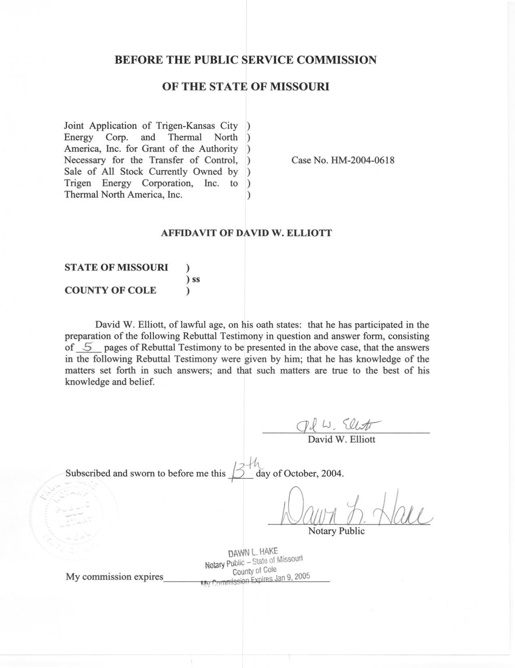
REBUTTAL TESTIMONY

OF

DAVID W. ELLIOTT

TRIGEN-KANSAS CITY ENERGY CORPORATION

AND

THERMAL NORTH AMERICA, INC.

CASE NO. HM-2004-0618

Q. Please state your name and business address.
A. David W. Elliott, P.O. Box 360, Jefferson City, Missouri, 65102.
Q. By whom are you employed and in what capacity?
A. I am employed by the Missouri Public Service Commission (Commission) as a Utility Engineering Specialist III in the Energy Department of the Utility Operations Division.
Q. Please describe your educational and work background.
A. I graduated from Iowa State University with a Bachelor of Science degree in Mechanical Engineering in May 1975. I was employed by Iowa-Illinois Gas and Electric Company (IIGE) as an engineer from July 1975 to May 1993. While at IIGE, I worked at Riverside Generating Station, first as an assistant to the maintenance engineer, and then as an engineer responsible for monitoring station performance. In 1982, I transferred to the Mechanical Design Division of the Engineering Department where I was an engineer responsible for various projects at IIGE's power plants. In September 1993, I began my employment with the Commission.
Q. Have you filed testimony previously before the Commission?
A. Yes. Please refer to Schedule 1 for the list of cases I have filed in.
Q. What is the purpose of your testimony in this Trigen-Kansas City Energy Corp. (Trigen) and Thermal North America Inc. (Thermal) case, Case No. HM-2004-0618?
A. The purpose of my testimony is to briefly describe the Grand Avenue Plant operation, briefly describe the heating and chilled water systems, and to identify the need for allocating fuel and plant costs in a future rate case.
Q. Have you visited the Grand Avenue Plant?
A. Yes. I visited the plant on October 8, 2004.
Q. Please briefly describe the Grand Avenue Plant.
A. The plant is located in Kansas City at 115 Grand Avenue and was originally owned and operated by Kansas City Power & Light Company (KCPL). The plant consists of two coal/gas-fired boilers, and two natural gas fired boilers that generate the steam used to supply the steam heating customers in downtown Kansas City, Missouri, and Missouri Trigen, the chilled water company. Located inside the plant building are three chillers and auxiliary equipment in an area of the plant leased to Trigen Missouri by Trigen. These chillers use steam purchased from Trigen as the heat source for the process to chill the water/glychol mixture sent to Trigen Missouri customers in downtown Kansas City, Missouri. There is a non-condensing turbine, which while generating electricity reduces the pressure and temperature of the boiler outlet steam to the operating conditions of the steam heating customer system and the chillers. The electricity generated by the turbine is either used in-house or fed into KCPL’s electrical grid. Schedule 2 shows the basic layout of the plant.
Q. Please briefly describe the heating steam system.
A. The boilers at Grand Avenue Plant burn coal or natural gas to heat water to generate high pressure superheated steam. This high-pressure steam is reduced to a lower pressure steam by either passing through the turbine or the pressure-reducing valve. Some of this lower pressure steam flows through pipe in the plant to the chillers and is metered at the chiller. Lower pressure steam also flows into an underground piping system to the downtown Kansas City, Missouri area. Steam heating customers are connected to this piping system and use the steam for either heating the building or use it in their manufacturing/production process.
Q. Please briefly describe the chilled water system.
A. The chillers at Grand Avenue Plant use the lower pressure steam as the heat source for the absorption refrigeration cycle for chilled water and use river water as cooling water. The chilled water is a closed loop system. The chilled water/glychol mixture from the chillers is pumped out through an underground piping system to the chilled water customers. There it passes through heat exchangers where it absorbs heat from the building, which cools the building, and then flows through the return piping back to the chillers at Grand Avenue Plant to be chilled again.
Q. What kind of fuel and plant cost allocations will be needed for a rate case?
A. In order to review operating and fuel expenses for a rate case, any common expenses associated with water usage, electricity usage, fuel burned, and plant equipment will need to be allocated either between regulated and non-regulated entities, or between heating and chilled water customers.
Q. Why are allocations important?
A. When expenses are incurred, such as for equipment maintenance or operation, and the equipment is used by two separate entities; these expenses must be shared between the two entities. Allocation provides a method of calculating the portion of the shared expenses for which each entity is responsible.
Q. Why does Staff believe allocation is an issue that needs to be raised in this case?
A. Staff believes that the Commission and all parties to this case need to be aware that in a rate case there will be a need for an allocation of plant, fuel, water, electricity, and operating expenses.
Q. Does Trigen have an allocation manual?
A. Yes. Trigen has developed an cost allocation manual (CAM) for the purpose of meeting the affiliated transaction record keeping requirements of
4 CSR 240-80.015.
Q. Has Staff reviewed this allocation manual and determined if it is adequate for rate case purposes?
A. Staff has done a cursory review and will do a more extensive review for a rate case, and if necessary work with Thermal to develop any additional allocations needed.
Q. If the sale of assets is approved by the Commission, do you have any recommendations?
A. Yes. I recommend that the Commission require Thermal to provide to the Manager of the Energy Department the reporting requirements listed on Schedule 3.
Q. Why do you believe these reporting requirements are important?
A. The first seven requirements of the steam heating and chilled water requirements would assist Staff in running the fuel model for a rate case or earnings investigation, and the last reporting requirement of each would allow Staff to monitor the safety of Thermal’s steam heating and chilled water operations.
Q. Why have you listed reporting requirements for the chilled water operation?
A. Staff is taking the position that the chilled water operation is subject to regulation by this Commission. If the Commission does not adopt Staff’s position then these chilled water reporting requirements would not be included in my recommendations for the sale of the assets.
Q. Does this conclude your Rebuttal Testimony?
A. Yes, it does.

Previous Testimony of

David W. Elliott

- ER-94-163, St. Joseph Light & Power Co.
- HR-94-177, St. Joseph Light & Power Co.
- ER-94-174, The Empire District Electric Co.
- ER-95-279, The Empire District Electric Co.
- EM-96-149, Union Electric Co.
- ER-99-247, St. Joseph Light & Power Co.
- EM-2000-369, UtiliCorp United, Inc. and The Empire District Electric Co.
- ER-2001-299, The Empire District Electric Co.
- ER-2001-672, Utilicorp United, Inc.
- ER-2002-424, The Empire District Electric Co.
- ER-2004-0034, Aquila, Inc.
- ER-2004-0570, The Empire District Electric Co.
SCHEDULE 2 HAS BEEN DEEMED
HIGHLY CONFIDENTIAL IN ITS ENTIRETY
Recommended Reporting Requirements for Thermal North America, Inc.

Steam Heating Operation

A) To be reported on a monthly basis to the Manager of Energy Department:

- Hourly boiler steam generation for each boiler.
- Monthly total fuel usage by fuel for each boiler.
- Boiler and turbine forced outages. Report to include the cause, the date of outage, the time of outage, and the duration of the outage.
- Boiler and turbine planned outage annual schedule.
- Citations or notices of violation received from any state or federal agency.
- Date, time, and duration of any loss of piping capacity that limited plant output.

B) To be reported by telephone within one business day following discovery, and in writing within 5 business days to the manager of the Energy Department:

- Boiler forced outage, which reasonably could be anticipated to last more than 3 days.
- Details of any accident at the steam plant involving serious physical injury or death or property damage in excess of $100,000.

Chilled Water Operation

A) To be reported on a monthly basis to the manager of Energy Department:

- The hourly chiller flow/load for each chiller.
- Monthly steam usage by the chillers.
- Chiller forced outages. Report to include the cause, the date of outage, the time of outage, and the duration of the outage.
- Chiller planned outage annual schedule.
- Citations or notices of violation received from any state or federal agency.
- Date, time, and duration of any loss of piping capacity that limited plant output.

B) To be reported by telephone within one business day following discovery, and in writing within 5 business days to the manager of the Energy Department:

- Boiler forced outage, which reasonably could be anticipated to last more than 3 days.
- Details of any accident at the steam plant involving serious physical injury or death or property damage in excess of $100,000.

