M E M O R A N D U M

TO: Missouri Public Service Commission Official Case File
Case No. EA-2004-0077, Union Electric Company

FROM: /s/Jim Ketter, Energy Department

/s/Lena Mantle__10/15/03___ /s/ Steven Dottheim 10/15/03
Energy Department/Date General Counsel’s Office/Date

SUBJECT: Staff Recommendation for Approval of Application To Construct 34.5 kV Line

DATE: October 15, 2003

SUMMARY OF REQUEST

On August 4, 2003, Union Electric Company, d/b/a AmerenUE, filed an APPLICATION for permission and authority to construct, operate, own and maintain a 34.5 kV line in New Madrid County and Mississippi County, Missouri. This proposed line would provide a connection between the Matthews Substation and East Prairie Main Substation, both of which are within the certificated service territory of AmerenUE. Approximately 5.5 miles of the proposed 12.6 miles of the route for the proposed line are outside of AmerenUE’s certificated service territory (SEMO Electric Cooperative provides electric service to its members in New Madrid County and Mississippi County). The proposed line will be constructed using single wood-pole structures. The estimated cost of the line, including right-of-way costs and connection costs at the substations, is $2.9 million.

AmerenUE states that this 34.5 kV circuit extension will benefit the electric customers in this area by providing a quick restoration in the event of (1) an outage affecting the 161-34.5 kV supply or (2) other 34.5 kV line outages in the area. There are approximately 1,460 electric customers that would benefit from this system upgrade.

STAFF RECOMMENDATION

The Staff recommends approval of the APPLICATION for permission and authority to construct, operate, own and maintain a 34.5 kV line in New Madrid County and Mississippi County, Missouri. This proposed line is necessary to ensure reliable electric service to approximately 1,460 electric customers in this portion of the AmerenUE service area.

This proposed 34.5 kV circuit extension would connect two existing 34.5 kV distribution substations, providing an alternate electrical source in the event of an outage involving the normal 161 kV supply. The interruption of the 161 kV supply would affect 1,460 AmerenUE customers in this area. These 34.5 kV lines deliver electric service to local customers of AmerenUE and will not impact the capability of the AmerenUE high-voltage transmission system. AmerenUE’s 34.5 kV network provides power to the distribution substations that serve electric customers and their function is to transmit power from the high voltage transmission system to distribution substations.

The Staff inspected the route and the substations where the line is proposed. For that portion of the line outside the AmerenUE certificated service area, the single-pole structures (See Attachment 1) would be placed on a highway right-of-way for a portion of the route and on private property along a county road for the remainder of the route. A thirty-foot easement will be necessary for construction on private property. Construction of the remainder of the line that is within the AmerenUE certificated service territory will utilize the same type of structures and utilize public and private easements.

The route chosen is a short and direct route along existing roadways, which will help keep construction cost low. The route will minimize the impact on existing residential structures, farming operations and requires fewer crossings of existing cooperative electric lines. Attachment 2 contains pictures of portions of the route along Highway 80 and private property along County Road 706. The proposed route transverses predominantly farm fields. The single-pole construction will have a small footprint and consequently, a limited impact on property owners.

AmerenUE has sent a letter to the sixteen property owners that will be impacted within the 5.5-mile section that is outside of AmerenUE’s service territory. AmerenUE representatives have met with individual property owners to review the project, both for the 5.5 miles outside its certificated area and the remainder of the route that is within its certificated area. AmerenUE states that property owners are most concerned with the impact on irrigation systems and the inconvenience of farming around the poles. The proposed route will be along the edge of fields that are presently irrigated or may potentially be irrigated in the future. The center -pivot systems used for irrigation in this area can be adjusted to accommodate obstacles on the edge of the property. AmerenUE states that road-crossings are considered to accommodate owner wishes when the property owner has land on both sides of the road.

The APPLICATION, filed pursuant to Section 393.170 RSMo (2000), is in compliance with the provisions of 4 CSR 240-2.060 for applications. Requirements outlined in 4 CSR 240-3.105(1)(B) for granting a certificate of convenience and necessity by an electric company have also been met, although the rule only specifically identifies transmission facilities. A certificate is necessary because a portion of the proposed route is outside of AmerenUE’s certificated service area. Review of the internal records of the Commission indicates that AmerenUE has filed its electric and gas annual reports and is current on its assessment payment. Action on this application will not affect other open cases of AmerenUE before this Commission. Open cases filed by AmerenUE include:

EO-96-14 EM-96-149 EE-2004-0092 EE-2004-0069
EC-2002-1 EC-2002-112 EO-2004-010 EF-2003-0514
EO-2003-0271 EO-2003-0464

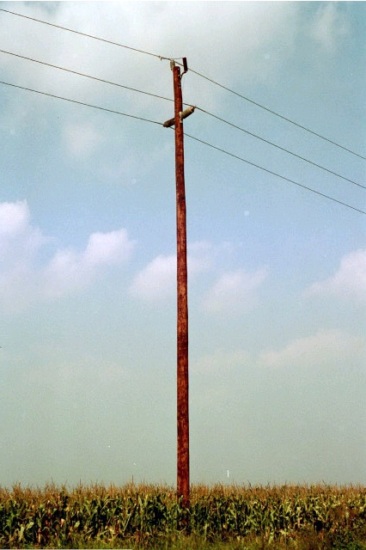

Example of single-pole construction that will be used
for the Matthews to East Prairie 34.5 kV line.

Attachment 1
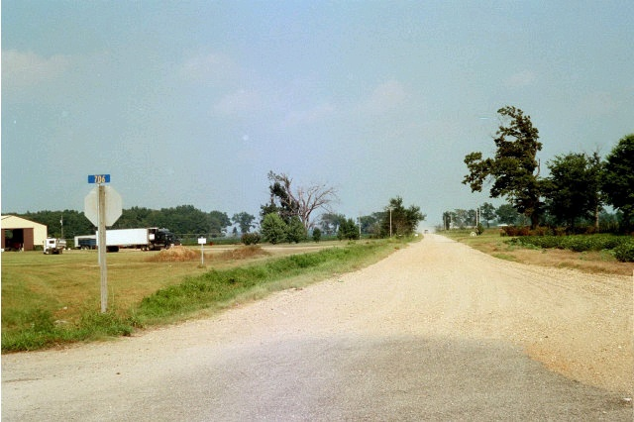
West end of County Road 706 at Highway 80 (looking east).
Proposed route is along left side of gravel road.

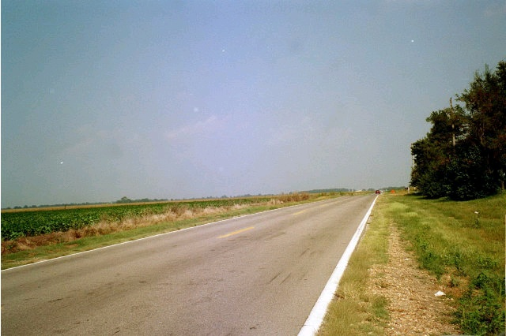
Highway 80 (looking east), proposed line would be constructed
within the highway right-of-way on the left side of the highway.

Attachment 2
Page 1 of 2
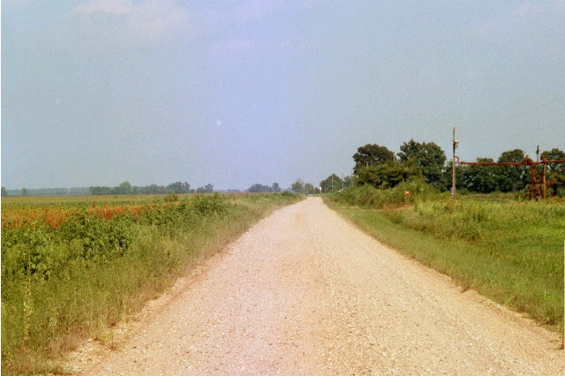
Proposed route is along left side of County Road 706.

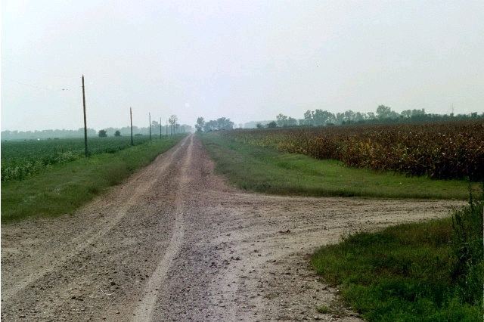
Proposed route is along left side of County Road 706 on private
property. Cooperative line is along edge of county road.

Attachment 2
Page 2 of 2

