Commissioners

JEFF DAVIS

Chairman

CONNIE MURRAY

STEVE GAW

ROBERT M. CLAYTON III

LINWARD “LIN” APPLING

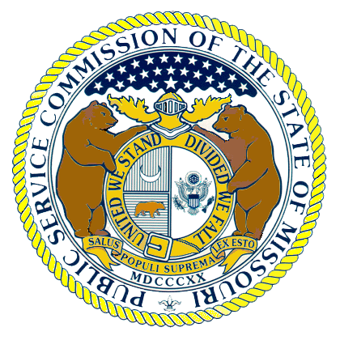

Missouri Public Service Commission

POST OFFICE BOX 360
JEFFERSON CITY MISSOURI 65102
573-751-3234
573-751-1847 (Fax Number)
http://www.psc.mo.gov

WESS A. HENDERSON

Director, Utility Operations

ROBERT SCHALLENBERG

Director, Utility Services

DALE HARDY ROBERTS

Secretary/Chief Regulatory Law Judge

DANA K. JOYCE

General Counsel

January 11, 2005

Dale H. Roberts
Secretary/ Chief Regulatory Law Judge
P.O. Box 360
Jefferson City, Mo 65102

Re: EA-2005-0180
In the Matter of the Application of Union Electric Company for a Certificate of Public Convenience and Necessity authorizing it to construct, install, own, operate, control, manage and maintain electric plant, as defined in § 386.020(14), RSMo, to provide electric service in a portion of New Madrid, County, Missouri, as an extension of its existing certified area.

Dear Mr. Roberts:

The Staff will file an executed affidavit of Michael S. Proctor shortly.

Sincerely,

/s/ Steven Dottheim
Steven Dottheim
Chief Deputy General Counsel
Missouri Public Service Commission
(573) 751-7489
steve.dottheim@psc.mo.gov

