Exhibit No.:
Issue: Depreciation
Witness: Paul W. Adam

Sponsoring Party: MoPSC Staff
Type of Exhibit: Direct Testimony
Case No.: ER-2002-424
Date Testimony Prepared: August 16, 2002

MISSOURI PUBLIC SERVICE COMMISSION

UTILITY SERVICES DIVISION

DIRECT TESTIMONY

OF

PAUL W. ADAM

THE EMPIRE DISTRICT ELECTRIC COMPANY

CASE NO. ER-2002-424

Jefferson City, Missouri

August 2002
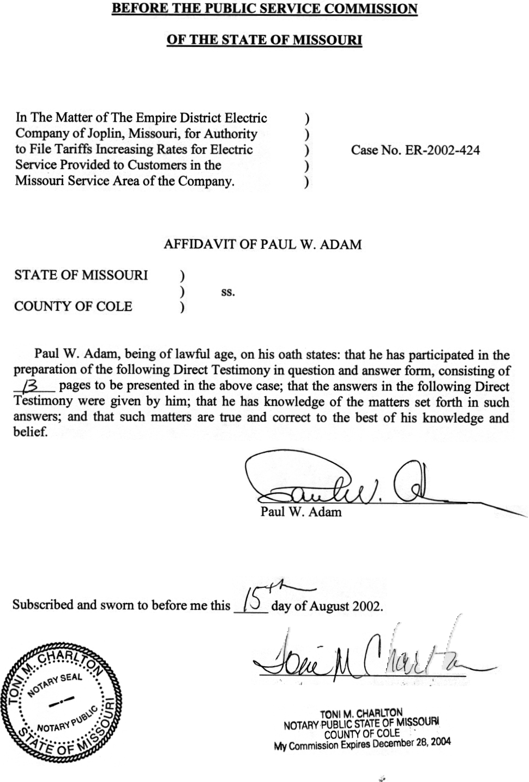
TABLE OF CONTENTS OF
DIRECT TESTIMONY OF
PAUL W. ADAM
THE EMPIRE DISTRICT ELECTRIC COMPANY
CASE NO. ER-2002-424
DEPRICIATION STUDY 4
NET SALVAGE DISCUSSION 6

DIRECT TESTIMONY
OF
PAUL W. ADAM
THE EMPIRE DISTRICT ELECTRIC COMPANY
CASE NO. ER-2002-424
Q. Please state your name and business address.
A. Paul W. Adam, P.O. Box 360, Jefferson City, Missouri 65102.
Q. By whom are you employed and in what capacity?
A. I am employed by the Missouri Public Service Commission (PSC or Commission) as an Engineer II in the Engineering and Management Services Department.
Q. What are your duties as an engineer in the Engineering and Management Services Department?
A. I am responsible for depreciation determinations and studies of companies regulated by the Commission.
Q. Would you please state briefly your qualifications, educational background and experience?
A. I am a Registered Professional Engineer in Missouri and Colorado. In 1967, I earned a Bachelor of Science degree in Chemical Engineering from the University of Missouri-Columbia. I served in the U.S. Army after graduating and subsequently was employed in the oil industry from 1969 until 1991 as an engineer in various capacities, with the exception of a brief period from 1971 to 1974 when I completed a Masters Degree in Business Administration at the University of Missouri and also built single-family homes.
From 1991 to 1993 I managed a concrete products plant in Northwest Missouri. In 1994, I accepted my current position.
Q. Have you ever testified before the Commission?
A. Yes.
Q. Please state the purpose of your testimony in this case.
A. The purpose of my testimony in this case is to present Staff’s proposed depreciation rates for capital plant owned by The Empire District Electric Company (Empire or Company) as presented in Schedule 1 attached to this direct testimony.
Q. Prior to addressing depreciation specifically, can you give a brief history of Empire’s growth focusing on generation of power?
A. Yes. Empire’s web site (http://207.51.138.108/About/history.htm) provides the following information: Empire was organized in 1909. At that time Empire had 109 miles of transmission line, 8 megawatts of generating capacity and 2,400 customers. In 1909 work began on the Riverton Generating Station in Kansas. The Riverton plant is currently generating 136 megawatts of electricity, it is one of the oldest power plants in the United States and is a vital part of Empire’s generation. Construction began on Ozark Beach Dam in 1911. Ozark Beach Hydroelectric Plant supplies Empire with 16 megawatts of power today.
From 1959 to 1966 Empire spent approximately $25 million on new transmission and distribution facilities to handle increased electric demand. In 1964 Empire’s System Operations center in Joplin was completed that monitors and controls production and power flow throughout the Empire system. In 1970 the $26 million Asbury Generating Station became operational. This “mine-mouth” coal plant ultimately added 213 megawatts to Empire’s system. In 1990 Asbury was converted to use a blend of local and Wyoming low-sulfur coal. In 1978 and 1981 two combustion turbine peaking units were installed at Empire’s Energy Center location northeast of Joplin. The two 90-megawatt units have subsequently been converted from oil burning to natural gas. Currently Energy Center has 180 megawatts of peak capacity. During this period of time Empire purchased a 12% interest in the IATAN Power Plant operated by Kansas City Power & Light (KCP&L). This 12% interest added 80 megawatts to the Empire system. Two new aero-turbine gas based peaking units are currently under construction at Energy Center and will add 100 megawatts to Empire’s system during 2003. In 1993 Empire added a 98-megawatt combustion turbine (CT) to their system at the State Line Power Plant located at Joplin. In 1995 a 150-megawatt CT was added at State Line. Subsequently the 150-megawatt CT was utilized with another 150-megawatt CT and a 200-megawatt steam turbine to construct a 500-megawatt gas-based combined cycle unit at the State Line Power Plant. Empire’s interest in the 500-megawatt combined cycle unit is 60%. This ownership adds another 300-megawatts to Empire’s system.
Q. Can you summarize the Company’s approximately 1000 megawatts of production capacity that provides service to over 150,000 Empire customers?
A. Yes.
Riverton Power Plant 136 megawatts
Ozark Beach Hydro Plant 16
Asbury Power Plant 213
Energy Center (current) 180
IATAN Power Plant 80
State Line Power Plant 98 (CT)
300 (combined cycle)
Empire’s Total Power 1023 megawatts

DEPRICIATION STUDY
Q. Have you conducted a depreciation study of Empire’s capital plant for this rate case?
A. Yes, my analysis includes: 1) an evaluation of the Company’s plant mortality data; 2) an on-site visit with corporate and plant management; 3) meetings with other PSC Staff that are knowledgeable about Empire’s plant; and 4) engineering judgment to consider any adjustments that should be made to plant life calculations so that Staff’s proposed lives and depreciation rates will better represent the current plant in service.
Some of this work was completed in a recent Empire rate case, Case No. ER-2001-299. Specifically, the mortality data for transmission, distribution and general plant were analyzed as well as steps 2, 3 and 4 for this plant. This mortality data was transferred to Empire’s new computer system when the system was installed.
For this case, the Company has provided mortality data for the Asbury generation plant that was not available on the new computer system in 2001. This mortality data has been analyzed. Additionally, site visits were made again for this case and meetings with other PSC Staff knowledgeable of Empire’s plant were held to address steps 2 and 3 for all plant. Engineering judgment was applied to all aspects of this work to determine reasonable lives and depreciation rates for each capital plant account.
In total, a full depreciation study has been completed for Empire’s current plant-in-service.
Q. Have your work papers for this study been provided to Office of the Public Counsel (OPC) and the Company?
A. Yes, they have.
Q. For transmission, distribution and general plant the Staff’s proposed rates in Case No. ER-2001-299 are the currently ordered rates. During your depreciation study for this case, did you determine if any plant changes have been made to any of these accounts that would justify a change to any account’s life or depreciation rate away from the currently ordered rates?
A. I believe the ordered rates should be continued for all transmission, distribution and general plant based on meetings with the Company.
Q. What generation plant does Empire have that can be evaluated for life characteristics?
A. Empire has only two generating plants that have sufficient retirement history to analyze the mortality data for valid average service lives (ASLs). Those two plants are Asbury and Riverton. Empire’s Energy Center turbines and their State Line turbines will not have a sufficient magnitude of retirements to develop a valid IOWA curve fit to a plot of surviving plant dollars. Iatan’s mortality data is with the operator, KCP&L.
Q. Have you evaluated generation plant with the mortality data submitted by the Company in July 2002?
A. I have evaluated mortality data submitted for Empire’s Asbury Power Plant. I have requested that the Company continue to work on the formatting of the Riverton mortality data onto the new computer system so that it can be analyzed in a future case. Mortality data for all of Empire’s generating plant are to be established on Empire’s current computer system and updated annually. These mortality files will then be available to the Company and the Staff for future depreciation studies.
The evaluation of the Asbury mortality data combined with engineering judgment from plant visits and discussions with engineers and operations personnel either support the continuation of the currently ordered ASLs and depreciation rates for each Asbury account or the data was insufficient to justify changing the currently ordered ASLs.
With the current absence of data for all other generating plant and with the knowledge gained from visits with the Company’s personnel, Staff’s proposal is that all other generating plant continue to be ordered the currently ordered ASLs and depreciation rates with one exception, account 315 at Riverton. Account 315, Accessory Electric Equipment, is over-accrued in excess of $100,000. Due to Riverton’s age, this over-recovery should exceed any possible future additions to this account. Therefore, Staff proposes that the depreciation rate of this account be set to zero.
Q. What is Staff’s proposal for depreciation rates?
A. Staff proposes the depreciation rates shown as “Staff’s Proposal”on Schedule 1 attached to this direct testimony be ordered. All rates are the same as the currently ordered rates except the 315 account at Riverton Power Plant.

NET SALVAGE DISCUSSION
Q. Have you evaluated net salvage cost for this Company?
A. No. The evaluation of net salvage cost has been conducted by the Staff auditors.
Q. Is this an application of the Full Recovery whole life technique?
A. Yes. The depreciation rates are determined to allow the Company to recover the original cost of plant over the plant’s average service life (ASL). The net salvage cost is determined to allow the Company to recover the Company’s current level of net salvage cost.
Q. Does this technique vary from the Traditional whole life technique’s recovery of net salvage cost?
A. Yes. The following chart shows how the collection and expenditure of net salvage is proposed to occur by those analysts that support the Traditional whole life technique.
Traditional Whole Life Technique
Net Salvage Chart

Actual Cost of Removal (COR)
Collection for COR
End of Account’s Use
Crossover Point
TIME
PAST NOW FUTURE

AREA A
AREA B

$ Greater

Area A and Area B are equal in size. This is a requirement of the net salvage determinations for the Traditional whole life technique. During the years represented by Area A, a company will collect more from customers than is spent for net salvage cost [the term cost of removal (COR) is used interchangeably with net salvage here], then during the years represented by Area B, the company will collect less from customers than is spent for net salvage cost. On the date that the account is terminated, the final net salvage cost would be booked and subtracted from the accrual balance and then the accrual balance would be “zero”.
Q. The result of the Traditional whole life technique is that over the life of an account, the amount of money collected from customers will equal the amount of money spent for net salvage cost. Is that correct?
A. Unadjusted for inflation, yes.
Q. During the period of time shown as Area B in the chart, when a company is spending more for cost of removal (COR) than the company is collecting, where does the cash that is needed to pay removal bills, that exceed the collection of removal cost from customers, come from?
A. Theoretically, the company has that cash in a secure place because the company collected that amount of money from previous customers during the time represented as Area A on the chart.
Q. What if the cash collected from customers during the Area A years was spent and is not available during the Area B years?
A. The cash to pay the removal bills during the Area B years would have to come from another part of the company’s operations.
Q. Does the Full Recovery whole life technique eliminate the situation that exists during the Area B years, where a company may have to get money from another part of the company to pay plant removal cost?
A. Yes. The Full Recovery whole life technique will eliminate the Area B situation where the company spends more for removal cost than it collects for removal cost from the customers. The following chart shows this situation.

Traditional
Whole Life Technique
Net Salvage Chart
Conversion to
Full Recovery
Whole Life Technique
Full Recovery
Whole Life Technique
Actual Cost of Removal (COR)
Collection for COR
Collection for COR
PAST NOW FUTURE
AREA A
TIME

$ Greater

If the change is made from Traditional whole life technique to Full Recovery whole life technique at the point in time shown as “NOW” on the chart, there will be a past collection for plant removal that exceeds the actual cost of removal as represented by Area A. In the future, the collection for plant removal and the actual cost of plant removal will be the same.
Q. In your previous chart, the company has collected more for plant removal cost over time than it has spent for plant removal cost. This is represented by Area A on the Traditional technique part of the chart. Doesn’t the company owe its cutomers the excess monies that have accumulated as represented by Area A?
A. Staff supports a credit to customers equal to the Area A monies. This can be done by applying a negative amortization or reduced depreciation rates to the depreciation accrual on a going forward basis. The following chart shows this situation.

The Amount of a
Negative Amortization, Annually
Traditional
Whole Life Technique
Conversion to Full Recovery Whole Life Technique
with Negative Amortization
Net Salvage Chart
Full Recovery
Whole Life Technique
with Negative Amortization
Actual Cost of Removal (COR)
Collection for COR
End of Amortization
AREA A
TIME
PAST NOW FUTURE
AREA B
Collection for COR

$ Greater

Area A would be determined by making a theoretical reserve calculation to determine the adjustment necessary to equate the actual reserve to the theoretical reserve. When an over-recovery is determined, as shown by Area A, that amount would be “paid back” to the company’s customers in lower tariffs.
Therefore, the Area B that represents a negative amortization will be equal to Area A, the amount the company has collected from customers in past years for removal of plant in excess of actual removal cost incurred. The amortization will stop when the two areas, A and B, are equal and from that point in time forward, the collections from customers for the removal of plant will be equal to the actual net of removal cost of plant.
Q. Are there other ways to handle the repayment to customers of plant removal cost that they have paid in excess of actual plant removal cost?
A. There could be any number of options. One is that the collection from customers for the removal of plant be set equal to the actual current cost of removal of plant currently and that a theoretical calculation be made to determine the difference between the actual reserve accrual and what the reserve accrual should be (i.e., the theoretical reserve). This difference could be retained and checked during rate cases over several years, perhaps 5 to 10 years, to determine if any unexpected events changed the magnitude of the difference between the actual reserve and the theoretical reserve. Then, after the depreciation engineer is comfortable that there is a difference between the actual reserve balance and the theoretical reserve, a negative amortization could be considered.
Q. Are the depreciation rates given in Schedule 1 of this testimony developed using the Full Recovery whole life technique?
A. Yes. There is no salvage component in these rates. The net salvage determination is presented as expense by Staff auditors.
Q. Are you proposing a negative amortization to repay customers’ moneys that have been collected from customers in excess of the amounts that have actually been spent?
A. Not at this time. Schedule 1-4 does show that the Company has collected $46,055,372 (in the rightmost column) more than the theoretical reserve for all General, Distribution and Transmission plant. When mortality data is available, Generation plant can be added to or subtracted from this determination. Currently, the $46 million is less than two times the annual accrual. This is not a relatively large over-recovery. In this case, it is Staff’s proposal that no negative amortization be initiated.
A theoretical calculation based on all plant should be made in the future when the data are available. If the over-recovery grows above the “two times” level, it could be appropriate to initiate a negative amortization at that time.
Q. Why is the Staff not recommending a negative amortization in the present proceeding as it recently did in AmerenUE Case No. EC-2002-1 and Laclede Gas Company, Case No. GR-2002-356?
A. Staff is not recommending a negative amortization because the over-accrual in this case is not of the magnitude of the over-accruals in the other proceedings. In addition, Staff prefer to postpone addressing the over-accrual in this case until it has sufficient mortality data of generation plant, as described previously in my testimony.
Q. What is your proposal for depreciation rates for this case?
A. I propose that the depreciation rates given as “Staff’s Proposal” in Schedule 1 of this testimony be ordered.
Q. Does this conclude your direct testimony?
A. Yes, it does.

The information in this sentence came from plant visits and Staff witness Dave Elliott.
IOWA curves are a set of type curves that can be fitted to plots of surviving plant to develop an expected average service life for the specific plant.
COR (Cost of Removal) is shown as increasing with time but the Traditional whole life technique requires that the equality of Area A and Area B must hold if COR is constant or decreasing over time.

