Exhibit No.:
Issues: Advertising Expense; Promotional
Giveaways; Donations; Dues; PSC
Assessment; Rate Case Expense;
Materials and Supplies and
Prepayments; Postage Expense;
Customer Deposits; Customer
Deposit Interest Expense; Customer
Advances; Lobbying Expenses
Witness: Sean T. DeVore

Sponsoring Party: MoPSC Staff
Type of Exhibit: Direct Testimony
Case No.: ER-2002-424
Date Testimony Prepared: August 16, 2002

MISSOURI PUBLIC SERVICE COMMISSION

UTILITY SERVICES DIVISION

DIRECT TESTIMONY

OF

SEAN T. DEVORE

THE EMPIRE DISTRICT ELECTRIC COMPANY

CASE NO. ER-2002-424

Jefferson City, Missouri

August 2002
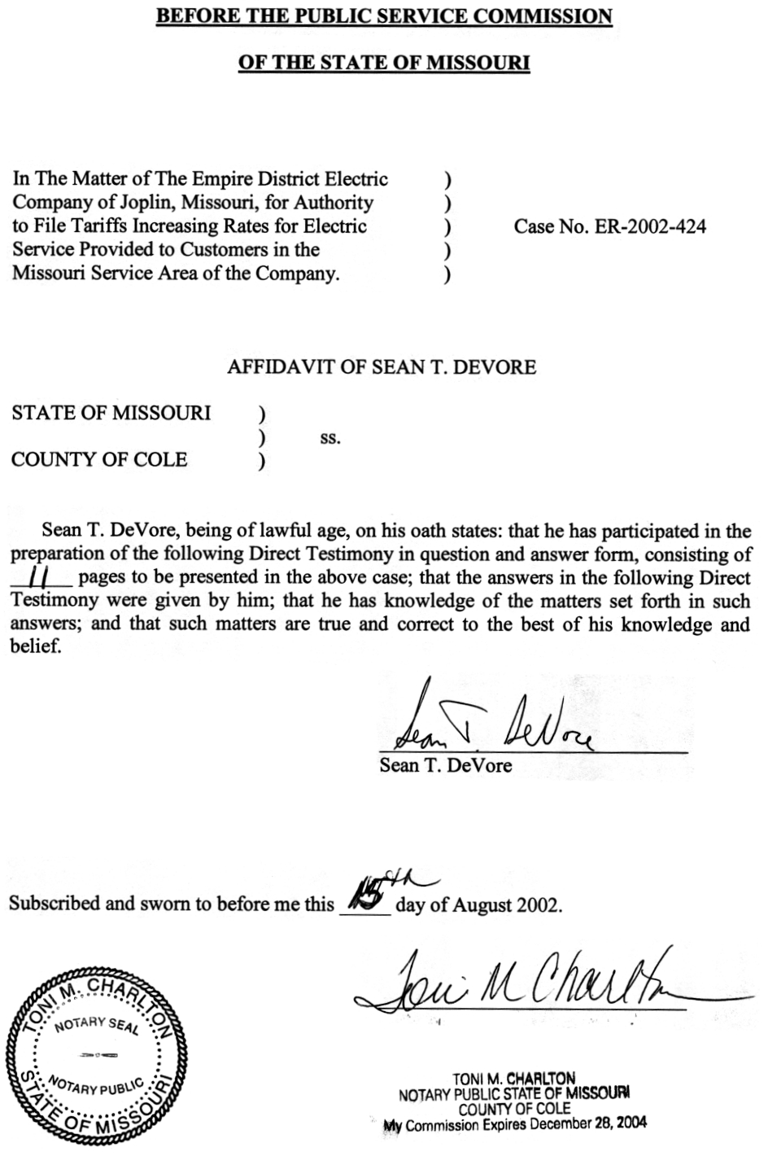
TABLE OF CONTENTS
SEAN T. DEVORE
THE EMPIRE DISTRICT ELECTRIC COMPANY
CASE NO. ER-2002-424
ADVERTISING EXPENSE 2
PROMOTIONAL GIVEAWAYS 7
DONATIONS 7
DUES 8
PSC ASSESSMENT 8
RATE CASE EXPENSE 9
MATERIALS AND SUPPLIES AND PREPAYMENTS 9
POSTAGE EXPENSE 10
CUSTOMER DEPOSITS 10
CUSTOMER DEPOSIT INTEREST EXPENSE 11
CUSTOMER ADVANCES 11
LOBBYING EXPENSES 11

DIRECT TESTIMONY
OF
SEAN T. DEVORE
THE EMPIRE DISTRICT ELECTRIC COMPANY
CASE NO. ER-2002-424
- Please state your name and business address.
A. Sean T. DeVore, 3675 Noland Road, Suite 110, Independence, MO 64055.
Q. By whom are you employed and in what capacity?
A. I am a Regulatory Auditor for the Missouri Public Service Commission (Commission or PSC).
Q. Please describe your educational and employment background.
A. I graduated from Truman State University in May 2002 with a Bachelor of Science degree in Accounting. I commenced employment with the Commission Staff (Staff) in May 2002.
Q. What has been the nature of your duties while employed by the Commission?
A. I am responsible for assisting in the audits and examinations of the books and records of utility companies operating within the state of Missouri.
Q. With reference to Case No. ER-2002-424, have you made an examination and study of the books and records of The Empire District Electric Company (Empire, EDE or Company)?
A. Yes, with the assistance of other members of the Staff.
Q. Please describe your areas of responsibility in Case No. ER-2002-424.
A. I am responsible for the areas of dues and donations expense, advertising expense, rate case expense, PSC assessment, materials and supplies, prepayments, customer deposits, customer advances, postage expense, promotional giveaways and lobbying expenses.
Q. Please describe the adjustments you are sponsoring in this case.
A. I am sponsoring the following adjustments:
Advertising S-74.1, S-89.3
Promotional Giveaway S-49.3, S-58.2, S-67.2, S-69.2,
S-72.2, S-73.2, S-76.2, S-77.3
Donations S-77.4, S-80.3, S-85.4, S-89.4

Dues S-67.4, S-72.4, S-73.3, S-76.3,

S-79.3, S-80.4, S-89.5
PSC Assessment S-87.1
Rate Case Expense S-87.2
Postage Expense S-80.1, S-69.4, S-69.5
Customer Deposits Expense S-71.2
In addition to those adjustments, I am sponsoring the rate base components identified on Accounting Schedule 2-Rate Base for Materials and Supplies, Prepayments and Customer Deposits offset.

ADVERTISING EXPENSE
Q. Please explain adjustments S-74.1 and S-89.3.
A. Adjustments S-74.1 and S-89.3 disallow certain advertising costs incurred by the Company.
Q. Please describe the past treatment of advertising expenses by the Commission.
A. As part of Re: Kansas City Power and Light Company, 28 Mo. P.S.C. (N.S.) 228 (1986) (KCPL), the Commission adopted an approach that classifies advertisements into five categories and provides separate rate treatment for each category. The five categories of advertisements adopted by the Commission for purposes of this approach are:
1. General - informational advertising that is useful in the provision of adequate service;
2. Safety - advertising which conveys the ways to use the Company's service safely and to avoid accidents;
3. Promotional - advertising used to encourage or to promote the use of the particular commodity the utility is selling;
4. Institutional - advertising used to improve the Company's public image; and
5. Political - advertising which is associated with political issues.
The Commission adopted these categories of advertisements because it believed that a utility’s rates should: 1) include the reasonable and necessary cost of general and safety advertisements; 2) disallow the cost of institutional or political advertisements; and 3) include the cost of promotional advertisements only to the extent that the utility can provide cost justification for the advertisement (Ibid., pp. 269-271).
Q. What standard did the Staff use to evaluate the Company’s advertising expense in this case and to develop the adjustments?
A. The Staff utilized the standards as initially established in the KCPL case and in subsequent cases to determine the test year level of allowable advertising expense for the general, safety, institutional, promotional and political advertising categories. The Staff proposes to disallow advertisements that are institutional, promotional, unrelated to the electric industry or that ask for charitable donations. The Staff allowed all general and safety-related advertisements to the extent that they were related to the electric industry and beneficial to Missouri ratepayers.
Q. How did you apply the standard established in the KCPL case to your examination of advertising expense in this case?
A. I categorized all of the Company’s advertisements on an ad-by-ad basis using the KCPL standard to determine the amount allowed or disallowed. I began by reviewing each advertisement to determine which of the following primary messages the advertisement was designed to communicate:
1. The promotion of a service or product (Promotional);
2. The dissemination of information necessary to obtain safe and adequate electric service (General and Safety);
3. The promotion of the Company image (Institutional); or
4. The endorsement of a political candidate or any political message (Political).
Once I determined the primary message, I classified the advertisements accordingly. Schedule 1, attached to this testimony, is my itemized analysis of the Company’s advertising costs and a copy of all the Company’s advertisements for the test year, as provided in response to Staff Data Request No. 79.
Q. How did the Staff develop its advertising adjustments?
A. The Staff requested that the Company supply the cost of all advertisements on a per-ad basis. Based on its categorization, the Staff disallowed the expense associated with advertisements that it classified as institutional or promotional, as well as general advertisements unrelated to the electric industry or Missouri ratepayers.
Q. What media does the Company utilize to place its advertisements?
A. The Company uses the following media:
1. Radio;
2. Television;
3. Print (Newspapers); and
4. Other Print.
Q. Describe the institutional advertisements that the Staff disallowed.
A. The Staff disallowed the following advertisements as institutional in nature: Christmas Elves, Christmas Phones, EDE Logo and Sponsorship advertisements, Project Help, Silver Inquirer (Project Help and Christmas Elves) and Yearbook Safety advertisements. The Christmas Elves advertising program requests donations of items for elderly customers. The Christmas Phones advertising program invites senior customers to come to the Company’s local office and place a free long-distance telephone call. The EDE Logo and Sponsorship advertisements sponsor and provide support for local causes and events. Project Help advertisements ask for donations to help pay the energy bills of the elderly and disabled. Silver Inquirer-Project Help and Silver Inquirer-Christmas Elves requests donations of items for elderly customers. The Yearbook Safety advertisements are general in content and provide no information on electrical safety or information necessary to Empire customers. The Yearbook advertisements are designed to build the Company’s image. The Company in essence helps to defray the cost to the schools for the publications in which the advertisements appear. None of these advertising programs are necessary for the provision of safe and adequate service.
Q. Please describe the promotional advertisements that the Staff disallowed.
A. The Staff disallowed the following advertisements as promotional in nature: Heating and Cooling Consultations, Lighting Solutions, State Line Combined Cycle Generating Facility (SLCC) and Surge Protection. The Heating and Cooling Consultations advertisements promote free consultation services on energy efficient heating and cooling systems. The Lighting Solutions advertisements promote high quality lighting products. The SLCC advertisement promoted the opening of the new State Line Power Plant that occurred during the 2001 test year. The Surge Protection advertisements promote products that protect against power surges.
Q. Has the Company provided any documentation in this case regarding the cost/benefit analysis of promotional advertising?
A. No. In the current case, the Company could not provide any documentation of the benefits associated with its promotional advertising. Therefore, the Staff is proposing that the test year cost of these advertisements be disallowed.
Q. Please describe the Staff’s adjustment for general and safety advertisements.
A. There was no adjustment for general and safety advertisements because they are considered to be reasonable and necessary.
Q. Did the Staff adjust test year expense for any political advertising?
A. The Company placed no political advertisements during the test year.

PROMOTIONAL GIVEAWAYS
Q. Please describe adjustments S-49.3, S-58.2, S-67.2, S-69.2, S-72.2, S-73.2, S-76.2 and S-77.3.
A. These adjustments decrease expenses for the Company’s promotional giveaway items distributed during the test year.
Q. Please describe the items that the Company offers as promotional giveaways.
A. The Company distributed many types of items (e.g., magnets, safety plugs, lollipops, desk items, etc.) during the test year. Some of the items display the Empire logo. The Staff believes that the cost of promotional giveaways provides no direct benefit to the ratepayer and, therefore, should not be included in rates. Additionally, the Commission has previously disallowed the cost of giveaway items that were similar in nature in a number of rate cases, including Missouri Cities Water Company, et al. Case No. WR-92-207.

DONATIONS
- Please explain adjustments S-77.4, S-80.3, S-85.4 and S-89.4.
A. These adjustments decrease test year expenses relating to various donations the Company has included in its cost of service. The Staff recommends disallowing the donations listed in Schedule 2, attached to my direct testimony. Such donations have been excluded because they are not necessary for the provision of safe and adequate service, and thus do not have any direct benefit to ratepayers. Allowing the Company to recover these expenses through rates causes the ratepayer to involuntarily contribute to these organizations.

DUES

Q. Please explain adjustments S-67.4, S-72.4, S-73.3, S-76.3, S-79.3, S-80.4 and S-89.5.
A. These adjustments decrease test year expenses relating to various dues the Company has included in its cost of service. The Staff recommends disallowing the dues listed in Schedule 3, attached to my direct testimony. These dues have been excluded because they are not necessary for the provision of safe and adequate service and, thus, do not provide any direct benefit to ratepayers.
Q. Do you have any specific comments on certain disallowances indicated on Schedule 3?
A. The dues to state and national chambers of commerce were disallowed on the basis that the activities of these groups duplicate the efforts of the local chambers of commerce located within the Company’s four-state service territory. Dues for memberships in local chambers of commerce were allowed because such memberships generally benefit the Company and its customers through the Company’s participation in the local communities in which it serves. The Commission has historically allowed to be included in rates, one chamber of commerce membership in each of the Missouri communities in which a utility serves.

PSC ASSESSMENT
- Explain adjustment S-87.1.
A. This adjustment normalizes expenses for the most current PSC Assessment.
Q. Is Empire current on its payments to the Commission relating to its PSC Assessment obligation?
A. It is my understanding that the Company is current on payments for its PSC Assessment for the first quarter of the current fiscal year beginning July 1, 2002.

RATE CASE EXPENSE
Q. Please describe adjustment S-87.2.
A. This adjustment normalizes rate case expense over a two-year period.
Q. How was rate case expense adjusted for Case No. ER-2002-424?
A. The total amount of rate case expense incurred by Empire through July 31, 2002 is being allowed at this time. Any additional cost that is a reasonably incurred rate case expense will be considered for inclusion later in the case. Some rate case costs, such as consulting fees, employee travel expenditures and legal representation are directly associated with the length of the case through the prehearing and hearing process. The Staff will work with the Company to establish an ongoing normalized level of rate case expense for inclusion in rates.

MATERIALS AND SUPPLIES AND PREPAYMENTS
- Please describe the Staff’s treatment of materials and supplies and prepayments.
A. Materials and supplies and prepayments are represented in the Staff’s rate base by 13-month averages. Due to the cyclical nature of these two items, 13-month averages are developed to smooth out seasonal variations.
Q. What are materials and supplies?
A. Materials and supplies are miscellaneous items that are stored by the Company in inventory for use in day-to-day routine maintenance and operational projects. These items are also stored in inventory for the Company’s construction projects. The type of items contained in materials and supplies range from bolts and electric cable to electric line poles.
- What are prepayments?
A. Prepayments relate to items that the Company “prepaid” so that the services will be on-hand during the normal course of the utility’s operations. These types of items include the prepayment of postage meters, insurance that is paid in advance of coverage, prepaid rents, etc.

POSTAGE EXPENSE
- Please explain adjustments S-80.1, S-69.4 and S-69.5.
A. Adjustments S-80.1, S-69.4 and S-69.5 were made to annualize postage expense to reflect the increase in postage rates, which took effect July 1, 2002.

CUSTOMER DEPOSITS
Q. Please describe the customer deposits amount that is deducted from rate base.
A. Customer deposits generally represent funds received from customers as security against potential loss arising from failure to pay for service. The deposit represents a liability to repay the funds received after a specified period or upon satisfaction of certain requirements. Since customer deposits are, in effect, an interest-free loan to the Company, a representative level is included as an offset to the rate base investment. This treatment allows customers to receive a “return” on the customer deposit amounts maintained by the Company. The customer deposits computation is represented by a 13-month average. As with materials and supplies and prepayments, a 13-month average is used to smooth out cyclical variations in the account.

CUSTOMER DEPOSIT INTEREST EXPENSE
Q. Please explain Income Statement Adjustment S-71.2.
A. Staff’s adjustment S-71.2 annualizes interest expense related to customer deposits. Customer deposits are interest bearing so the liability is deducted from rate base with the associated interest included as a cost of service. To calculate this adjustment, I used a 5.75% interest rate (prime + 1%) (recommended by Staff witness James C. Watkins of the Commission’s Energy Department) multiplied by the balance in customer deposits discussed earlier in my direct testimony.

CUSTOMER ADVANCES
Q. Please describe this item that is deducted from rate base.
A. The customer advances computations are represented by a 13-month average. Customer advances are funds provided by customers of the Company to assist in the costs of the provision of electric service. These funds, like customer deposits, represent interest-free money to the Company. Therefore, it is appropriate to include these funds as an offset to rate base. However, unlike customer deposits, no interest is paid to these customers for the use of the money.

LOBBYING EXPENSES
- Did the Staff evaluate the lobbying expenses incurred by the Company?
A. Yes, the Staff evaluated the lobbying expenses incurred by the Company and determined that all of the lobbying expenses were booked below the line. Therefore, these expenses are not included in rates.
Q. Does this conclude your direct testimony?
A. Yes, it does.

