**Ameren Distribution**

**Vegetation Management**

**Program and Practices**

**Last Updated: March 2024**

**Ameren Missouri Distribution**

**Vegetation Management Program and Practices**

The Ameren Missouri Distribution Vegetation Management Program is predicated on minimizing tree-caused outages and thereby enhances reliable service to our customers and promotes public safety. The actual tree trimming process is based on the concept of providing adequate clearances with minimum reduction in tree values.

Physical and environmental conditions are constantly changing. As these factors change, they must be reflected in similar changes in the Vegetation Management Program. Since many factors influence such a program, it must be flexible and must require considerable judgement in its application.

**Vegetation Management Program**

**General**

Tree trimming should be done in accordance with the natural pruning technique recommended by the International Society of Arboriculture (ISA). The standard recognized by ISA as ANZI A300. Since this method utilizes existing knowledge of natural physiological responses of trimmed trees, it provides several important benefits: (1) it may leave a more natural appearance to the trees or limbs pruned and (2) it reduces the number and vigor of epicormic shoots, which maximizes the effectiveness of the trimming process while removing a minimum amount of foliage from the tree.

Except in the case of emergency, all vegetation management operations should be done on a routine basis utilizing systematic crew scheduling to maximize system reliability and operating efficiencies.

All trimming, whether done for new construction or maintenance, is intended to provide clearances to acceptable standards in both urban and rural areas.

Trees located directly under primary lines, requiring repeated trimming, should be removed if the cost of removal does not exceed that necessary to accomplish two trimming operations. Before removing any trees that are in a formal landscaped setting, a signed permit should be obtained from the property owner.

Trees or limbs cleared in the processes of restoring service should be left for the customer's disposal; however, care should be taken in how and where the brush is left. Streets, alleys, sidewalks*,* and waterways such as creeks and drainage ditches, should not be blocked. If practical, brush should be placed on the property owner's property; otherwise, it should be left where tree or limb would have fallen if the line had not been there.

On routine trimming where dead trees are encountered that in falling will hit a primary line, the trees should be cut down or the portion likely to hit the line removed, whichever requires the least time. If possible, written consent should be obtained and the brush and logs left for the customer's disposal.

Before proceeding with any trimming or removal to clear for new equipment construction, written consent shall be obtained from governmental authorities where required by law and signed permits should be obtained from property owners.

When trimming trees for routine maintenance work, a diligent effort should be made to notify the property owner or residents that trimming is to be performed. Pre-notifications shall be mailed to all property owners or occupants on the circuit at least seven (7) days, but not more than ninety (90) days, prior to performing the planned vegetation. Crews should also attempt to contact the customer on the day of trimming. Pre-notifications shall be mailed to all municipal and county official's no later than two (2) months in advance of planned maintenance trimming.

If tree houses, swings, climbing steps, etc., are observed within a tree that if used will bring a person into contact with an energized conductor, the property owner shall be promptly notified to remove the tree house, etc. using trained personnel. If a property owner refuses to cooperate, legal remedies shall be pursued.

Where appropriate, tree growth should be controlled by using the appropriate herbicide and application method. Herbicides, even if applied by a contractor, must be approved by the Superintendent/Manager of Vegetation Management. Brush cutting by hand or other mechanical means is acceptable only when or where the use of herbicides is impractical.

**Customer Relations**

Personnel engaged in vegetation management work, supervisors, and tree crews have frequent contact with individual customers. It is important that they make every effort to maintain good customer relations. If a customer or property owner refuses to allow for proper clearances to be obtained between the vegetation and Ameren facilities, then the location should be noted on the circuit map by recording the address. The Ameren vegetation supervisor shall be made aware of the situation with 48 hours.

In the event that a customer threatens a crew then the crew shall exit the property and promptly contact their supervisor. The supervisor shall contact the Ameren vegetation management supervisor who should then notify the Ameren security department.

Ameren requires all contractor personnel to conduct themselves in a professional manner. Vendors are expected to keep their equipment in good working order. Contractor personnel should provide property owners with explanations, as needed, of the work to be done on their property. Additionally, contractor personnel shall be able to furnish a company issued identification card if asked by the property owner.

When an agreement is reached with a customer to leave brush or logs on the premise, brush shall be removed from roofs, driveways, sidewalks, waterways, etc. unless a prior agreement has been made that the customer will provide on-site assistance.

During routine trimming operations, brush should be removed from sidewalks and driveways if there will be a time lapse of over fifteen (15) minutes between trimming and brush cleanup. Limbs falling into the street shall be moved immediately. In remote areas all efforts should be made to contact the property owners before leaving brush neatly windrow in the same direction as the line.

**Customer Requests**

Customer requests are generally field inspected to determine Ameren's interest and responsibilities.

When assistance is given that requires placing a portion of the tree on adjoining property, streets, alleys, driveways, etc. no work should be done until the customer has an arborist on the job or otherwise demonstrates that they will carry out their portion of the work. Ameren vegetation personnel or contractors must have a signed permit from the customer stating that the customer is responsible for all wood and brush disposal. This permit must be obtained before work commences.

The following guide should be used in determining the extent and nature of the tree work to be done:

**Primaries** – If a tree which the customer wants to trim or remove interferes with our lines or has overhang within 10ft, the portion of the tree which overhangs the line shall be removed or line cover provided. At a minimum, branches shall be removed to provide the necessary clearances as described in table 3 of ANSI133.1-2017 – Minimum approach distances for energized conductors for persons other than qualified line-clearance arborists and qualified line clearance arborists trainees. A signed permit must be obtained by the contractor before work begins.

Generally, help jobs should be scheduled to optimize maintenance schedule efficiency. The Ameren Vegetation Management department should schedule help jobs as per the agreed to time frame noted on the permit and as field conditions warrant. Delays may occur due to weather conditions or changes in operating conditions.

**Service Drops** – Trees should not be trimmed, removed, or topped for removal to clear service drops, but the wires should be temporarily dropped by a Troubleman so the customer can remove or trim the tree. Troubleman may do limited amounts of limb removal based on customer requests.

**Streetlight and Dusk/Dawn Circuits** – Same policy as Service drops

**Secondary** - Tress should not generally be trimmed, removed, or topped for removal except when a dead tree is involved, and the tree or wire condition poses a hazard to Ameren facilities or work persons. When possible, secondary wires should be dropped if the cost is less than the tree work involved.

**General Practices**

The amount and type of line clearance depends on the voltage and importance of the line involved. Priority is given as follows: 69kv, 34.5kv, 12.47kv, 4.16kv, 7.2kv, 2.4kv, secondary, street light circuits and services.

All trimming personnel, while working for Ameren, should follow the American National Standard Z133.1-2017 for arboricultural operations-pruning, repairing, maintaining, and removing trees and cutting brush-safety requirements.

1. **69kv, 34.5kv –** The Ameren subtransmission system shall generally be trimmed on a 6 year cycle, under the classification of rural defined by less than 35 customers per total circuit mile, and taking reliability into consideration.Subtransmission circuits may have accelerated or deferred maintenance based on circuit level reliability. All obvious danger trees that can be removed should be cut down or trimmed to a point they are no longer a threat to the conductor.

* Overhang: All overhanging branches shall be removed from over the conductors. To the extent possible, lateral branches left should be those growing in a direction away from the conductor.
* Under: Trees should be cut clear of the lowest Ameren wire and provide clearance for the primary wire.
* Side: A minimum of 15 feet of clearance shall be obtained between 69kv conductors and tree growth or to the edge of the right-of-way whichever is less. A minimum of 10 feet of clearance shall be obtained between 34.5kv conductors and tree growth or to the edge of the right-of-way whichever is less. Limbs should be swept back to prevent their contacting conductors if they would happen to break or hinge over.
* Exceptions - Mature trees whose trunks or limbs have sufficient strength and rigidity to prevent the trunk or limbs from damaging the conductor under reasonably foreseeable wind and weather conditions are exempt from the minimum clearance requirements. Exceptions should be noted by the contractor supervisor on the maintenance maps and approved by the Ameren vegetation supervisor by dating and initialing after field checking.

1. **12.47kv, 4.16kv, 7.2kv, & 2.4kv** –Ameren service areas shall generally be trimmed on a 4 or 6 year cycle depending on classification of the feeder as either urban or rural and taking reliability into consideration.Urban feeders are defined as having on average, 35 or more customers per total circuit mile and should be managed for a 4 year cycle length. Rural feeders are defined as having on average, less than 35 customers per total circuit mile and should be managed for a 6 year cycle length. Urban or rural circuits may have accelerated, or deferred maintenance based on circuit or device level reliability.

Three Phase

* Overhang: Three (3) phase conductors (portion of a distribution system directly interconnected with the distribution substation and prior to the first protective device) shall be trimmed vertically to remove overhanging limbs. Three phase conductors beyond the first protective device should also be trimmed accordingly.
* Under - Trees should be cut clear of the lowest Ameren wire and provide clearance for the primary wire.
* Side - A minimum of 10 feet clearance shall be obtained between the conductors and tree growth or to the edge of the right-of-way whichever is less.
* Exceptions - Mature trees whose trunks or limbs have sufficient strength and rigidity to prevent the trunk or limbs from damaging the conductor under reasonably foreseeable wind and weather conditions are exempt from the minimum clearance requirements. Exceptions should be noted by the contractor supervisor on the maintenance maps and approved by the Ameren vegetation supervisor by dating and initialing after field checking.

Single and Two-Phase

* Overhang: A minimum of 10 feet of clearance shall be obtained between the conductor and tree growth.
* Under: Same as three phases.
* Side: Same as three phases.
* Exceptions – Same as three phases.

1. **Reliability Improvement**

A mid-cycle (based on feeder classification of urban or rural) vegetation patrol shall be performed. The intent of the patrol is to identify where vegetation management is needed. Items noted should include dead or dying trees, excessive vine conditions, and storm damage. Once identified the need for vegetation management work should be done in a timely manner.

1. **Secondary**

Secondaries should be trimmed incidental to trimming on primary circuits. Any trimming necessary should be done as the result of tree problems reported.

**5**. **Street Light System**

Circuits - No routine trimming should be done exclusively for street light circuits. Any trimming necessary should be done as the result of tree trouble reported.

Luminaries – No routine maintenance should be done to remove limbs which interfere with distribution from street light luminaries. Clearing trees for light distribution is the responsibility of the city or other governing body having jurisdiction over trees and lights. In some districts, however, because of different policy in the past or inclusion of tree trimming in the sales program, it may be necessary to do a limited amount of trimming for light distribution.

Tree trimming should be done upon initial installation of dusk to dawn lights. On initial contact, customers should be informed that the billing rate does not include any future trimming for light distribution or clearance around the fixture.

Service Drops – Trees should not be trimmed, removed, or topped for removal to clear service drops, but the wires should be temporarily dropped by a Troubleman so the customer can remove or trim the tree. Troubleman may do limited amounts of limb removal based on customer requests.

**6. Quality Assurance**

Ameren's Vegetation Management requires each contractors' compliance with Ameren's specifications. At a minimum, contractor management should submit one formal audit per crew, per month (2 days of work). Ameren supervision should review 1 completed contractor audit and review the entire week of work in which the audit occurs (see Appendix A1). Contractor management shall patrol the entire circuit or mark off as crews progress such that the entire circuit is patrolled before the map is turned in as complete to Ameren. Ameren supervision should review the map to make sure all lines are marked as completed and should post patrol a portion of the total regularly scheduled maintenance mileage completed by contractors (See Appendix A1-B).

Ameren supervision should perform regular observations (see Appendix B & B1) of contractor crews to monitor compliance with safety, specifications, performance, and invoicing. Herbicide application efficacy audits (Appendix B2) should review at a minimum 15% of the total work.

All work found to be non-compliant shall be corrected promptly to meet Ameren specifications. If non-compliant work is found, then the contractor should audit 100% of the work done by that crew as reviewed and determined by Ameren on all circuits where work was performed and correct any deficiencies at contractor expense.

**7.** **Performance Management**

Amerenvegetation management personnel should hold quarterly performance management review sessions with contractors. Discussions should focus on Safety, Quality, Project Management, Think Customer, and Diversity. See Appendix J-3 (Performance Management Scorecard). The performance management scorecard should be reviewed annually, and adjustments may be made to key indicators measured in each quadrant and year-end targeted performance.

**8. Public Education and Outreach**

To educate the public, Ameren shall keep current pertinent information on vegetation management on the Amerenweb page. Information should include such topics as Right Tree Right Place and reasons for vegetation management and shall address some of the more common questions. In addition, this type of information should be in brochure format and available to the general public. Ameren shall also provide an annual public outreach program to all customers. This program at a minimum should provide similar educational components.

**9. Reporting**

Ameren shall file an annual report on April 1st of each year documenting:

A) Expenditures for vegetation management in the preceding year.

B) Vegetation management budget for the current year.

C) Circuits, completion dates, and miles trimmed in the previous year.

D) Circuits, completion dates, and miles scheduled for the current year.

E) Total distribution miles for the system and corresponding classification between rural and urban.

**Appendix A1**

**Vegetation Management Distribution Work Audit**



**Appendix A1-B**



**Appendix B**

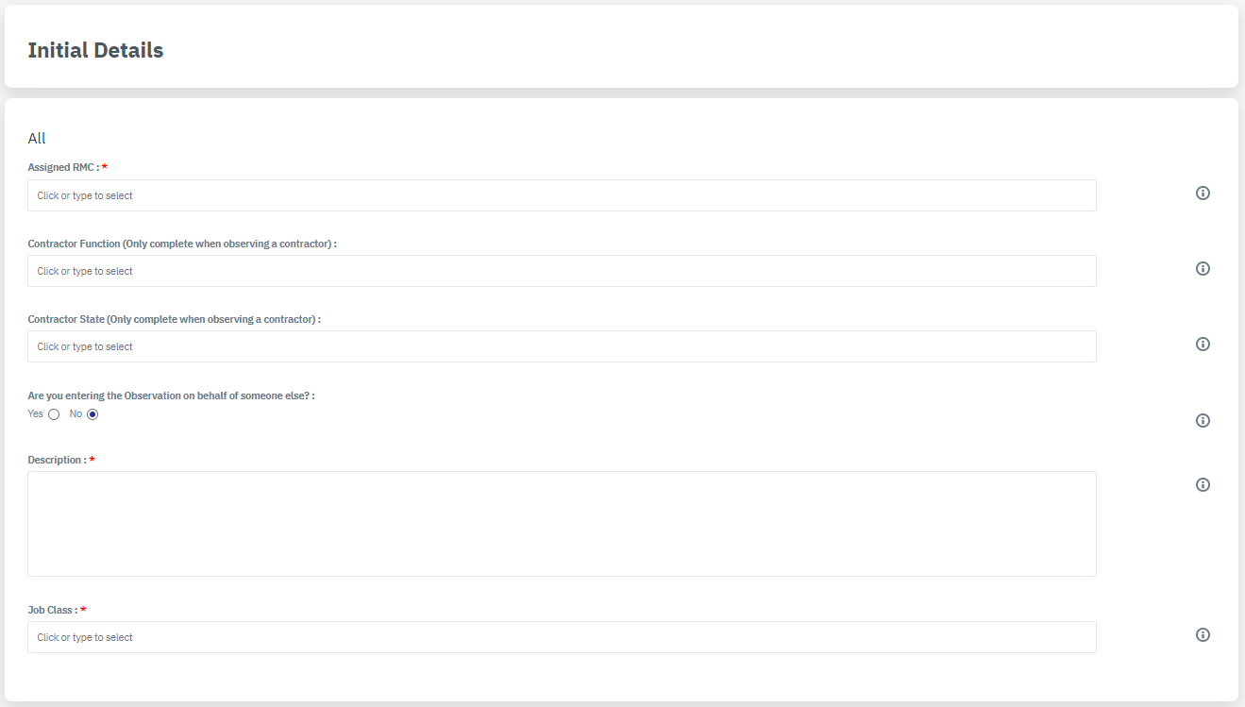

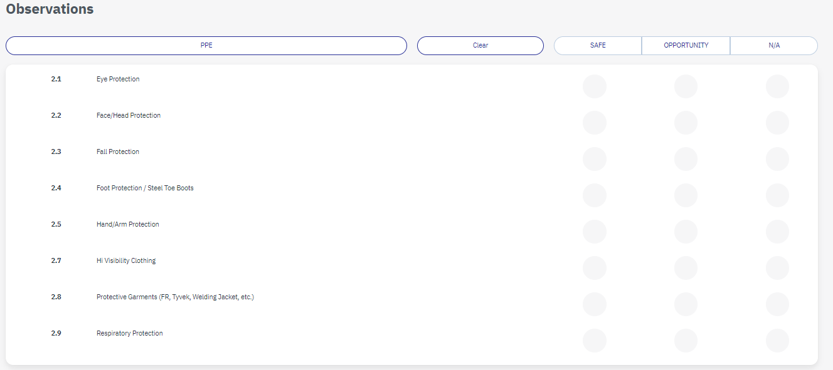

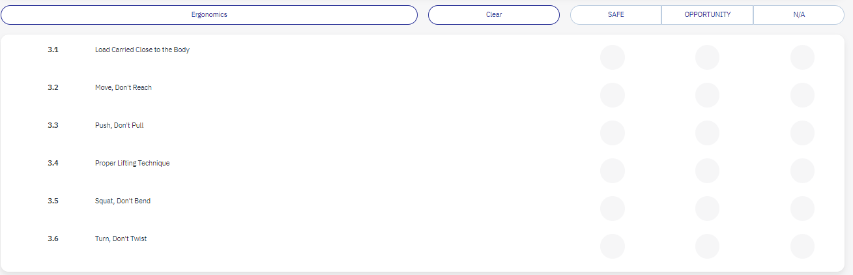

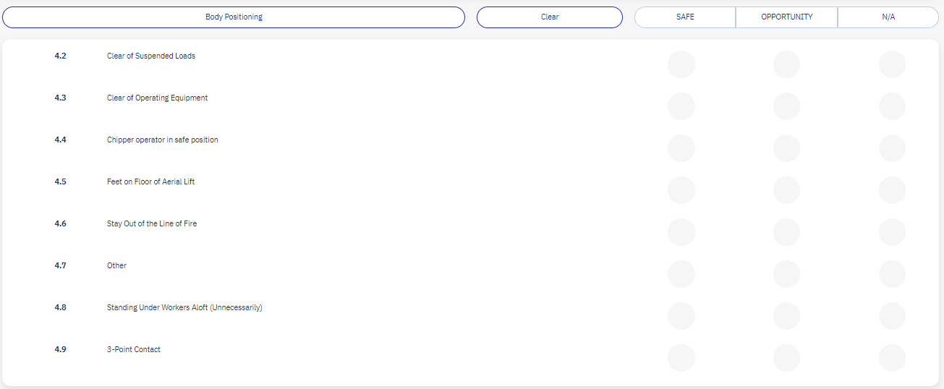

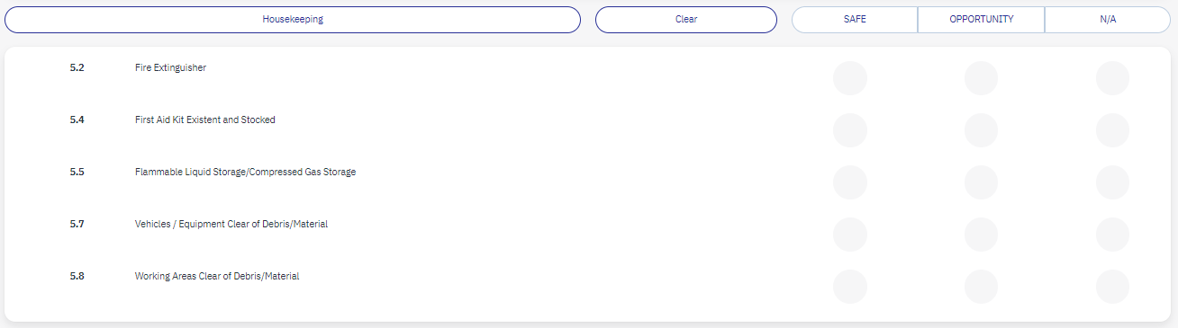

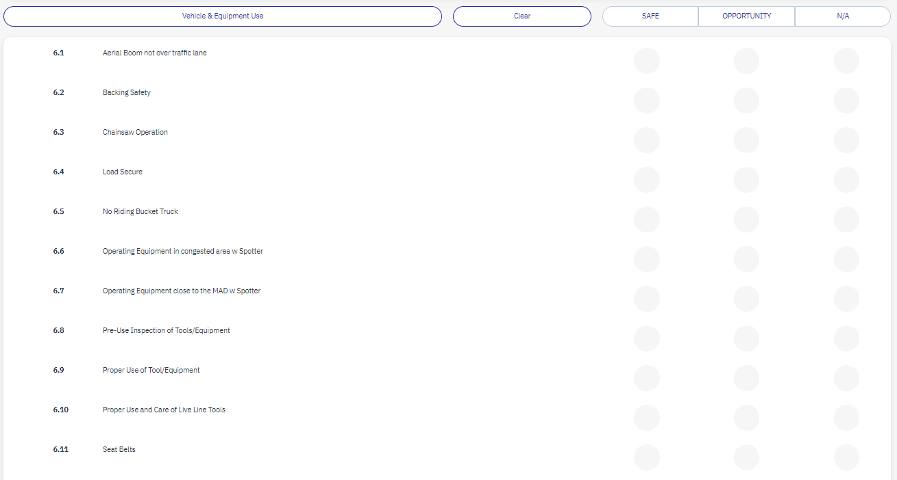

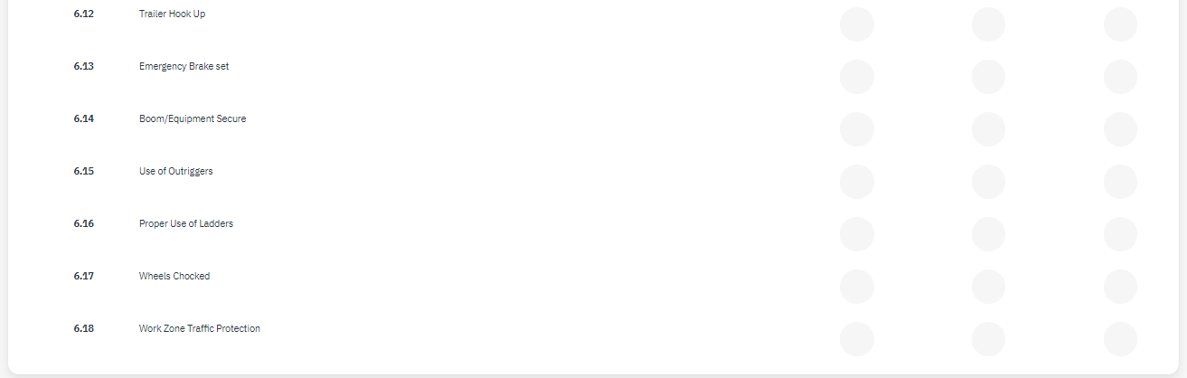

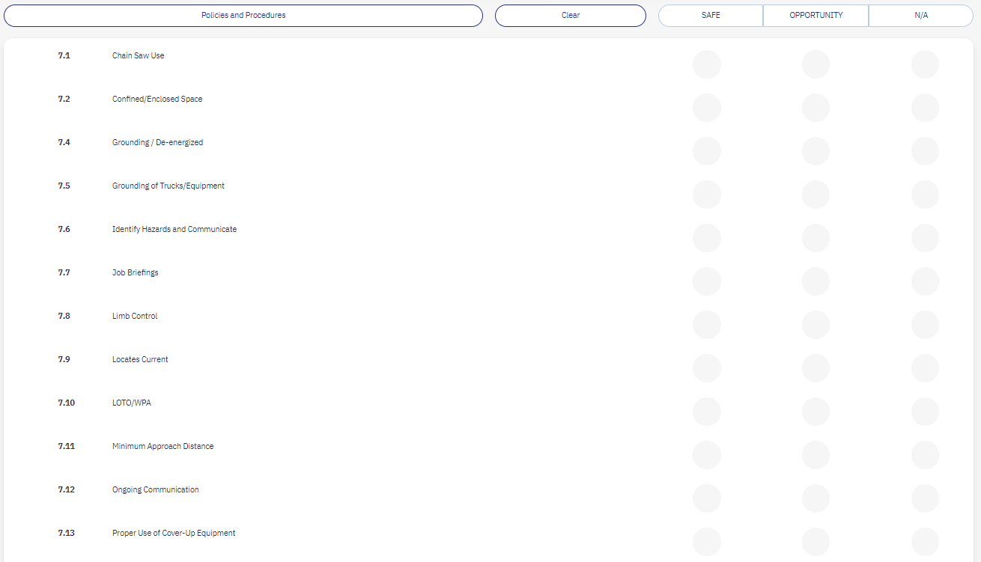

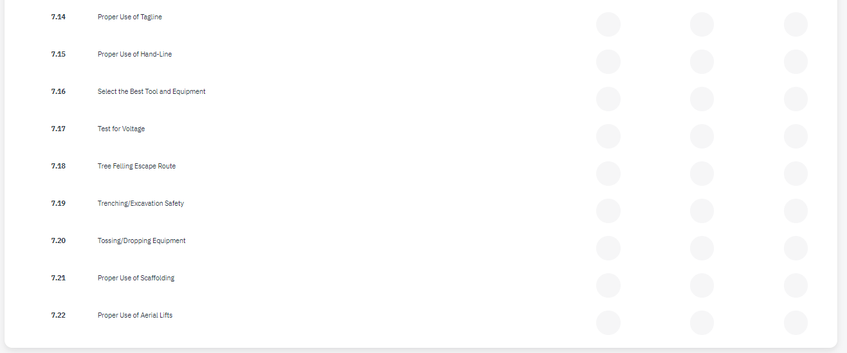

**Appendix B1**



**Appendix B2**

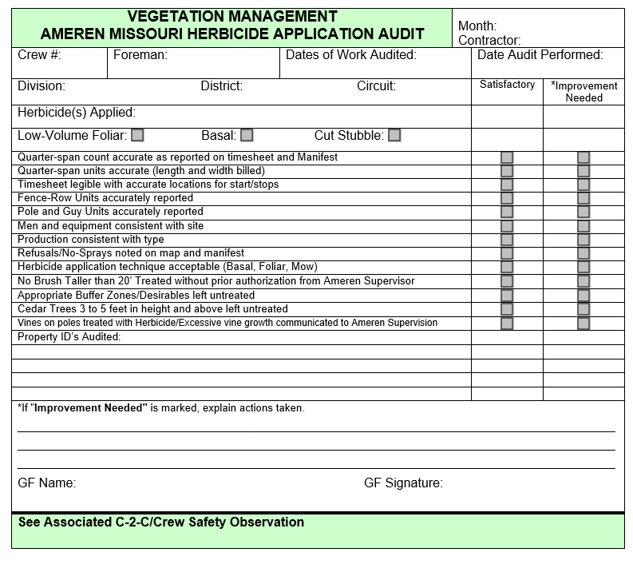

**Appendix J3**

