**Ameren Transmission Vegetation Management Strategy (TVMS)**

Last Updated: March 2024

Ameren’s objectives for managing vegetation on transmission rights-of-way, are to prevent outages from vegetation, located on transmission rights-of-way, and to minimize outages from vegetation located adjacent to the rights-of-way, so that transmission circuits can operate as intended. In addition, vegetation is managed for visibility of facilities to ensure security of the transmission system. To meet this objective, Ameren incorporates a defense-in-depth strategy to improve reliability of the electric transmission system, minimizing the risk of vegetation related outages that could lead to cascading events, while following procedures and maintaining documentation as evidence of compliance.

The Ameren Transmission Vegetation Management Annual Work Plan will document the methods to be utilized, and the circuits that will have vegetation management work performed in that year.

*Please refer to appendix "A-1" Ameren Transmission Vegetation Management Procedure VMP-R7 Annual Work Plan Procedure.*

In developing the annual work plan, considerations will include, but are not limited to, line voltage, circuit criticality, historical data, and annual vegetation patrols, which will take into account the future growth of vegetation. The annual work plan may change throughout the year as the result of changing conditions.

**Patrol Policy**

Ameren’s annual vegetation inspections are conducted to identify vegetation concerns, develop the annual work plan and prevent vegetation encroachment inside the Minimum Vegetation Clearance Distance (MVCD). Resulting corrective actions ensure no encroachment inside the MVCD. This procedure defines the inspection/patrol methods on transmission circuits greater than 100kV to identify vegetation work, short and long term, to ensure no preventable vegetation encroachments occur within the MVCD. Ameren performs annual vegetation inspections as measured by circuits, at least once per calendar year.

Ameren will perform vegetation inspection/patrols on 100% of transmission circuits by air or ground at least once per calendar year with no more than 18 calendar months between inspections on the same ROW. The inspections, both in content and actual completion, take into account anticipated growth of vegetation and environmental or operational factors that may impact the relationship of the vegetation to the transmission lines. The schedule is flexible enough to adjust to changing conditions such as major storms, flooding, or circuit load above rating due to excessive heat, and additional inspections may be added as needed to prevent encroachments into the MVCD between annual work plan activities.

*Please refer to Appendix "A-2" Ameren Transmission Vegetation Management Procedure VMP-R6 Inspection Procedure.*

**Clearance Specifications**

Maximum circuit operating conditions at Rating and all Rated Electrical Operating Conditions, including movement of conductors and vegetation due to wind, were considered when developing the clearance requirements. Additionally, these clearance specifications are based on Ameren’s patrol policy, vegetation management techniques, species type and growth rates, species failure characteristics, climate/rainfall patterns in the Ameren service area, line terrain and elevation, circuit design, location of the vegetation within the span, and worker approach distance. Ameren’s definition of Clearance 1 and Clearance 2 does not allow any vegetation to overhang any conductors, guy wires or structures anywhere on a transmission circuit, which also satisfies the requirements of Section B of NESC 218.

**The Wire Zone is defined as the area occupied by the structures and conductors. The zone will start at the centerline of the structure and extend 20’ beyond the outside conductor.**

**The Border Zone is defined as the area from outside edge of the Wire Zone extending to the outside edge of the defined right-of-way (ROW).**

**Vegetation management work for voltages on 200kV, or greater, NERC applicable lines.**

**Clearance 1** – to be achieved at the time of transmission utility vegetation management. Any deviations or exceptions from these Clearance 1 specifications shall be reported both verbally and in written form to the Ameren Vegetation Management (VM) Supervisor or (VM) Manager. The specific location and description of the deviation or exception should be noted on the *Less than Standard Clearance* form (see VMP R5).

Wire Zone - Except for the condition description in the following paragraph below, vegetation in this zone should be managed to promote the growth of plant species that have a mature height of 10 feet or less. All plant species that normally reach a mature height greater than 10 feet should be removed by mechanical methods or controlled by approved herbicide application, subject to limits of the ROW and legal rights related to vegetation management.

If conductors, operating within Rating and all Rated Electrical Operating Conditions, have a maximum displacement at a location in a span, such that the distance to ground is greater than 100 feet, then all vegetation must be managed to provide a minimum of 20 feet clearancefrom the point of maximum displacement to any vegetation that could exceed 10 feet in height.

Border Zone - All vegetation should be managed to create side clearance of 40' from the at-rest position of the conductor, subject to limits of ROW and legal rights related to vegetation management. In the border zone floor, vegetation should be managed to promote plant species with a mature height of 20' or less. All plant species that normally reach a mature height greater than 20' should be removed by mechanical methods or controlled by approved herbicide application. Exceptions may be permissible for locations where the clearance between the conductor (at maximum displacement) and vegetation is greater than 100 feet.

In an area where the conductor sag at Rating and all Rated Electrical Operating Conditions places the line at less than 30' of clearance from the ground at it's at-rest position, then vegetation in the border zone shall be managed to promote species which are 10 feet or less at maturity.

**Vegetation management work on voltages below 200kV and above 100kV.**

Clearance 1 - to be achieved at the time of transmission utility vegetation management. Any deviations or exceptions from these Clearance 1 specifications shall be reported both verbally and in written form to the VM Supervisor or VM. The specific location and description of the deviation or exception should be noted on the *Less than Standard Clearance* form (see VMP-R5).

Wire Zone - Except for the condition description in the following paragraph below, vegetation in this zone should be managed to promote the growth of plant species that have a mature height of 10 feet or less. All plant species that normally reach a mature height greater than 10 feet should be removed by mechanical methods or controlled by approved herbicide application, subject to limits of ROW and legal rights related to vegetation management.

If conductors, operating within Rating and all Rated Electrical Operating Conditions, have a maximum displacement at a location in a span, such that the distance to ground is greater than 100 feet, then all vegetation must be managed to provide a minimum of 20 feet clearancefrom the point of maximum displacement to any vegetation that could exceed 10 feet in height.

Border Zone - All vegetation should be managed to create side clearance of 30 feet from the at-rest position of the conductor subject to limits of ROW and legal rights related to vegetation management. In the border zone floor, vegetation should be managed to promote plant species with a mature height of 20 feet or less. All plant species that normally reach a mature height greater than 20' should be removed by mechanical methods or controlled by approved herbicide application. Exceptions may be permissible for locations where the clearance between the conductor (at maximum displacement) and vegetation is greater than 100 feet.

In an area where the conductor sag operating within Rating and all Rated Electrical Operating Conditions places the line at less than 30 feet of clearance from the ground at its at-rest position, then vegetation in the border zone shall be managed to promote species which are less 10' or less at maturity.

**Vegetation management work on all circuits above 100kV.**

Clearance 2 – minimum clearance distance to be maintained at all times.

Wire Zone – vegetation in this zone should be maintained at no less than 15 feet of clearance from the conductor. Vegetation at 15 feet or less is considered a priority 1 (P1) and is to be addressed immediately.

Border Zone – vegetation in this zone should be maintained at no less than 15 feet of clearance from the conductor subject to limits of the ROW and legal rights related to vegetation management. Vegetation at 15 feet or less is considered a priority 1 (P1) and is to be addressed immediately.

At no time shall minimum clearances, while conductors are operating within Rating and all Rated Electrical Operating Conditions be less than the MVCD. Minimum vegetation clearance distance is to be maintained between vegetation and conductors within Rating and Rated Electrical Operating Conditions. The MVCD is defined as the minimum distances per NERC standard FAC-003, Table 2. Ameren utilizes the elevation range of 1,000 to 2,000 feet based on the highest level of elevation point within the Ameren transmission system. See Table 1.

*Table 1 – Minimum clearances between vegetation and transmission conductors*

|  |  |
| --- | --- |
| **Nominal Voltage** | **Minimum Vegetation Clearance Distance**  **(MVCD)** |
| 345kV | 4.4 feet |
| 230kV | 4.2 feet |
| 161kV* | 2.8 feet |
| 138kV* | 2.4 feet |

***\*Noted lines are applicable to this standard only if the Planning Coordinator has identified lines as an IROL based on FAC-014.***

Facilities Clearing – to be achieved at the time of vegetation management work on all voltages 100kV and above.

No tree growth shall be allowed to overhang any conductor, structure or guy line associated with any transmission circuit.

Structure Clearing – plant species within 10 feet of any transmission structure/tower base or guy wire should be removed. From 10 feet to 20 feet around the structure/tower base or guy wire, plant species that normally reach a mature height greater than 3 feet should be removed. Exceptions will be made for annual crops such as corn, soybean, rye, winter wheat and wildlife food plots.

*Please refer to Appendix "A-3" Ameren Transmission Vegetation Management Procedure VMP-R3 Clearance Specifications/Work Practices.*

**Customer Relations**

Personnel engaged in vegetation management work, supervisors, planners, surveyors and tree crews have frequent contact with individual customers. It is important that they make every effort to maintain good customer relations. If a customer or property owner refuses to allow for proper clearances to be obtained between the vegetation and Ameren facilities, the constraint mitigation procedure (VMP-R5) shall be followed.

*Please refer to appendix "A-4" Ameren Transmission Vegetation Management Procedure VMP-R5 Constraint Mitigation Procedure.*

In the event that a customer threatens a crew, the crew shall exit the property safely, and promptly contact their supervisor, or law enforcement, depending upon the severity of the threat or action. The supervisor shall contact the Ameren vegetation management supervisor who will in turn notify *the* Ameren security department.

Ameren requires all contractor personnel to conduct themselves in a professional manner. Vendors are expected to keep their equipment in good working order. Contractor personnel should provide property owners with explanations, as needed, of the work to be done on their property. Additionally, contractor personnel shall be able to furnish a company issued identification card if asked by the property owner.

**Quality Assurance**

Line clearance contractor general foreman (GF) will complete one audit per crew, per month covering 2 days of work of which at a minimum, 20% will be audited in the field by Ameren supervision. Specific tasks that are to be audited include but are not limited to; proper clearance, proper cuts, danger tree mitigation (including off ROW), proper structure clearing, herbicide application, and production.

Work audits are submitted for review to the Vegetation Manager, Program Manager, and contractor 2nd line supervision via email by the 15th of the month following.

VM Supervisors will complete a monthly audit in the field with contractor planner/patrol personnel when planners are inspecting lines without an Ameren VM Supervisor. The audit session should focus on recording data as required per the clearance specifications in the patrol software for patrol work completed and patrol work to be done in the future. Specific tasks are to be audited which include but not limited to; Review of patrol work completed with a focus on the accuracy of information on patrols and review of the documentation of clearance requirements and work types identified.

Ameren supervision will be responsible for performing a minimum of 4 monthly Job Site Audits (JSAs) to monitor compliance with safety, crew configuration including equipment and personnel, contractor performance, productivity and invoicing.

JSAs are submitted to the Vegetation Manager, Program Manager, and Safety Team representatives, contractor GF and 2nd line supervision via email as completed.

*For further detail, please refer to appendix "A-5" Ameren Transmission Vegetation Management Procedure VMP-R7.1 Quality Control/Audit Procedure.*

**Performance Management**

Amerenvegetation management personnel will also hold quarterly performance management review sessions with contractors. Discussions will focus on Safety, Quality, Project Management, Think Customer, and Diversity. See Appendix J-3 (Performance Management Scorecard). The performance management scorecard will be reviewed annually, and adjustments may be made to key indicators measured in each quadrant and year-end targeted performance.

**Public Education and Outreach**

To educate the public, Ameren will keep current pertinent information on vegetation management on the Amerenweb page. Information will include such topics as Right Tree Right Place and reasons for vegetation management and shall address some of the more common questions. In addition, this type of information will be in brochure format and available to the general public. Amerenwill also provide an annual public outreach program to all customers. This program, at a minimum, will provide similar educational components.

**Reporting**

Amerenwill file an annual report on April 1st of each year documenting:

* Expenditures for vegetation management in the preceding year.
* Vegetation management budget for the current year.

Quarterly NERC submittals to the MPSC per the Vegetation Management Rule 20 CSR 4240-23.030(5).

**Personnel Qualifications**

**Ameren Transmission Vegetation Supervisors**

**Education:** High School Diploma or equivalent required. Bachelor’s Degree in Forestry or related field from an accredited college or university preferred.

**Experience:** Five or more years of experience in Forestry/Horticulture with knowledge of overhead construction and operations. Successful applicant will be required to obtain International Society of Arboriculture Arborist Certification within one year of acceptance of a Vegetation Management Supervisor position.

**Other:** Successful applicant must sign agreement stating that they will gain ISA certification within one year of accepting supervisor position. Ameren Vegetation Supervisors should maintain their arborists’ certification as long as they are employed as an Ameren Vegetation Supervisor. Good leadership, decision-making, communication and human relations skills, particularly relating to customer relations.

**Ameren Transmission Vegetation Manager**

**Education:** High school graduate. Prefer Bachelor of Science Degree in Forestry or related field.

**Experience:** Must have 10 or more years of experience in the utility vegetation management field. Must have knowledge of overhead electrical construction and operations.

**Other:** Must be an ISA Certified Arborist. Shall maintain their arborist’s certification as long as they are employed in this position. Good leadership, decision-making, communication, and human relations skills, particularly relating to customer relations.

**Contractor Personnel**

All contractor first line supervision must attain ISA arborist certification within one year of accepting a position as a general foreman. All contractor supervisory personnel must demonstrate knowledge of overhead electrical construction and operations and have thorough knowledge of ANSI 133.1 and ANSI A300-2001standards. All contractor personnel shall be line clearance qualified trimmers and shall follow ANSI 133.1 and ANSI A300-2001 standards when performing line clearance trimming work. All contractor personnel applying herbicides on Ameren rights-of-way shall possess all applicable state and federal licenses and certifications required for this work. In addition, all contractor personnel shall meet the qualifications required by their companies before performing work as line clearance qualified employees on Ameren’s system. Each contractor will be required to certify that all of their employees will have the required training, licenses and certifications to perform vegetation management on Ameren rights-of-way.

**Appendix A-1**

Ameren Transmission

Vegetation Management Procedure VMP-R7

Annual Work Plan Procedure

1. **Purpose**
   1. The annual vegetation work plan is developed annually to ensure no vegetation encroachments occur within the MVCD. This procedure outlines the process for developing Ameren’s annual work plan and quarterly reporting of the completed work. It includes details about what methods of vegetation management should be included, what information should be considered, and the process of relaying and approving the annual plan once it has been developed. This annual plan also ensures documentation of the lines where work will be performed as well as the completion of activities at the line level.
2. **References**
   1. FAC-003 (R7), Process Map for Transmission Maintenance
3. **Procedure** – The following steps should be taken during the development of the annual plan.
   1. Scheduling Work
      1. The Vegetation Management (VM) Supervisor develops a schedule at a circuit level. This is based on:

* Cycle length and historical information
* Criticality of line
* Voltage
* Crew availability and methods of vegetation control
* Annual patrols which take into account the current state of vegetation
* Anticipated growth of vegetation and other environmental factors such as changing weather conditions
* Mitigation areas, LiDAR data, and previous patrol data
  1. The VM Supervisor determines the scope of the work and a methodology for the work to be performed.
     1. Trimming and removals can be performed by one or all of the following methods: aerial trimming (helicopter), aerial basket, remote trimmers (i.e. Jaraffe, Timberland), and manual climbing crews.
        1. Herbicide can be applied by one or more of the following methods: aerial application or ground application methods – cut stump, basal and foliar, bare ground weed control.
        2. Mowing needs are determined by density and/or size of woody vegetation, site characteristics, environmental considerations, and access or herbicide restrictions.
        3. Hazard trees are structurally unsound trees, typically outside the rights-of-way (ROW), with visible defects, which could strike transmission facilities. These can include dead, dying, diseased, decayed or uprooting trees.
     2. The VM Supervisor submits the annual work plan for VM Manager Approval.
     3. Once approved, resources are contacted with the scope of the work to be performed discussed with the contractor(s).
  2. Documentation
     1. The VM Supervisor assigns work to the appropriate contractors with expectations for completion of work including priority work.
     2. The contractor submits the completed circuit maps/patrol forms to the VM Supervisor. Contractor crews will initial and date completion of all priority work on patrol forms or summary sheet.
        1. The hard copy circuit maps/patrol forms/summary notes are physically filed in the appropriate VM Supervisor’s office and the patrol form information is entered into the shared drive in the *Patrol Folder*. All entries are to be organized by year.
  3. The VM Supervisor enters the completed miles into the Annual TX Completed Work Plan on a quarterly basis; this file is found on the shared drive. Comments will be added on the electronic file for any work not completed as scheduled or any additional work completed that was not scheduled, to indicate the variance and need. Scheduled miles in red font are to be changed to black to indicate completed work. Comments will be added on the provided carry over tab noted for work scheduled but not completed. Any reasoning or justification for not completing scheduled work within the work plan must be entered in the carry over tab on this file for any work not completed, as scheduled, or any additional work completed that was not scheduled, to indicate the variance and/or need for variance.
  4. Completed vegetation work shall meet the specifications as defined in the Clearance 1 specifications. Ameren audits work to ensure contractor compliance to clearance specifications, trimming standards, work practices and patrol procedures. Informal audits are performed during patrols with formal audits occurring monthly. These formal audits include herbicide application, herbicide efficacy, patrols, and Job Safety Audits. Quality Control is outlined in VMP-R7.1

**Appendix A-2**

Ameren Transmission

Vegetation Management Procedure VMP-R6

Inspection Procedure

1. **Purpose**
   1. Ameren’s annual vegetation inspections are conducted to identify vegetation concerns, develop the annual work plan and prevent vegetation encroachment inside the Minimum Vegetation Clearance Distance (MVCD). Resulting corrective actions ensure no encroachment inside the MVCD. This procedure defines the inspection/patrol methods on transmission circuits greater than 100kV to identify vegetation work, short and long term, to ensure no preventable vegetation encroachments occur within the MVCD. Ameren performs annual vegetation inspections as measured by circuits, at least once per calendar year.
2. **References**
   1. FAC-003 (R-6), Master Patrol Log, Process Map for Patrols

2.3 Patrols methods are completed by air or ground (foot/ UTV).

2.4 Contractors may complete patrols on non FAC-003 applicable circuits and assist the Transmission Vegetation Management (VM) Supervisor with FAC-003 applicable circuits as directed.

1. **General Inspection**
   1. Ameren will perform vegetation inspection/patrols on 100% of transmission circuits by air or ground at least once per calendar year with no more than 18 calendar months between inspections on the same ROW. The inspections, both in content and actual completion, take into account anticipated growth of vegetation and environmental or operational factors that may impact the relationship of the vegetation to the transmission lines. The schedule is flexible enough to adjust to changing conditions such as major storms, flooding, or circuit load above rating due to excessive heat, and additional inspections may be added as needed to prevent encroachments into the MVCD between annual work plan activities.
2. **FAC-003 Applicable Circuit Inspections**
   1. These circuits will be patrolled twice per calendar year.
      1. One of the two scheduled patrols will be conducted by ground. The second patrol may be completed by either ground or air.
   2. Both scheduled patrols shall be approved by the Transmission VM Supervisor. Trained contractor resources may assist with patrolling.
   3. Ameren has a developed patrol schedule, *Master Patrol Log*, which is on file electronically.
      1. The schedule is flexible enough to adjust to changing conditions such as:

* Storms
* Flooding
* Circuit load above rating due to excessive heat.
  + 1. Additional patrols may be completed as needed due to changing conditions.

4.4 Ameren VM Supervisors patrol dates will be captured in the electronic *Master Patrol Log.*

1. **Non FAC-003 Applicable Circuits**
   1. These circuits will be patrolled at a minimum, once per calendar year.
      1. A portion of the circuit patrols should be conducted by ground, while the remaining circuits patrolled by air.
      2. The following year the ground and air patrols will be reversed so the non FAC-003 reportable circuits are patrolled by ground every other year and by air every other year. Circuits can be patrolled by ground every year if the VM Supervisor deems appropriate.
      3. Trained contractor resources may complete patrols on non FAC-003 applicable circuits.
   2. Ameren has a developed patrol schedule, *Master Patrol Log*, which is on file electronically.
      1. The schedule is flexible enough to adjust to changing conditions such as:

* Storms
* Flooding
* Circuit load above rating due to excessive heat.
  + 1. Additional patrols may be completed as needed due to changing conditions

5.2.3 Ameren Vegetation Supervisors patrol dates will be captured in the electronic *Master Patrol Log.*

1. **Patrol Objectives & Results**
   1. Vegetation inspections are conducted to identify vegetation conditions and prevent any encroachments inside the MVCD (including arbor to arbor facilities when applicable) as well as develop the annual work plan for the following year. The objective of these scheduled patrols, including the recording and reporting of any encroachments into the MVCD of the line being inspected[1], is to meet FAC-003, R6 as well as ensure safety and reliability.
   2. Data collected based upon clearance specifications, including priority work, should be recorded on the *Transmission Vegetation Patrol/Inventory Form*.
      1. Data should be captured via computer/tablet/notebook. Data captured in writing will be transferred to electronic file on the shared drive.
   3. The *Transmission Vegetation Patrol/Inventory Form* is to be stored/filed on the shared drive in *Patrol Folder* by year.
   4. Collected data is used to assign emergent work and to develop the annual work plan for the following year.
2. **Notification of Air Patrols**

7.1 Notifications shall be made to ensure safety and to alert power plants and governmental agencies of air patrols in their areas.

* + 1. Prior to the flight, the VM Supervisor shall call the TOS (314.554.2988) to notify the intent to fly over transmission facilities.

* + 1. Prior to flight, the VM Supervisor shall send an email with a list of the lines to be flown, the counties the area covers, and the approximate time of approaching power plants. The email will be sent to:
* TOS
* Ameren Corporate Security
* GOB Alarm Center
* VM Manager
* In Missouri – Community Relations. In Illinois – the key account executives.
* Government agencies applicable by state
  + - 1. This email will also be sent to the helicopter service provider for their pre-flight planning as well as documentation to include with invoicing.

* + 1. Following the flight, the VM Supervisor shall call the TOS (314.554.2988) to notify of the completion of flight over transmission facilities.

**Appendix A-3**

Ameren Transmission

Vegetation Management Procedure VMP-R3

Clearance Specifications / Work Practices

1. Purpose

* 1. This procedure defines the clearance specifications to be achieved, and maintained by the transmission vegetation management staff along transmission rights-of-way. To ensure safety and reliability of the system as well as federal compliance, Clearance 1 will be achieved at the time of vegetation management work and Clearance 2 will be the clearance distance to be maintained. At no time shall minimum clearances, while the conductors are operating within Rating and All Rated Electrical Operating Conditions, encroach into the Minimum Vegetation Clearance Distance (MVCD) as determined by the FAC-003, Table 2.

2.1 FAC-003, R3

3. Procedure Description

3.1 Maximum circuit operating conditions at Rating and all Rated Electrical Operating Conditions, including movement of conductors and vegetation due to wind, were considered when developing the clearance requirements. Additionally, these clearance specifications are based on Ameren’s patrol policy, vegetation management techniques, species type and growth rates, species failure characteristics, climate/rainfall patterns in the Ameren service area, line terrain and elevation, circuit design, location of the vegetation within the span, and worker approach distance. Ameren’s definition of Clearance 1 and Clearance 2 does not allow any vegetation to overhang any conductors, guy wires or structures anywhere on a transmission circuit, which also satisfies the requirements of Section B of NESC 218.

3.1.2 The Wire Zone is defined as the area occupied by the structures and conductors. The zone will start at the centerline of the structure and extend 20’ beyond the outside conductor.

3.1.3 The Border Zone is defined as the area from outside edge of the Wire Zone extending to the outside edge of the defined right-of-way (ROW).

4. Specifications

4.1 Vegetation management work for voltages 200kV and above and NERC applicable lines.

4.1.2 Clearance 1 – to be achieved at the time of transmission utility vegetation management. Any deviations or exceptions from these Clearance 1 specifications shall be reported both verbally and in written form to the Ameren Vegetation Management (VM) Supervisor or (VM) Manager. The specific location and description of the deviation or exception should be noted on the *Less than Standard Clearance* form (see VMP R5).

4.1.2.3 Wire Zone - Except for the condition description in the following paragraph below, vegetation in this zone should be managed to promote the growth of plant species that have a mature height of 10 feet or less. All plant species that normally reach a mature height greater than 10 feet should be removed by mechanical methods or controlled by approved herbicide application, subject to limits of the ROW and legal rights related to vegetation management.

If conductors, operating within Rating and all Rated Electrical Operating Conditions, have a maximum displacement at a location in a span, such that the distance to ground is greater than 100 feet, then all vegetation must be managed to provide a minimum of 20 feet clearancefrom the point of maximum displacement to any vegetation that could exceed 10 feet in height.

4.1.2.4 Border Zone - All vegetation should be managed to create side clearance of 40' from the at-rest position of the conductor, subject to limits of ROW and legal rights related to vegetation management. In the border zone floor, vegetation should be managed to promote plant species with a mature height of 20' or less. All plant species that normally reach a mature height greater than 20' should be removed by mechanical methods or controlled by approved herbicide application. Exceptions may be permissible for locations where the clearance between the conductor (at maximum displacement) and vegetation is greater than 100 feet.

In an area where the conductor sag at Rating and all Rated Electrical Operating Conditions places the line at less than 30' of clearance from the ground at it's at-rest position, then vegetation in the border zone shall be managed to promote species which are 10 feet or less at maturity.

4.2 Vegetation management work on voltages below 200kV and above 100kV.

4.2.1 Clearance 1 - to be achieved at the time of transmission utility vegetation management. Any deviations or exceptions from these Clearance 1 specifications shall be reported both verbally and in written form to the VM Supervisor or VM.

4.2.2 Wire Zone - Except for the condition description in the following paragraph below, vegetation in this zone should be managed to promote the growth of plant species that have a mature height of 10 feet or less. All plant species that normally reach a mature height greater than 10 feet should be removed by mechanical methods or controlled by approved herbicide application, subject to limits of ROW and legal rights related to vegetation management.

If conductors, operating within Rating and all Rated Electrical Operating Conditions, have a maximum displacement at a location in a span, such that the distance to ground is greater than 100 feet, then all vegetation must be managed to provide a minimum of 20 feet clearancefrom the point of maximum displacement to any vegetation that could exceed 10 feet in height.

4.2.3 Border Zone - All vegetation should be managed to create side clearance of 30 feet from the at-rest position of the conductor subject to limits of ROW and legal rights related to vegetation management. In the border zone floor, vegetation should be managed to promote plant species with a mature height of 20 feet or less. All plant species that normally reach a mature height greater than 20' should be removed by mechanical methods or controlled by approved herbicide application. Exceptions may be permissible for locations where the clearance between the conductor (at maximum displacement) and vegetation is greater than 100 feet.

In an area where the conductor sag operating within Rating and all Rated Electrical Operating Conditions places the line at less than 30 feet of clearance from the ground at its at-rest position, then vegetation in the border zone shall be managed to promote species which are less 10' or less at maturity.

4.3 Vegetation management work on all circuits above 100kV.

4.3.1 Clearance 2 – minimum clearance distance to be maintained at all times.

4.3.2 Wire Zone – vegetation in this zone should be maintained at no less than 15 feet of clearance from the conductor. Vegetation at 15 feet or less is considered a priority 1 (P1) and is to be addressed immediately.

4.3.3 Border Zone – vegetation in this zone should be maintained at no less than 15 feet of clearance from the conductor subject to limits of the ROW and legal rights related to vegetation management. Vegetation at 15 feet or less is considered a priority 1 (P1) and is to be addressed immediately.

4.3.5 At no time shall minimum clearances, while conductors are operating within Rating and all Rated Electrical Operating Conditions be less than the MVCD. Minimum vegetation clearance distance is to be maintained between vegetation and conductors within Rating and Rated Electrical Operating Conditions. The MVCD is defined as the minimum distances per NERC standard FAC-003, Table 2. Ameren utilizes the elevation range of 1,000 to 2,000 feet based on the highest level of elevation point within the Ameren transmission system. See Table 1.

Table 1 – Minimum clearances between vegetation and transmission conductors

|  |  |
| --- | --- |
| **Nominal Voltage** | **Minimum Vegetation Clearance Distance**  **(MVCD)** |
| 345kV | 4.4 feet |
| 230kV | 4.2 feet |
| 161kV* | 2.8 feet |
| 138kV* | 2.4 feet |

*Noted lines are applicable to this standard only if the Planning Coordinator has identified lines as an IROL based on FAC-014.

4.4 Facilities Clearing – to be achieved at the time of vegetation management work on all voltages 100kV and above.

4.4.1 No tree growth shall be allowed to overhang any conductor, structure or guy line associated with any transmission circuit.

4.4.2 Structure Clearing – plant species within 10 feet of any transmission structure/tower base or guy wire should be removed. From 10 feet to 20 feet around the structure/tower base or guy wire, plant species that normally reach a mature height greater than 3 feet should be removed. Exceptions will be made for annual crops such as corn, soybean, rye, winter wheat and wildlife food plots.

4.5 Hazard Trees

4.5.1 Hazard trees should be cut down or trimmed to a point that if they were to fail would not cause a flashover on the circuit or damage to any facility, including guy wires. This applies to all trees that are determined to be a hazard within the right-of-way boundary and outside the right-of-way boundary, subject to limits of the ROW and legal rights related to vegetation management. Hazard trees typically are those trees that have apparent structural defects and may include dead or live trees.

**Work Practices**

4.6 Tree Trimming

4.6.1 All trimming shall be performed in accordance with the current (unless a regulatory body has elected a different version) ANSI A300 standard. In addition, all trimming personnel shall follow as a minimum the safe work practices as stated in the current ANSI Z133.1. ANSI A300 and ANSI Z133.1 have been adopted by the International Society of Arboriculture and the National Arborist Association as pruning standards for the utility industry.

4.6.2 Work types include manual trimming and trimming with a variety of mechanized equipment such as boom-mounted saws or aerial saws depending on the terrain and accessibility. Mechanical mowing may also be utilized to control vegetation: when vegetation may be too tall for herbicide applications, when vegetation management must be conducted in areas where herbicides may be incompatible with the surrounding environment, or when customers object to the use of herbicides on private property.

4.7 Herbicide Applications

4.7.1 As part of Ameren’s commitment to provide reliable service to our customers in a safe, economical and environmentally sound manner, herbicide applications are used to maintain vegetation within the transmission rights-of-way.

4.7.2 Only EPA-registered herbicides shall be applied on Ameren rights-of-way. All herbicides to be applied shall be approved by Ameren. Contractors are required to submit a Pesticide Use Request form before herbicide is applied to Ameren rights-of-way.

4.7.3 Contractor shall follow all federal, state and local laws and regulations.

4.7.4 Application Techniques - all herbicides are to be mixed and applied in accordance with product labels. Applications may be done using the following application methods if approved by Ameren Vegetation Management personnel:

* Aerial foliar (helicopter only)
* Low volume foliar
* High volume foliar
* Basal
* Cut stubble
* Cut stump

4.7.5 All ground applications are to be done using selective application methods. Only woody plants, vines and noxious vegetation should be targeted. Forbs, legumes, grasses and wild flowers are not to be treated. Cultivated berry bushes, ornamental shrubs, fruit trees and yard trees are not to be treated except under specific instructions from VM Supervisors. Brush located along roadways, fences, railroad rights-of-way that following treatment, could subsequently fail and cause a public hazard should not be treated. Generally, woody brush up to 10 tall should be targeted.

4.7.6 VM Supervisors shall be notified of any herbicide applications that are to take place in a dedicated wetland type environment. Only herbicides labeled specifically for wetlands shall be applied. Every effort should be made for applications outside of the peak nesting period for waterfowl (April/May). In Illinois, herbicide application within 300’ of a Nature Preserve or a Land and Water Reserve requires a notification to kelly.neal@Illinois.gov no less than one week prior to application.

4.7.7 It is preferred that all foliar applications are completed between May 1 and October 15. If temporal climatic and/or environmental conditions impact the desired application window, then applications should be adjusted to accommodate this anomaly.

**Appendix A-4**

Ameren Transmission

Vegetation Management Procedure VMP-R5

Constraint Mitigation Procedure

1. **Purpose**
   1. This procedure defines the constraint (mitigation) procedure to be followed when Ameren is constrained from performing vegetation management work on an applicable line operating within its Rating and all Rated Electrical Operating Conditions, and the constraint may lead to a vegetation encroachment into the MVCD prior to the implementation of the next annual work plan. This mitigation procedure outlines the corrective action to ensure continued vegetation management to prevent encroachments into the MVCD.
2. **References**
   1. FAC-003 (R5, M5), FERC Order 777
3. **Procedure Description**
   1. Mitigating circumstances, including refusals, are handled on a case-by-case basis. If issues such as easement language, environmental concerns, or property owner objections prevent work from being done to meet Clearance 1 standards, then at a minimum, Clearance 2 should be obtained with these locations and pertinent information documented.
      1. Every effort will be made to permanently remove vegetation that is preventing Clearance 1 standards from being achieved with an emphasis being placed on incompatible yard trees located within the right-of-way. Ameren may include incentives, including disbursements for tree replacements or stump grinding, to the property owners with the agreement that any replacement trees will be planted off right-of-way.
      2. Ameren Vegetation Management Supervisors (VM Supervisors) will work with the appropriate Ameren personnel, property owners and outside agencies to achieve clearances as defined in Clearance 1. Notification to Manager of TX vegetation and/or Program Manager will be made by the VM supervisor. During this process, inspections, and if necessary, incremental vegetation management activities, will ensure that vegetation will not encroach into the MVCD.
4. **Responsibilities of Involved Parties**
   1. Vegetation Contractor Crew Responsibilities:
5. Call contractor general foreman (GF) or Ameren Vegetation Supervisorimmediately.
6. Fill out Less Than Standard Clearance form.
7. Submit form to GF with weekly paperwork.
   1. Contractor GF responsibilities

* Contact property owner to achieve Clearance 1.
* If Clearance 1 cannot be attained, work to achieve Clearance 2.
* If Clearance 2 cannot be attained, contact VM Supervisor immediately.
  1. VM Supervisors
     1. Work with property owner and outside agencies (local law enforcement) to ensure a minimum of Clearance 2 is maintained. Increase monitoring and address vegetation as needed until Clearance 1 can be attained.
     2. Work with appropriate Ameren personnel (Real Estate, Legal, Environmental), outside agencies (local law enforcement), and property owners to attain Clearance 1.
     3. Enter data from the *Less Than Standard Clearance* form into electronic mitigation file on shared TX Master drive.
     4. If Clearance 2 cannot be attained, contact the TOS to alter operations as needed where constraint causes potential risk to a NERC applicable transmission line.
     5. Review the mitigation file on the shared TX Master drive annually to ensure that mitigation areas are addressed within the annual plan as needed. After reviewing the mitigation file, the manager of TX vegetation will send an email each October as a reminder, with confirmation responses from each VM Supervisor filed in the TX Master drive>Internal Controls>Mitigation Review Reminder. Confirmations. The TX vegetation manager has a reoccurring event in Outlook to send the reminder to the VM supervisors the first week of October.

1. **Vegetation Management Work on all Circuits Above 100kV**
   1. Clearance 2 – to be maintained.
      1. Wire Zone – 15 feet of clearance from the conductor. All plant species that normally reach a mature height greater than 10 feet should be removed by mechanical methods or controlled by approved herbicide applications. Unless such clearance between the conductor and the ground is greater than 100 feet.
      2. Border Zone – 15 feet of clearance from the conductor or to the edge of the legal easement, if there is a restricted easement that does not allow for 15 feet.
   2. Any encroachment inside Clearance 2 as outlined above is a Priority 1 (P1) and shall be addressed immediately.
   3. At no time shall minimum clearances, while conductors are operating within Rating and all Rated Electrical Operating Conditions be less than the MVCD as shown in Table 2 in the FAC-003. Any conditions encroaching into the MVCD shall be reported as an imminent threat.
      1. Conditions encroaching into the MVCD are to be investigated and shall be self-reported by the Ameren VM Manager if determined to be a violation of the FAC-003.

**MVCD**

Minimum vegetation clearance distance is to be maintained between vegetation and conductors within Rating and Rated Electrical Operating Conditions. The MVCD is defined as the minimum distances per NERC standard FAC-003, Table 2. Ameren utilizes the elevation range of 1,000 to 2,000 feet based on the highest level of elevation point within the Ameren transmission system. See Table 1.

Table 1 – Minimum clearances between vegetation and transmission conductors

|  |  |
| --- | --- |
| **Nominal Voltage** | **Minimum Vegetation Clearance Distance**  **(MVCD)** |
| 345kV | 4.4 feet |
| 230kV | 4.2 feet |
| 161kV* | 2.8 feet |
| 138kV* | 2.4 feet |

*Noted lines are applicable to this standard only if the Planning Coordinator has identified lines as an IROL based on FAC-014.

**Appendix A-5**

Ameren Transmission

Vegetation Management Procedure VMP-R7.1

Quality Control/Audit Procedure

1. **Purpose**
   1. This procedure defines the audit processes that encompass all types of contractor work including trimming, herbicide, brush mowing and patrolling activities on all Ameren transmission rights-of-way. The Ameren Vegetation Management Transmission audit process is designed to ensure contractor’s compliance to Ameren’s clearance specifications, trimming standards, work practices, and patrol procedures.
2. **Audit Descriptions**
   1. Work Audits

At a minimum, line clearance contractor general foreman (GF) will complete one audit per crew, per month covering 2 days of work of which at a minimum, 20% will be audited in the field by Ameren supervision.

* + 1. Specific tasks are to be audited which include but not limited to:
* Proper clearances
* Proper cuts
* Danger trees cleared including off-ROW trees
* Proper structure clearing
* Herbicide application techniques
* Production
  + 1. In addition, as applicable, GPS reports that track location of the crews will be reviewed for the days audited to ensure proper work locations and travel routes.
    2. If audits reveal deficiencies in clearances, structure clearing, danger trees not effectively cleared or herbicide applications not applied to stumps, contractors are sent back on overhead to complete work to meet specifications.
    3. Work audits are submitted to Vegetation Management (VM) Manager and contractor 2nd line supervision via email by the 15th of the month following. Audits are stored in shared drive.
  1. Patrol Audits
     1. VM Supervisors will complete a monthly audit in the field with contractor planner/patrol personnel when planners are inspecting lines without an Ameren VM Supervisor. The audit session should focus on recording data as required per the clearance specifications in the patrol software for patrol work completed and patrol work to be done in the future. Specific tasks are to be audited which include but not limited to:
* Review of patrol work completed with a focus on the accuracy of information on patrols.
* Review the documentation of clearance requirements and work types identified.
  + 1. Patrol audits are submitted in the same manner as the non-herbicide application work

audits for each month as applicable.

* + 1. If patrol audits reveal deficiencies in recording accurate clearance information, then the

contractor shall re-patrol all circuits assigned to the individual planner who performed patrols for that patrol period. The re-patrols should be done at no additional cost to Ameren and should be scheduled without intentional time delay upon discovery of deficiencies.

* 1. JSAs - Ameren supervision will be responsible for performing monthly Job Site Audits (JSAs) to monitor compliance with safety, crew configuration including equipment and personnel, contractor performance, productivity and invoicing.
     1. JSAs are submitted to (VM) Manager, Program Manager, and Safety Team representatives, contractor GF and 2nd line supervision via email as completed.
  2. Herbicide Application Audits
     1. The purpose of this audit is to monitor specific tasks including but not limited to:
* Proper application for brush present
* Not treating desirables
* Buffers left as required
* Proper application technique
* Presence of herbicide labels/SDS
  + 1. Audits for herbicide application will be done in two stages:
       1. Stage 1 - VM Supervisors will do an application audit per month at the time of the herbicide application. The purpose of this application audit is to monitor the following: safe work practices, adequate coverage, documentation/field marking of “no spray” areas, and that proper application techniques are followed.
       2. Stage 2 – VM Supervisors will do an efficacy audit on each circuit that has had herbicide applications. The purpose of the audit is to ensure that acceptable efficacy levels are obtained as a result of the herbicide application per Ameren specifications. Timing of this audit will be dependent upon the application technique employed and the time of year that the application was done.
       3. Efficacy expectations are to control 95% of applicable brush per span on each circuit. Any deficiencies will result in the contractor re-treating the area at no cost to Ameren.

1. **Additional work**

In addition to the audits listed above, Ameren supervision should review completed work as they do circuit patrols. Any unacceptable work is to be corrected to meet Ameren specifications.

**Appendix B-1**

**Job Briefing Observation Audit (JBO)**

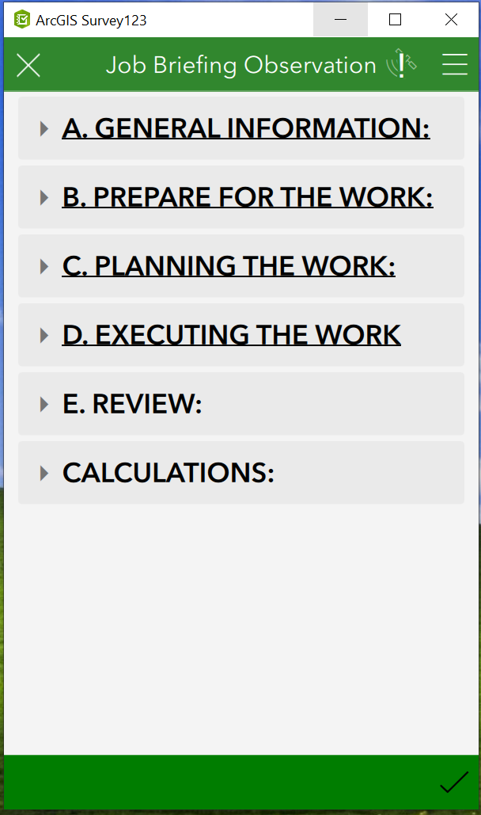

**Appendix B-2**

**Job Site Safety Audit (JSA)**

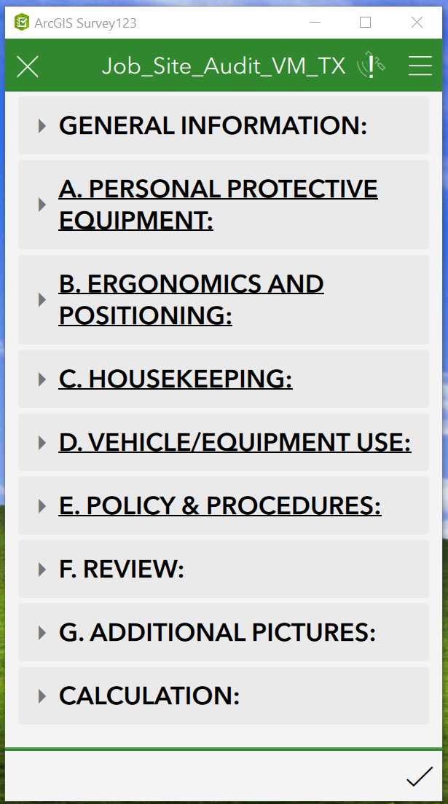

**Appendix B-3**

**Job Site Work Audit**

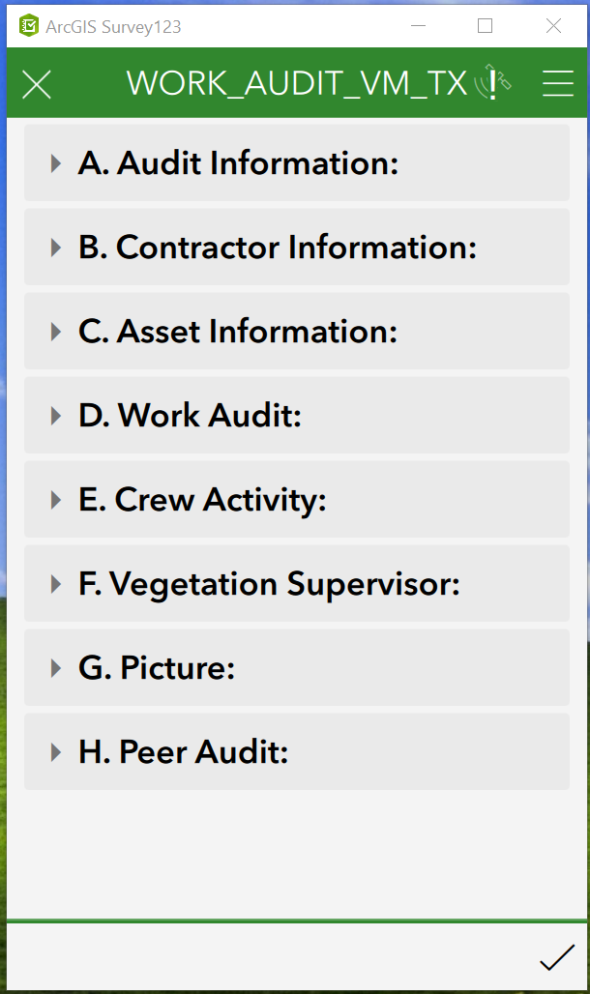

**Appendix B-4**

**Herbicide Efficacy Work Audit**

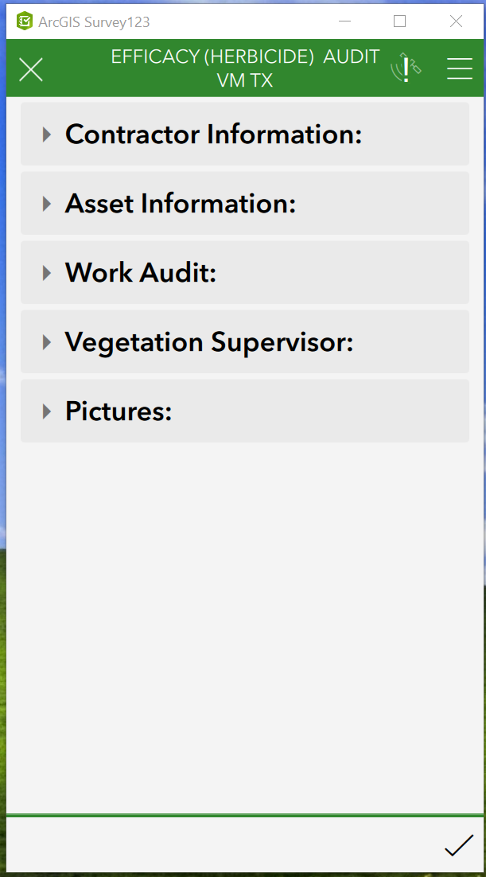

**Appendix C-1**

**Contractor Scorecard**

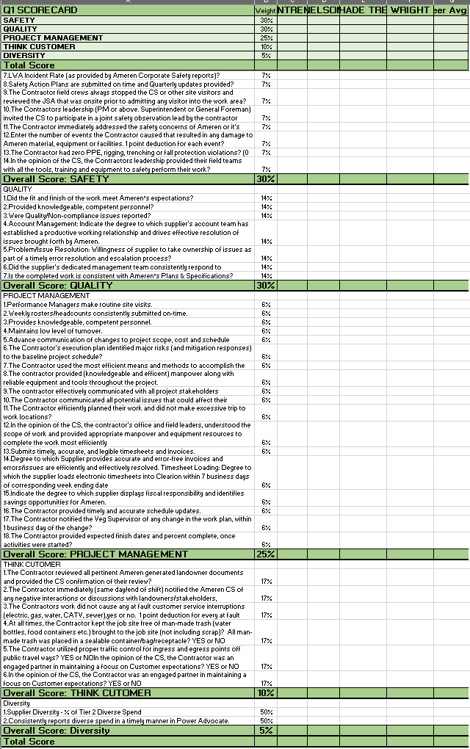

1. Encroachments are defined in VMP-R1 section 2.1