Exhibit No.:
Issues: Weather Normalization

Witness: George Chikhladze
Sponsoring Party: MO PSC Staff
Type of Exhibit: Direct Testimony
Case No.: ER-2004-0570
Date Testimony Prepared: September 20, 2004

MISSOURI PUBLIC SERVICE COMMISSION

UTILITY OPERATIONS DIVISION

DIRECT TESTIMONY

OF

GEORGE CHIKHLADZE

THE EMPIRE DISTRICT ELECTRIC COMPANY

CASE NO. ER-2004-0570

Jefferson City, Missouri
September 2004
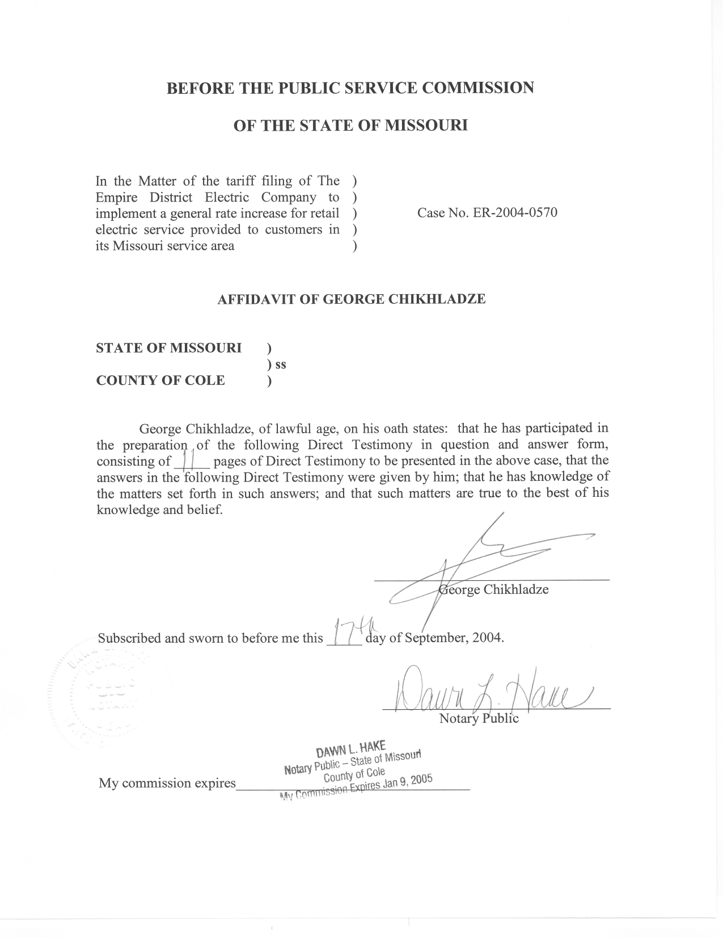

TABLE OF CONTENTS

Personal, Educational and Work Experience 1
Introductory Summary 2
Products 3
Background 4
Method 9
Crosschecks 10

DIRECT TESTIMONY

OF

GEORGE CHIKHLADZE

THE EMPIRE DISTRICT ELECTRIC COMPANY

CASE NO. ER-2004-0570

Personal, Educational and Work Experience
Q. Please state your name and business address.
A. My name is George Chikhladze and my business address is Missouri Public Service Commission, P.O. Box 360, Jefferson City, Missouri, 65102.
Q. What is your present position with the Missouri Public Service Commission (Commission)?
A. I am a Regulatory Economist in the Energy Department of the Utility Operations Division.
Q. Please review your educational background and work experience.
A. I received undergraduate training in Economics (University of Missouri, BA, 2000) and completed MA in Economics and MS in Applied Mathematics (University of Missouri-Columbia, 2003). I joined the Staff of the Commission in April 2004. I have worked closely with Dennis Patterson and other staff members in the Energy Department since my arrival at PSC. I have become familiar with methods of analysis and weather data developed by the Staff. I taught introductory economics at the University of Missouri-Columbia as a teaching assistant and participated in several industrial workshops.

Introductory Summary
Q. What is the purpose of your direct testimony?
A. The topic is weather normalization of test year electricity sales. A key question I focus on in my testimony is whether temperatures from the Springfield Regional Airport (SGF) should be used to perform the weather normalization in this case. I have concluded that they should. I will explain the Staff’s method of using NOAA temperature normals and supported products to create a thirty-year history of daily maximum temperatures (Tmax) and daily minimum temperatures (Tmin) for SGF that are consistent with the Tmax and Tmin observations that were measured at SGF during the test year. Where it is not otherwise explained, the term “temperatures” will refer to daily Tmax and Tmin observations.
Q. What are the products you have provided to other Staff witnesses in this case?
A. I provided SGF temperatures to Staff witness Richard J. Campbell. This included an observation of each day’s temperatures for all days from January 1, 1971 through March 31, 2004. The daily temperatures dating from January 1, 1971 through December 31, 2000 contain adjustments that bring them into agreement with published normals from the National Oceanic and Atmospheric Administration (NOAA). The large data set containing these daily temperatures for SGF is provided in my work papers. In his direct testimony, Mr. Campbell explains how he used this information to calculate normal weather variables.
Q. What is the method you used for your calculations?
A. The method I used for calculating historical SGF temperatures in this case is consistent with that used in previous cases. The Commission accepted this methodology in the Report and Order for the Missouri Gas Energy rate case, Case No. GR-96-285. Staff economist Dennis Patterson developed the method in 1992 and has continued to apply it consistently since 1994 for weather normalization in electric, natural gas and water cases. Since joining the Commission, I have become familiar with the method. I have also double-checked Mr. Patterson’s results which were used in the current case, and have adopted these results in my direct testimony.
Q. How is your direct testimony organized?
A. The remainder of my written direct testimony is organized as follows:
Introductory Summary
Products
Background
Method
Crosschecks

Products
Q. What products did you provide to other Staff witnesses?
A. The products relevant to this case are SGF daily Tmax and Tmin for the test year and adjusted SGF daily Tmax and Tmin for the thirty years, 1971-2000. These data have been prepared for the purpose of calculating unbiased daily normal temperatures, and are included in my workpapers. I provided them to Staff witness Richard Campbell who used the 1971-2000 adjusted Tmax and Tmin to derive normal weather.
Q. What products have you provided as part of your direct testimony?
A. Since the SGF daily temperature data are voluminous, I have provided three summaries for the Commissioners. For brevity in the presentation of these summaries, I have calculated daily average temperatures (Tavg) as the average of daily Tmax and Tmin, where Tavg = (Tmax + Tmin)/2. I have also calculated monthly Tavg as the average of daily Tavg for each month.
Q. What is the first summary you have provided?
A. The first summary is adjusted monthly Tavg for all the months between January 1971 and March 2004 (Schedule 1-1). Schedule 1-1 was calculated from the adjusted temperatures I provided to Mr. Campbell.
Q. What is the second summary that you have provided?
A. The second summary is recorded monthly Tavg for all the months between January 1971 and March 2004 (Schedule 1-2). Schedule 1-2 was calculated from recorded daily temperatures before they had been adjusted to make them consistent with temperatures as they are currently measured at SGF.
Q. What is the third summary that you have provided?
A. The third summary, found at Schedule 1-3, is the difference between the adjusted Tavg in Schedule 1-1 and the recorded Tavg in Schedule 1-2. These differences represent the sums of the adjustments that I applied to each daily Tmax and Tmin between 1 January 1971 and 31 December 2000.

Background
Q. Why have you chosen to recommend that SGF weather be used for weather normalization in this case?
A. I chose to use the SGF weather station because SGF is a first-order weather station for which the data of the highest quality is available, because both a complete daily weather history and NOAA normals products are available, and because SGF is near the EDE service area.
Q. Did you consider other weather stations in the EDE service area?
A. Yes, I also considered the Joplin FAA Airport (JLN) weather station.
Q. Why did you choose SGF over JLN?
A. The JLN weather data had numerous missing values during the 1971-2000 normals period, including temperatures for those dates that were near-record cold days at neighboring stations. The SGF data were complete.
Q. What is a first-order weather station?
A. A first-order weather station is usually located at a regional or municipal airport, where professional observers continuously monitor the weather instruments. The instruments record hourly observations of precipitation, temperature, dew point, wind and other weather elements, as well as the daily maximum and minimum temperatures. In contrast, cooperative weather stations are usually manned by trained volunteers who record daily observations.
Q. How are daily Tmax and Tmin observations collected?
A. At SGF, special modern instruments are used to measure and record the 24-hour instantaneous extreme temperatures electronically. Observed daily Tmax and Tmin are forwarded to NOAA where they are subjected to quality checks. When the quality checks are complete, they are published on the Internet and printed in monthly official publications. (NOAA “Local Climatological Data,” National Climatic Data Center, Federal Building, Asheville, NC). Monthly averages of Tmax, Tmin are published at the same time as the daily temperatures for a month are published.
Q. Why have you chosen to base your analysis on NOAA normals products for the 1971-2000 normals period?
A. I chose to use the 30-year, 1971-2000 weather normals period, and to base all adjustments to historical data on NOAA normals products for this period, because they represent the best climatological analysis that is available to the Staff. Also, the use of the NOAA 30-year normals and 30-year normals period complies with a provision of the Commission’s Report and Order in the Missouri Gas Energy rate case, Case No.
GR-96-285, which is the most recent Commission finding on the subject. At page 18, the Commission’s Report and Order states: “The Commission finds that NOAA’s 30-year normals is the more appropriate benchmark… In addition, the data upon which Staff’s recommendation is based has gone through the process established by NOAA to ensure the best data possible.”
Q. Why was it necessary to apply adjustments to historical temperature observations?
A. SGF has a first-order weather station. When monthly temperatures normals are calculated for first-order stations and for most cooperative stations, special measures are taken to insure that all years of monthly temperatures in the calculations are consistent. To achieve this consistency, NOAA makes adjustments to the historical monthly temperatures for the effects of exposure changes e.g., changes in observation practices, instrument type, or instrument location.
Q. Have exposure changes occurred at SGF?
A. Yes. Examination of the data shows that NOAA applied exposure change adjustments dating backward in time from 1978, 1984, 1990 and 1995. The adjustments were applied to monthly Tmax and Tmin from the years before 1996, and were intended to cause the earlier temperature readings to correspond with those from the current weather instrument installation at SGF, namely, the Automated Surface Observing System (ASOS). Consequently, temperatures for the years from 1996 forward are the baseline, and contain no adjustments. My calculations of adjusted monthly Tavg, recorded monthly Tavg, and adjustments calculated as the difference between the two (adjusted minus recorded) are displayed at Schedule 1-1 through 1-3 respectively. The more detailed adjustments for monthly averages of Tmax and Tmin are included in my workpapers.
Q. What was the source of NOAA’s adjusted temperatures?
A. These are published as data files for users of the current NOAA weather normals (“TD-9641: 1971-2000 Sequential Temperature and Precipitation”. Asheville, North Carolina: National Climatic Data Center, NOAA/NESDIS/NCDC, Federal Building, 37 Battery Park Avenue, Asheville, NC 28801-2733). I will call these the “Monthly Sequentials” for brevity.
Q. How did you use the Monthly Sequentials?
A. The Monthly Sequentials provided benchmark for calculating adjusted daily Tmax, Tmin and Tavg for Staff witness Richard J. Campbell to use in calculating normal weather values for use in weather normalization. NOAA climatologists tabulate 30 years of actual (recorded) monthly average maximum and minimum temperatures for each weather station from the recorded daily observations. The resulting 360 monthly observations are adjusted for exposure changes at the end of each decade to make them consistent with the most recent measurement conditions.
Q. What is an official weather normal?
A. An official weather normal is simply an average of properly adjusted observations of a weather element calculated over a prescribed period of time by government climatologists. NOAA applies this concept to temperature by calculating 30-year temperature normals as monthly averages for Tmax, Tmin and Tavg. NOAA’s normal temperatures for each of the 12 calendar months for SGF are calculated as the average of the NOAA monthly sequentials, over thirty years. The end product is called NOAA thirty-year monthly temperature normals (Climatography of the United States No. 81 Monthly Station Normals of Temperature, Precipitation, and Heating and Cooling Degree Days, 1971-2000, 23 MISSOURI, NOAA, National Environmental Satellite, Data and Information Service, National Climatic Data Center, Asheville, NC).
Q. Does NOAA provide calculations of normal daily Tmax and Tmin?
A. Yes. NOAA calculates 365 daily normal temperatures as one of the official normals products. However, these are calculated by reading from a smooth curve fitted to the 12 monthly normals of Tmax and Tmin. Unfortunately, such daily normals would not be appropriate for the purpose of normalizing electricity usage because the expected variance between days of the year has been smoothed away. Staff witness Richard Campbell instead calculates 365 daily normal temperatures using the method he describes in his direct testimony.
Q. What is the thirty-year period for which NOAA calculates normal temperatures?
A. For the current edition of the 30-year temperature normals NOAA uses the three most recent decades, which are the thirty years ending December 31, 2000. International agreements among member nations of the World Meteorological Organization, and its predecessor, the International Meteorological Committee, have established that three-decade periods are appropriately long and uniform periods for the calculation of normals (World Meteorological Organization, 1989: Calculation of Monthly and Annual 30-Year Standard Normals, WCDP-No. 10, WMO-TD. 341, Geneva: World Meteorological Organization.). NOAA recalculates 30-year normals at the end of each decade as a way of dealing with known changes in measurement conditions and possible changes in the climate itself.

Method
Q. How did you calculate adjusted daily Tmax, Tmin and Tavg for the years 1971-2000?
A. I applied discrete monthly adjustments to daily Tmax and Tmin for each of the 360 months in the thirty-year period, 1971-2000. I then calculated adjusted Tavg as the simple average of each day’s adjusted Tmax and Tmin.
Q. Does NOAA publish such monthly adjustments?
A. No. NOAA does not publish the monthly temperature adjustments for the 1971-2000 normals period for SGF. However, the user of the data can calculate the adjustments as differences between recorded monthly temperatures and adjusted monthly temperatures from NOAA normals products.
Q. What were the sources of your temperature information?
A. As mentioned above, adjusted monthly temperatures for SGF are published in NOAA’s Monthly Sequentials. Recorded monthly average Tmax and Tmin were obtained by averaging the daily observations of those temperatures in each month. The source for unadjusted observations of Tmax and Tmin at SGF was the Midwestern Regional Climate Center Website (MRCC), one of NOAA’s regional climate centers.
Q. Does the MRCC provide reliable data?
A. Yes. The data are certified as official by NOAA. However, data from the individual station is subjected to quality control procedures, so that some observations may be initially missing or subsequently rejected. In cases where some observations are missing for a given station, averages of the corresponding values from three alternate weather stations are used. The detailed process and alternate weather stations are discussed in my workpapers.
Q. Is it possible that exposure changes might occur after the 30-year temperature normals have been calculated and published?
A. Yes. Since NOAA makes adjustments to the monthly average temperatures only at the end of each decade, additional and independent efforts must be made by Staff to insure the data consistency in case any exposure changes were documented during the given time period. However, there have not been any instrument moves or type changes at SGF since the 1971-2000 monthly sequentials were published. Thus the use of unadjusted weather data from MRCC covering the period from 2001 up through the test year is justified.

Crosschecks
Q. Did you perform crosschecks to verify that your temperature products corresponded with NOAA normals products?
A. Yes. I verified that the adjusted monthly averages of the daily maximum and minimum temperatures were equal to the monthly sequential temperatures used by NOAA to calculate its 30-year temperature normals. I also verified that the twelve 30-year monthly averages of the adjusted daily temperatures were equal to NOAA’s 12 monthly normal temperatures for SGF. The crosschecks were successful in this case, thus insuring that the adjusted daily temperature products that I supplied to
Mr. Campbell, which are the temperatures he used to calculate the normal weather variables in the present case, did indeed correspond with the NOAA’s 1971-2000 thirty-year normals. The spreadsheets where these crosschecks were calculated appear in my workpapers.
Q. What is your recommendation to the Commission?
A. I recommend that Springfield temperature data, including Staff’s adjustments to the daily weather temperature based off of NOAA’s adjustments over the normals period 1971-2000, be used in the present case.
Q. Does this conclude your direct testimony?
A. Yes, it does.

