Exhibit No.:
Issues: Other Telephone Issues

Witness: Bill Peters
Sponsoring Party: MO PSC Staff
Type of Exhibit: Rebuttal Testimony
Case No.: AO-2004-0036
Date Testimony Prepared: May 18, 2004

MISSOURI PUBLIC SERVICE COMMISSION

UTILITY OPERATIONS DIVISION

REBUTTAL TESTIMONY

OF

BILL PETERS

THE HEART OF AMERICA UNITED WAY, INC.

CASE NO. AO-2004-0036

Jefferson City, Missouri
May 2004
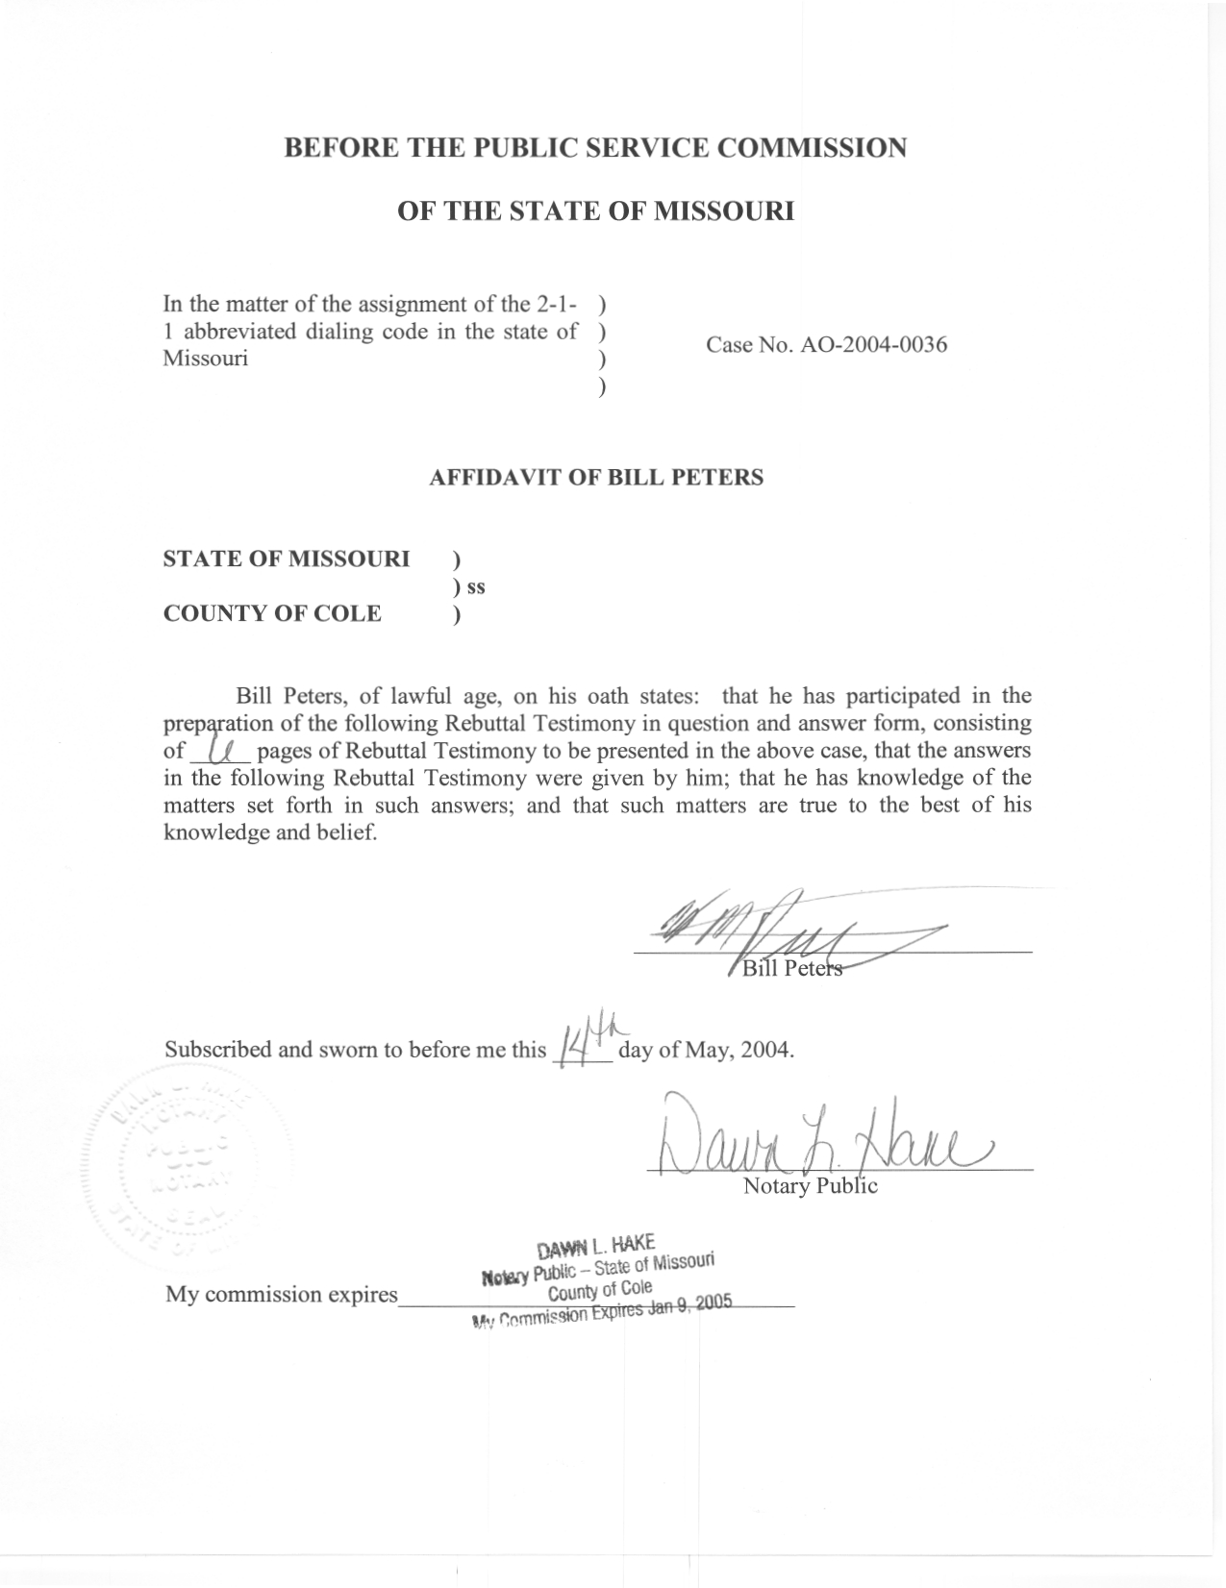

REBUTTAL TESTIMONY

OF

BILL PETERS

THE HEART OF AMERICA UNITED WAY, INC.

CASE NO. AO-2004-0036

Q. Please state your name and give your business address.
A. My name is Bill Peters and my business address is Post Office Box 360, Governor Office Building, Suite 500, 200 Madison Street, Jefferson City, Missouri 65102-0360.
Q. By whom are you employed?
A I am employed by the Missouri Public Service Commission (PSC or Commission).
Q. How long and in what capacity have you been employed at the Commission?
A. I was hired as a Regulatory Economist for the Telecommunications Department Staff (Staff) in September 2001.
Q. Describe your educational background and employment history.
A. I received a B.S. in Economics from Illinois State University in August of 1998 and an M.S. in Applied Economics from the same institution in May of 2001. My Master’s sequence was “Regulation of Public Utilities: Telecommunications, Electricity and Natural Gas.” In between my degrees, I volunteered with Peace Corps – Armenia as an instructor of Economics and English at Shirak University in Gumri, Armenia. Also, after returning from the Peace Corps, I completed a four-month internship at the Citizens Utility Board, a consumer advocacy organization, in Chicago, IL.
Q. What are your duties at the Commission?
A. Since beginning employment with the Commission, I have reviewed, analyzed and written recommendations for various case filings, tariff filings and interconnection agreements. Filings are reviewed and recommendations are written to ensure consistency with the public interest, Missouri and Federal rules and regulations. I have also reviewed cost studies, prepared Commission rules, conducted general research related to telecommunications and economics, and worked on Commission projects such as an Industry Task Force Report on VoIP.
Q. Have you previously testified before the Commission?
A. Yes, I testified in Case No. TO-2002-222, In the Matter of the Petition of MCImetro Access Transmission Services LLC, Brooks Fiber Communications of Missouri, Inc., and MCI WorldCom Communications, Inc., for Arbitration of an Interconnection Agreement With Southwestern Bell Telephone Company Under the Telecommunications Act of 1996, and IT-2004-0015, In the Matter of Southwestern Bell Telephone Company, d/b/a SBC Missouri’s Proposed Revised Tariff Sheet Intended to Increase by Eight Percent the Rates for Line Status Verification and Busy Line Interrupt as Authorized by Section 392.245, RSMo, the Price Cap Statue. I have also filed testimony in Case TC-2002-1076, Staff of the Missouri Public Service Commission, Complainant, v. BPS Telephone Company, Respondent.

Issue Discussion
Q. What is the purpose of your testimony?
A. My testimony will respond to the Direct Testimony of W. Thomas Dugard Jr. and explain Staff’s position regarding the Heart of America United Way’s (HAUW) Application to become an authorized 211 provider in the area including and surrounding Kansas City, Missouri.
Q. Does Staff have any concerns with the direct testimony of W. Thomas Dugard Jr.?
A. No. Staff provides Rebuttal Testimony as additional support for HAUW’s application.
Q. What work have you done as a result of HAUW’s application?
A. Since HAUW’s initial Application to provide 211 service, I have conducted broad research on 211 and other abbreviated dialing codes. This research included studying what actions the FCC and other states have taken on 211. I have reviewed relevant portions of the FCC’s July 21, 2001 Third Report And Order And Order On Reconsideration as well as material from TN, GA, FL, MI, WI, OH, VT, NC, MN, CA, and TX. Research was focused on existing 211 systems and other state laws/procedures in order to draft a Commission rule regarding 211. I also reviewed the 211 tariffs and associated cost support filed by SBC on June 20, 2003 and Sprint on March 3, 2004. SBC subsequently withdrew its proposed tariff filing, and Sprint’s tariff filing became effective March 31, 2004.
Q. Did you work on the recently published proposed Commission rule 4 CSR 240-32.200 General Provisions for the Assignment, Provision and Termination of 211 Service and its companion emergency rule?
A. Yes, under the direction of the Commission and with the help of Staff Economist Natelle Dietrich, I drafted these rules.
Q. Since the emergency rule has been effective has HAUW complied with the provisions in that rule?
A. Staff is satisfied with HAUW’s voluntary supplement to its original application. With the supplement to its original application pursuant to Sections 386.250 (2), 386.320, RSMo 2000; 4 CSR 240-2.060, and Emergency Rule 4 CSR 240-32.200, HAUW states that “Applicant is ready and willing to abide by Commission rules, regulations and policies.” Staff has found no reason to disagree with this statement.
Q. Does HAUW possess sufficient managerial, financial and technical ability?
A. Staff found HAUW’s statement of managerial, financial and technical ability, in its supplement to application provided insufficient information for review and subsequently requested HAUW provide additional details in support of this statement. In response to Staff’s Data Request, HAUW provided a more detailed explanation of HAUW’s technical (computer hardware/software/telephone) setup, finances, and staff. According to their supporting documentation, the HAUW has experience implementing and operating 211 service, currently has sufficient technical resources to operate the service, has significant experience raising funds to support initiatives such as 211, expects to be fully compliant with acknowledged I&R standards [Alliance of Information & Referral Systems (AIRS)], and employs an AIRS certified I&R specialist with 26 years of I&R experience. After reviewing these qualifications, Staff agrees with HAUW’s statement that it possesses the managerial, financial and technical ability to provide 211 service as an authorized Missouri I&R provider.
Q. Is implementing the abbreviated dialing code 211 for Information & Referral Services in the interest of Missourians?
A. If Missouri’s citizens are adequately informed of the availability and nature of 211, its implementation can only make accessing human services easier. Although these services may already be available, anecdotal evidence suggests that implementing an abbreviated dialing code could significantly increase awareness and use. After switching from the relatively easy to remember 333-3333 to 511, the Cincinnati, OH metropolitan area’s travel information hotline, Advanced Regional Traffic and Information System (ARTIMIS), saw a significant increase in call volume. It should be noted that an advertising campaign was a part of 511 deployment in the area. Further, just as it is now nearly second nature to dial 911 in case of an emergency, if 211 is eventually made available in the rest of the United States, citizens will find it easier to move about the nation and still find easy access to human services information.
Q. Will HAUW serve affected Missourians in accordance with Commission rules?
A. I believe so. HAUW has stated in its supplemental application that it will abide by Commission rules, regulations, and policies. HAUW will provide Missourians a valuable resource if it abides by this statement of conduct.
Q. Does Staff have any concerns with HAUW’s application?
A. Staff has just one procedural concern. HAUW asks for authority to provide 211 service in exchanges within the counties of Andrew, Buchanan, Dekalb, Clinton, Caldwell, Platte, Clay, Ray, Jackson, Lafayette, Cass, Johnson, Saline, Pettis, Bates and Henry, Missouri. According to the 211 emergency rule (4 CSR 240-32.200), the Commission issues I&R Provider authorization by telephone exchange, and applications for such authorization should include a statement that sets forth the exchange(s) to be served. Staff is working with HAUW to specify the telephone exchanges in which it is seeking authority to provide 211 service.
Q. Who will pay for the provisioning of 211 service?
A. According to the Commission’s emergency 211 rules, the authorized Missouri I&R Provider, in this case HAUW, will pay for the provisioning of service. Additionally, according to the rule, end users will not be charged for dialing 211.
Q. Does Staff support HAUW’s application to become an authorized 211 provider?
A. Yes.
Q. Does this conclude your testimony?
A. Yes it does.

FCC 00-256 - In the Matter of Petition by the United States Department of Transportation for Assignment of an Abbreviated Dialing Code (N11) to Access Intelligent Transportation System (ITS) Services Nationwide (NSD-L-99-24) - Request by the Alliance of Information and Referral Systems, United Way of America, United Way 211 (Atlanta, Georgia), United Way of Connecticut, Florida Alliance of Information and Referral Services, Inc., and Texas I&R Network for Assignment of 211 Dialing Code (NSD-L-98-80) - The Use of N11 Codes and Other Abbreviated Dialing Arrangements (CC Docket No. 92-105)

