April 8, 2025

***Via EFIS***

Nancy Dippell, Secretary

Missouri Public Service Commission

200 Madison Street, PO Box 360

Jefferson City, MO 65102-0360

RE: Consolidated Communications Enterprise Services, Inc. - Tariff Cancellation – P.S.C. Tariff No. 6, Exchange Access Services

Dear Secretary:

This filing is to cancel the Consolidated Communications Enterprise Services, Inc. P.S.C. Tariff No. 6 Exchange Access Tariff. On November 30, 2022, Consolidated Communications Enterprise Services, Inc. (the “Company”) concluded a transaction where it sold the assets comprising the Kansas City metropolitan area competitive local exchange carrier business to Everfast Fiber Networks, LLC (“Everfast”). On October 6, 2022, in Docket TA-2023-0124, the Commission authorized Everfast to provide telecommunications service in Missouri as a competitive local exchange carrier and as an interexchange carrier. The Consolidated Communications Enterprise Services, Inc. P.S.C. Tariff No. 6 Exchange Access Tariff was applicable to the assets that were sold to Everfast and is no longer needed by the Company.

The remaining active Consolidated Communications Enterprise Services, LLC competitive local exchange carrier utilizes P.S.C. Tariff No. 3 for intrastate access services.

Please contact me at the number above or at [carole.williamson@consolidated.com](mailto:carole.williamson@consolidated.com) with any questions or concerns regarding this filing.

Thank you for your assistance in this matter. Regards,

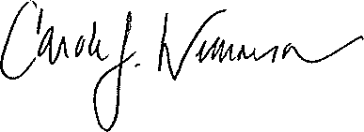

Carole J. Williamson