Before the Public Service Commission
Of the State of Missouri

Donita Tegeler,  Complainant,  v.  Laclede Gas Company,  Respondent. | ))))))))) | Case No. GC-2003-0212

MOTION FOR EXTENSION OF TIME
COMES NOW the Staff of the Missouri Public Service Commission (Staff) and for its Motion for Extension of Time states:
1. On December 20, 2002, Donita Tegeler filed a complaint against Laclede Gas Company alleging that she had been improperly billed and treated rudely by Laclede’s customer service representatives.
2. On February 5, 2003, Laclede filed its Answer and Motion to Dismiss the complaint stating that it was difficult to fully comprehend Ms. Tegeler’s complaint. In its Answer and Motion, Laclede generally denied all of Ms. Tegeler’s claims or averred that her claims had been satisfied.
3. The Commission issued its Order Directing Filing of a Staff Investigation Report directing Staff to file its report on February 23, 2002.
4. Staff requests that the Commission extend the time for filing its Investigation Report until March 23, 2003 to allow time to do a complete investigation including submission of data request and review of records, as well as completion of interviews if necessary.
WHEREFORE Staff requests that the Commission extend the time for Staff to file its Investigation Report.
Respectfully submitted,

DANA K. JOYCE
General Counsel
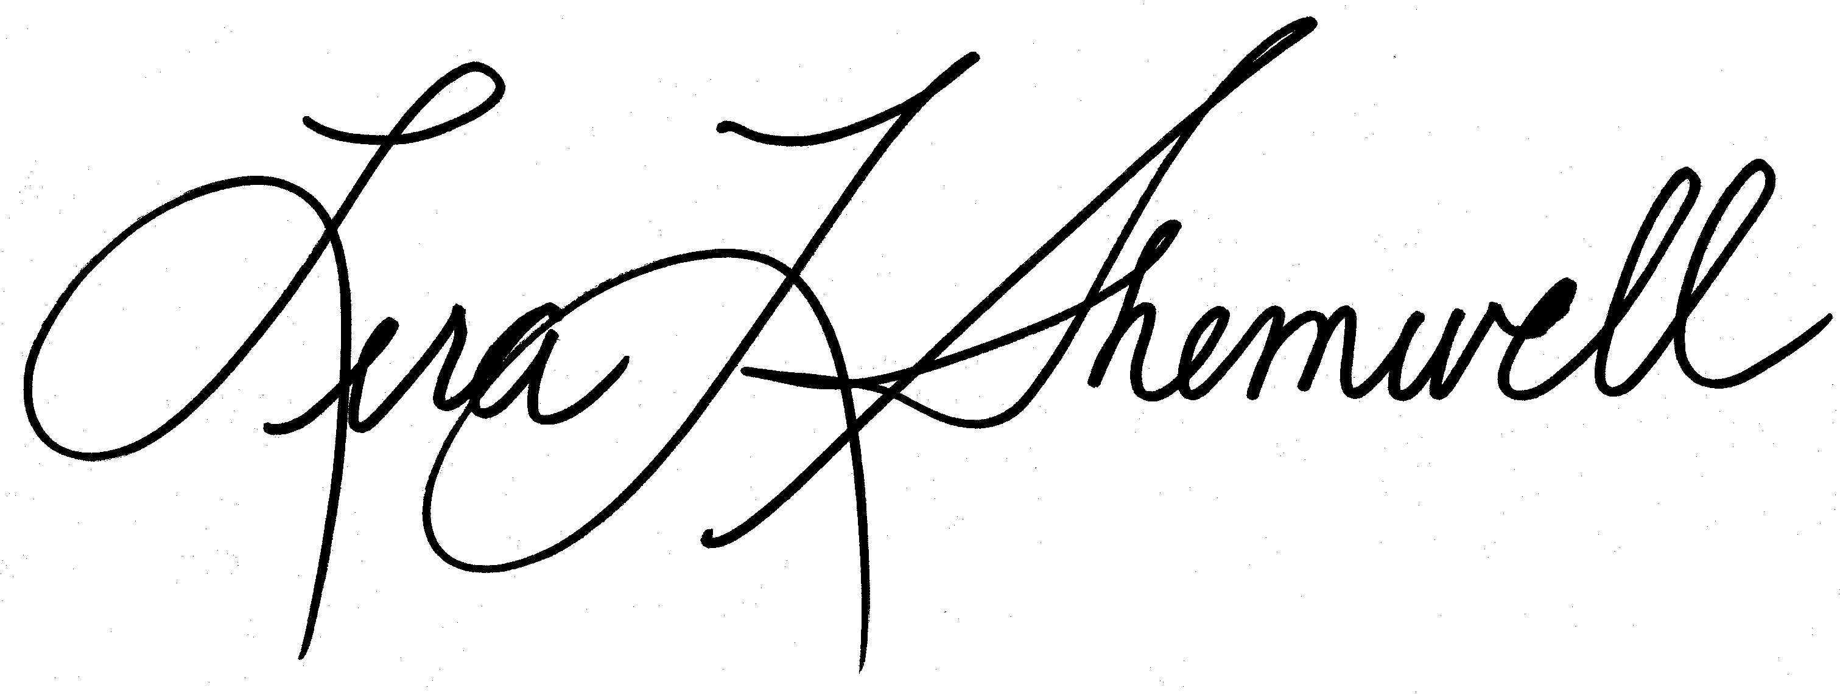
Lera L. Shemwell
Associate General Counsel Missouri Bar No. 43792

Attorney for the Staff of the
Missouri Public Service Commission
P. O. Box 360
Jefferson City, MO 65102
(573) 751-7431 (Telephone)
(573) 751-9285 (Fax)
lerashemwel@psc.state.mo.us

Certificate of Service

I hereby certify that copies of the foregoing have been mailed or hand-delivered to all counsel of record as shown on the attached service list this 19th day of February, 2003.

