Exhibit No.:
Issues: Purchasing Practices-Neelyville District; Purchasing Practices-Consolidated District; Deferred Carrying Cost Balance; and Propane

Witness: Anne M. Allee
Sponsoring Party: MoPSC Staff
Type of Exhibit: Direct Testimony
Case Nos.: GR-2001-396 and GR-2001-397 (Consolidated)
Date Testimony Prepared: December 23, 2002

MISSOURI PUBLIC SERVICE COMMISSION

UTILITY SERVICES DIVISION

DIRECT TESTIMONY

OF

ANNE M. ALLEE

ATMOS ENERGY CORPORATION
CASE NO. GR-2001-396
AND
UNITED CITIES GAS COMPANY
CASE NO. GR-2001-397
(CONSOLIDATED)

Jefferson City, Missouri
December 2002

**Denotes Highly Confidential Information** NP
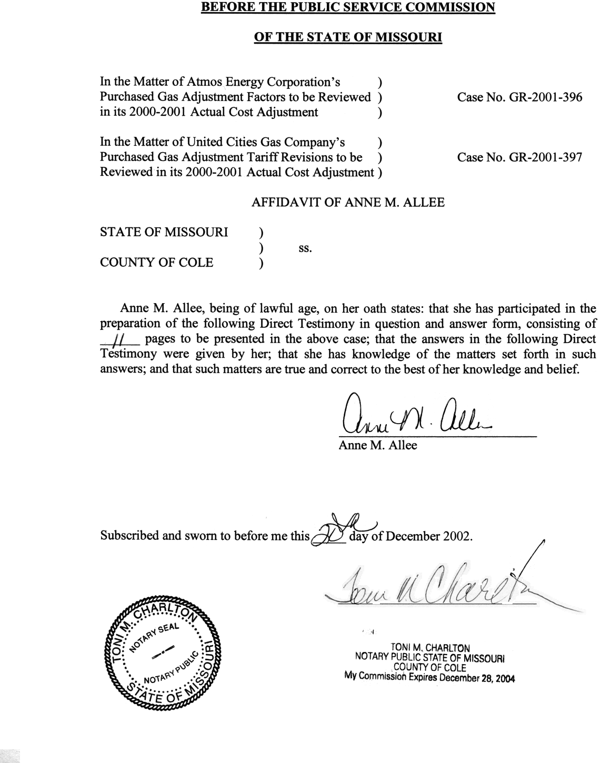

TABLE OF CONTENTS

DIRECT TESTIMONY OF

ANNE M. ALLEE

CASE NOS. GR-2001-396 AND GR-2001-397
(CONSOLIDATED)

DEFERRED CARRYING COST BALANCE (DCCB) 4
PROPANE 4
PURCHASING PRACTICES- NEELYVILLE DISTRICT 5
PURCHASING PRACTICES – CONSOLIDATED DISTRICT 7

DIRECT TESTIMONY
OF
ANNE M. ALLEE
ATMOS ENERGY CORPORATION
CASE NO. GR-2001-396
AND
UNITED CITIES GAS COMPANY
CASE NO. GR-2001-397
(CONSOLIDATED)

- Please state your name and business address.
- Anne M. Allee, P.O. Box 360, Jefferson City, Missouri 65102.
- By whom are you employed and in what capacity?
- I am a Regulatory Auditor with the Missouri Public Service Commission (Commission).
- Please describe your educational and professional background.
- I graduated from the University of Missouri at Columbia with a Bachelor of Science degree in Accounting in 1989. I am currently a licensed Certified Public Accountant in the state of Missouri.
- What has been the nature of your duties while in the employ of the Commission?
- My employment with the Commission began in October 1990 as a Regulatory Auditor in the Accounting Department. My duties included assisting with audits and examinations of the books and records of utility companies operating within the state of Missouri.
In October 1993, I obtained my current position as a Regulatory Auditor in the Procurement Analysis Department. Since that time, my responsibilities include reviewing and analyzing amounts charged by natural gas local distribution companies (LDCs) through the Purchased Gas Adjustment (PGA)/Actual Cost Adjustment (ACA) mechanism.
Q. Have you previously filed testimony before this Commission?
A. Yes, I have previously filed testimony before this Commission. Schedule 1, attached to my direct testimony, is a list of cases and issues in which I have filed testimony.
Q. Did you make an examination and analysis of the books and records of United Cities Gas Company (United Cities or Company) in regard to matters raised in this case?
A. Yes. A review was made to ensure that the gas costs passed on to the consumers through the PGA provisions reflects the Company’s actual cost of gas. I also reviewed the Company’s purchasing practices to determine the prudence of the Company’s purchasing decisions.
Q. What matters will you address in your testimony?
A. I will address issues identified in Staff’s August 29, 2002 ACA recommendation for the former United Cities in Case GR-2001-397; specifically the sections of the Staff recommendation entitled “Deferred Carrying Cost Balance (DCCB),” “Propane,” “Purchasing Practices – Neelyville District,” and “Purchasing Practices – Consolidated District.” Subsequent to the filing of the Staff’s recommendation, United Cities Gas Company changed its name to Atmos Energy Corporation. In addition, Case No. GR-2001-397 has been consolidated with Atmos Energy Corporation’s 2000-2001 ACA case, Case No. GR-2001-396. Case No. GR-2001-396 has been designated the lead case number. The direct testimony of Staff witness Phil Lock will address issues identified in the Staff’s September 30, 2002 ACA recommendation Case No. GR-2001-396.
Q. What knowledge, skill, experience training or education do you have in these matters?
A. Since my time in the Procurement Analysis Department, I have performed and/or assisted in performing approximately 30 ACA reviews. I have evaluated the prudence of an electric company’s gas purchasing practices. In two merger cases, I reviewed the impact of mergers on the LDC’s gas procurement function. In an application case, I calculated the Staff’s level of gas costs to be included in determining the applicant’s viability and reviewed the reliability of natural gas supply and transportation. In addition, I have attended conferences on the mechanics of financial instruments and have assisted in reviewing the results of a futures market pilot program operated by an LDC in the state.
Q. What is the purpose of your direct testimony?
A. My direct testimony addresses the hedging adjustment found in the Purchasing Practices-Neelyville District and the Purchasing Practices-Consolidated District of the Staff ACA recommendation in Case No. GR-2001-397. I also address the calculation of the storage adjustment proposed in the Purchasing Practices-Consolidated District section of the ACA recommendation in Case No. GR-2001-397. The direct testimony of Staff witness Lesa Jenkins provides support for the proposed hedging and storage adjustments discussed in my direct testimony.
Q. Please describe the service areas of United Cities during your ACA review.
A. United Cities separates its gas operations into the Consolidated and Neelyville Districts. The Consolidated District is composed of the historical Hannibal/Canton, Palmyra and Bowling Green districts and serves approximately 15,200 customers in the northeastern part of Missouri. The Neelyville District serves approximately 600 customers in the southeastern part of the state.

DEFERRED CARRYING COST BALANCE (DCCB)
- Please explain the Staff’s adjustment related to the DCCB.
- The Staff made adjustments to the Company ACA balances to reflect the miscalculation of carrying costs applied to the DCCB in the Neelyville and Consolidated Districts.
- Is this an issue in this case?
- No. In Atmos Energy Corporation’s Response To Staff Recommendation, the Company states that it will accept Staff’s recommendation in regard to the calculation of the DCCB.

PROPANE
- Please explain the Staff’s adjustment in regard to propane.
A. The Staff reduced the Company’s gas costs to remove propane costs included in its ACA filing. The propane service provided by United Cities is a non-regulated service and any associated costs should not be included in the ACA filing.
Q. Is this an issue in this case?
A. No. In Atmos Energy Corporation’s Response To Staff Recommendation, the Company states that it will accept Staff’s recommendation in regard to propane.

PURCHASING PRACTICES- NEELYVILLE DISTRICT
- Please explain why the Staff proposed an adjustment to the Neelyville District’s gas costs?
- In this ACA period, United Cities did not have a documented hedging plan. In the Staff’s opinion, a hedging strategy should be included in the Company’s gas procurement process. Additionally, the Staff believes that it is reasonable to expect United Cities to hedge a minimum level of its natural gas purchases for the winter months of the ACA period. The Staff believes the Company should have taken steps to hedge at least 30% of its normal monthly requirements for each month during November 2000 through March 2001. The direct testimony of Staff witness Jenkins will address the reasoning for Staff’s opinion that a minimum hedge of 30% of normal monthly requirements is a reasonable expectation.
- Please explain what you mean when you use the term “hedging.”
- I use the term hedging to mean techniques used by an LDC to reduce its exposure to price risk or price volatility. Financial instruments and storage are some tools an LDC can use to fix its costs prior to the heating season. Hedging allows the Company to make the cost of gas to its customers more stable over time than they would be otherwise. In particular, hedging allows the Company to provide its customers some protection from price spikes during the heating season when they occur. Hedging mechanisms can also be included in the gas contracts in the form of provisions that fix or cap the price of gas.
- Please explain what you mean by the term “financial instruments.”
A. Futures and option contracts are financial instruments. Futures contracts allow the LDC to lock in or fix the price of future gas purchases. While a futures contract fixes the price of gas, an option contract establishes a ceiling for the price of gas. Both futures and option contracts are tools an LDC can use to hedge the price of gas.
Q. Please explain how storage can be used as a hedge.
A. LDCs generally inject gas into storage during the summer months for withdrawal in the winter months. Storage provides an effective hedge because it fixes the cost of gas prior to the heating season. Therefore, the Company knows the cost of this portion of its requirements prior to the heating season. Gas withdrawn from storage during the winter has a known, fixed price and thus helps protect against price spikes.
Q. Please explain the Company’s monthly planned hedged volumes of gas.
A. The planned monthly hedged volumes are the Company’s normal planned monthly storage withdrawals plus any other hedging mechanisms used by the Company. In this district, storage was the only hedging mechanism used by the Company during the winter of 2000-2001.
Q. Please explain the calculation of the Staff’s proposed hedging adjustment.
A. The Staff compared the Company’s monthly planned hedged volumes to 30% of normal monthly requirements in order to determine if the Company met the Staff’s hedging expectations. The difference between the monthly planned volumes and the 30% of normal requirements is shown in column H of Schedule 2 (attached to this testimony) and represents the volumes of gas that, in the Staff’s opinion, were unreasonably exposed to price risk. In this district, the Company did not hedge at least 30% of normal requirements in any of the months from November 2000 through March 2001. Column I of Schedule 2 is the additional amount of gas the Company needed to have hedged in order to meet the minimum hedge of 30%.
Since the Company did not hedge these volumes, the Staff then estimated a reasonable price at which the Company could have hedged these volumes prior to the winter of 2000-2001. This price appears in column K of Schedule 2. Next, the Staff subtracts the estimated hedged price from the monthly NYMEX closing price to determine the per unit cost of gas that could have been avoided had the Company hedged 30% of normal requirements. The result of subtracting the estimated hedged price from the NYMEX closing price is shown in Schedule 2 column L and is multiplied by the amount of gas unreasonably exposed to price risk in column I to determine the increased cost to the customers of United Cities because the Company failed to hedge at least 30% of normal monthly requirements.
Q. How did the Staff estimate the price at which the volumes of gas could have been hedged as discussed above?
A. I computed a simple average of the NYMEX closing prices for June 1 through October 30, 2000 for the delivery months of November 2000 through March 2001. This is the estimate of the Company’s price of gas had it hedged the volumes exposed to price risk with a fixed price contract or a futures contract prior to the winter of 2000-2001. The estimated hedged prices are shown in column K of Schedule 2.
Q. What was the result of the calculations discussed above?
A. The result is that the customers paid approximately $15,875 more for gas than they would have paid had the Company hedged at least 30% of normal monthly requirements. Therefore the Staff proposes to reduce the Neelyville gas costs by $15,875.

PURCHASING PRACTICES – CONSOLIDATED DISTRICT
Q. Please explain the Staff’s proposed adjustments.
A. The Staff has proposed two adjustments for the Consolidated district. As in the case of the Neelyville district, the Staff calculated an adjustment for United Cities’ failure to hedge at least 30% of its normal monthly requirements. Additionally, the Staff proposes an adjustment based upon United Cities’ storage operation.
Q. Please explain the why the Staff made an adjustment related to hedging for the Consolidated District.
A. The Staff proposes an adjustment related to hedging for the same reasons stated with respect to the Neelyville District. In this ACA period, United Cities did not have a documented hedging plan. Again, the Staff believes it is reasonable to expect Untied Cities to have hedged at least 30% of its normal monthly requirements for each month from November 2000 through March 2001.
Q. Did the Company use any hedging mechanisms other than storage for the Consolidated District?
A. Yes. In addition to storage, the Company obtained fixed prices for a portion of its winter gas purchases. The volumes of gas purchased using fixed prices are added to the storage withdrawal volumes to determine the Company monthly planned hedged volumes.
Q. Please explain the calculation of the proposed hedging adjustment for the Consolidated District.
A. The calculation is similar to the Neelyville calculation. The Staff compared the Company’s monthly planned hedged volumes to 30% of normal monthly requirements in order to determine if the Company met Staff’s hedging expectations. The result of this comparison is shown in column H of Schedule 3. In this district for the winter of 2000-2001, the Company hedged at least 30% of normal requirements for November, December and January but failed to do so for February and March. Column I of Schedule 3 (attached to this testimony) shows the additional amount of gas the Company needed to have hedged in February and March in order to meet the minimum hedge of 30%.
Since the Company did not hedge these volumes, the Staff then estimates a reasonable price at which the Company could have hedged these volumes prior to the winter of 2000-2001. This estimated price appears in column K of Schedule 3. The Staff then subtracts the estimated hedged price from the monthly NYMEX closing price to determine the per unit cost of gas that could have been avoided had the Company hedged 30% of its normal monthly requirements. The result of subtracting the estimated hedged price from the NYMEX closing price is shown in Schedule 3 column L and is multiplied by the amount of gas exposed to price risk in Schedule 3 column I to determine the increased cost to the customers of United Cities because the Company failed to hedge at least 30% of normal monthly requirements.
Q. What was the result of the calculation discussed above?
A. The result was that the customers paid approximately $105,326 more for gas then they would have paid had the Company hedged at least 30% of normal monthly requirements. Therefore, the Staff proposes reducing the gas costs of the Consolidated District by $105,326.
Q. Please explain why the Staff is proposing a purchasing practices adjustment in regard to storage operation.
- In January and February 2001, United Cities relied too heavily on flowing supplies rather than storage withdrawals and this decision led to higher gas costs in January, February and March 2001. The direct testimony of Staff witness Jenkins addresses the decisions the Company made that led to higher gas costs in January through March 2001. I calculated the costs that could have been avoided had the Company followed a reasonable approach for planned flowing gas and storage withdrawals for November 2000 through March 2001.
Q. Please explain the calculation of the purchasing practices storage adjustment.
A. The Staff calculated the difference between the expected storage withdrawals, based upon a reasonable plan for flowing volumes and storage for each month of the winter season, and the actual storage withdrawals for November 2000 through March 2001. In column N of Schedule 3, the negative numbers in November and December indicate that the Company withdrew more gas from storage than the Staff would have expected. In January, February and March 2001, the positive numbers indicate that the Company withdrew less gas from storage then the Staff would have expected. The direct testimony of Staff witness Jenkins addresses the expected versus actual storage volumes shown in Schedule 3 column N.
The Staff then compared the weighted average cost of storage withdrawals in Schedule 3 column O to the Panhandle Eastern Pipe Line (PEPL) first-of-month (FOM) index price in column P. Schedule 3 column Q shows that the PEPL FOM price of gas was greater than the weighted average cost of storage withdrawals each month. This means that it would have been cheaper to withdraw gas from storage than to buy flowing supplies based upon the PEPL FOM index. (Flowing supplies generally means gas that is purchased for current consumption and not withdrawn from storage). The price difference between storage weighted average cost of gas (WACOG) and PELP FOM in column Q was then multiplied by column N to determine the effect on the cost of gas of withdrawing gas from storage versus buying flowing supplies to meet system requirements. The impact is determined for each winter month and the sum is the total amount of Staff’s proposed adjustment.
The result of this calculation shows that the ratepayers paid $454,763 more than they would have had the Company followed a reasonable approach for planned flowing gas and storage withdrawals.
Q. What is the storage Weighted Average Cost of Gas (WACOG)?
- The storage WACOG is the cost of gas withdrawn from storage weighted by its respective volumes for each storage agreement. In this ACA period the Company used four storage agreements to serve the Consolidated District.
- What is the PEPL FOM?
A. This is the index reported in Inside FERC’s Gas Market Report on the first day of each month. The Staff used the PEPL FOM index because the pricing provisions of the Company’s supply agreements are tied to the PEPL FOM index. This represents the price the Company would pay for flowing supplies.
Q. Please summarize your testimony.
A. The Staff proposes purchasing practices adjustments of $15,875 and $105,326, respectively, to the United Cities Neelyville and Consolidated District gas costs to reflect the hedging activity shortfall during the 2000-2001 winter period. The Staff also proposes a $454,763 purchasing practices adjustment to the Untied Cities Consolidated District gas costs to reflect the negative effect of the Company plans for flowing gas and storage withdrawals.
Q. Does this conclude your testimony?
A. Yes.
SUMMARY OF TESTIMONY

ANNE M. ALLEE

Company Name | Case Number | Issues
Choctaw Telephone Company | TR-91-336 | Payroll; Payroll Taxes; Employee Pensions/Benefits; Voucher Analysis; Other Misc. Expenses
Laclede Gas Company | GR-92-165 | Payroll; Payroll Taxes; Employee Pensions and Benefits
United Cities Gas Company | GR-93-47 | Rate Base; CWC, Dues & Donations; Misc. Expenses
St. Louis County Water Company | WR-93-204 | Rate Base; CWC, Dues & Donations; Misc. Expenses
Ozark Natural Gas Company | GA-96-264 | Cost of Gas per Dth and Reliability of Transportation
Missouri Gas Energy Company | GR-96-285 | Natural Gas
St. Joseph Light and Power Company | GR-96-47 | Gas Purchasing Practices
Union Electric Company | GR-97-393 | Natural Gas Storage Inventory Prices
Missouri Public Service | GR-96-192 | Winter Storage Allocation and Overrun Penalties
Missouri Gas Energy | GR-98-140 | Natural Gas Storage; Inventory Prices
Ozark Natural Gas Company | GR-98-227 | Cost of Gas per Dth and Reliability of Supply and Transportation
St. Joseph Light and Power Company | GR-99-246 | Natural Gas; Inventory Prices
UtiliCorp United Inc. and St. Joseph Light and Power Company | EM-2000-292 | Conditions to be Made Part of Approved Merger

SCHEDULES 2 AND 3
ARE DEEMED
HIGHLY CONFIDENTIAL

IN THEIR ENTIRETY

