Before the Public Service Commission
Of the State of Missouri

Donita Tegeler,  Complainant,  v.  Laclede Gas Company,  Respondent. | ))))))))) | Case No. GC-2003-0212

MOTION FOR EXTENSION OF TIME
COMES NOW the Staff of the Missouri Public Service Commission (Staff) and for its Motion for Extension of Time states:
1. On December 20, 2002, Donita Tegeler filed a complaint against Laclede Gas Company alleging that she had been improperly billed among other allegations.
2. On February 5, 2003, Laclede filed its Answer and Motion to Dismiss the complaint. In its Answer, Laclede generally denied all of Ms. Tegeler’s claims or averred that her claims had been satisfied.
3. The Commission issued its Order Directing Filing of a Staff Investigation Report directing Staff to file its report on February 23, 2002.
4. Staff requests that the Commission issue its order extending the time for filing its Investigation Report until May 30, 2003, to allow time for Staff to complete its investigation, and determine whether the claim has been satisfied.
5. Staff thought that Mrs. Tegeler’s claim against Laclede had been satisfied, but upon further investigation discovered that Mrs. Tegeler is challenging her natural gas bills for two different time periods. Staff needs additional time to complete its investigation into the circumstances surrounding billing during the second period of time and whether there were any agreements between Laclede and Mrs. Tegeler regarding bill payment.
6. Staff has consulted Laclede and contacted Mrs. Tegeler and concerning this request and neither objects.
WHEREFORE Staff requests that the Commission extend the time for Staff to file its Investigation Report until May 30, 2003.
Respectfully submitted,

DANA K. JOYCE
General Counsel
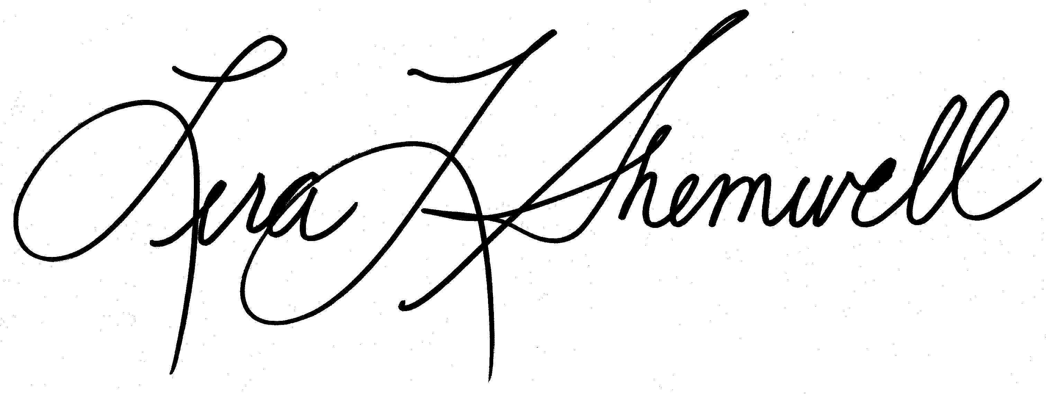
Lera L. Shemwell
Senior Counsel Missouri Bar No. 43792

Attorney for the Staff of the
Missouri Public Service Commission
P. O. Box 360
Jefferson City, MO 65102
(573) 751-7431 (Telephone)
(573) 751-9285 (Fax)
lerashemwell@psc.state.mo.us

Certificate of Service

I hereby certify that copies of the foregoing have been mailed, emailed or hand-delivered to all counsel of record this 30th day of April, 2003.

