Exhibit No.:
Issues: Tariff Issues

Witness: James M. Russo
Sponsoring Party: MO PSC Staff
Type of Exhibit: Direct Testimony
Case No.: GC-2004-0305
Date Testimony Prepared: June 8, 2004

MISSOURI PUBLIC SERVICE COMMISSION

UTILITY OPERATIONS DIVISION

DIRECT TESTIMONY

OF

JAMES M. RUSSO

MISSOURI GAS ENERGY

CASE NO. GC-2004-0305

Jefferson City, Missouri
June 2004
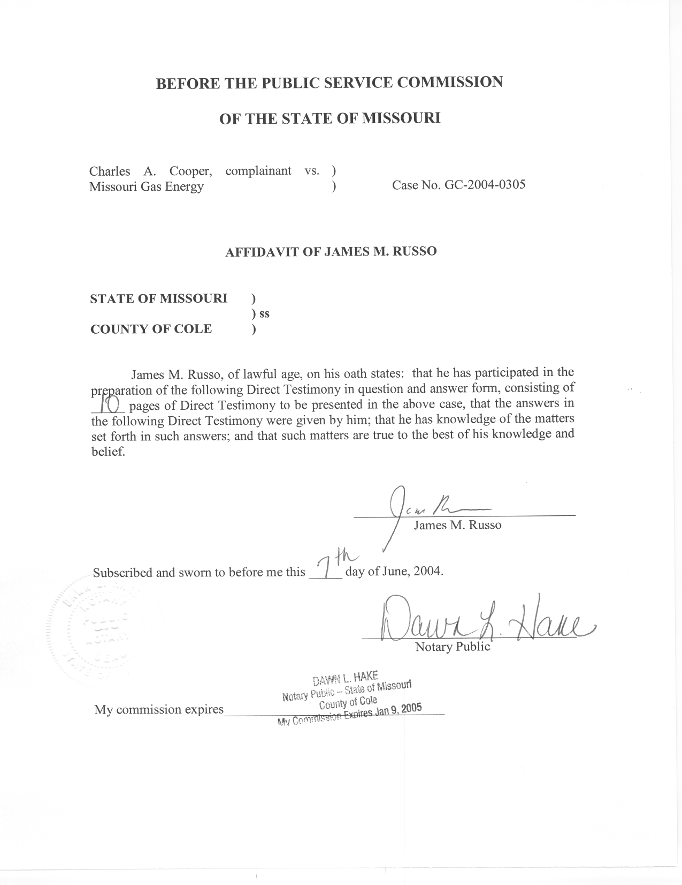

TABLE OF CONTENTS

Background 3
Tariffs 7
Summary of Staff Findings 9

DIRECT TESTIMONY

OF

JAMES M. RUSSO

MISSOURI GAS ENERGY

CASE NO. GC-2004-0305

Q. Please state your name and business address.
A. James M. Russo, P.O. Box 360, Jefferson City, Missouri 65102.
Q. By whom are you employed and in what capacity?
A. I am a Regulatory Auditor IV with the Missouri Public Service Commission (Commission).
Q. Please describe your educational background and other qualifications.
A. I graduated from California State University-Fresno, Fresno, California, and received a Bachelor of Science degree in Accounting. Prior to my employment with the Commission, local elected officials in county government employed me in various capacities. I was the assistant treasurer-tax collector for San Joaquin and El Dorado Counties in California. My responsibilities included all financial dealings of the counties and all accounting activities of the agency. In addition, I was the supervising accountant auditor in El Dorado County for two years. My division was responsible for internal audits of all county agencies, special districts, and franchise/lease agreements.
Q. What has been the nature of your duties with the Commission?
A. From April 1997 to December 2001, I worked in the Accounting Department of the Commission, where my duties consisted of directing and assisting with various audits and examinations of the books and records of public utilities operating within the State of Missouri; under the jurisdiction of the Commission. On December 16, 2001, I assumed the position of Regulatory Auditor IV in the Energy Tariffs/Rate Design Department where my duties consist of analyzing applications, reviewing tariffs, and making recommendations based upon these evaluations.
Q. Have you previously filed testimony before this Commission?
A. Yes. A list of cases in which I have filed testimony before this Commission is attached as Schedule 1 to my direct testimony.
Q. With reference to Case No. GC-2004-0305, have you reviewed and studied the complaint filed by the Complainant (Mr. Cooper) and the documentation provided by the Commission’s Consumers Service Staff (CSS) and Missouri Gas Energy (MGE or Company)?
A. Yes, I have.
Q. What other steps did you take in reviewing and studying this complaint?
A. I discussed the complaint with the Complainant, CSS and MGE. In addition, I reviewed MGE’S current tariff on file with the Commission.
Q. What is the purpose of your direct testimony?
A. The purpose of my direct testimony is to present the Commission Staff’s (Staff) findings relating to the complaint filed by the Complainant.
Q. What does Staff believe is the basis of the complaint?
A. Staff believes the complaint is whether MGE’s tariff allows MGE to deny Complainant’s service and charge Complainant for prior indebtness of a bill caused by unauthorized use of gas on one of the Complainant’s rented business properties. The identity of the person(s) responsible for the unauthorized use cannot be identified.

Background
Q. Please provide the history of this complaint.
A. The Complaint was filed on January 27, 2004, by Mr. Charles A. Cooper for property located at 6303-05 Evanston Avenue, Raytown, Missouri (6305 Evanston). MGE filed their response on February 26, 2004. Staff filed its recommendation on March 26, 2004. MGE filed its response to the Staff’s recommendation on April 5, 2004. A prehearing conference was held on April 21, 2004. The parties were unable to resolve the complaint at the prehearing conference and an Order Adopting Jointly Proposed Procedural Schedule was issued on May 11, 2004.
Q. What information did the Energy Department Staff (EDS) review from CSS?
A. EDS reviewed the documentation collected by the CSS Staff as it relates to this case. This includes the information entered by CSS in the Consumer Complaint Inquiry program, faxes between CSS and MGE and all the documentation CSS received from the Complainant and MGE.
Q. What information did the EDS review from the Complainant?
A. The EDS reviewed the correspondence, complaint, and the supporting documentation filed by the Complainant. In addition, Staff talked with Mr. Cooper concerning his complaint.
Q. When did Mr. Cooper receive the assignment of leases from the previous property owner?
A. Mr. Cooper received the assignment of leases for the property on July 2, 2001.
Q. Did Mr. Cooper provide Staff a copy of any of the leases?
A. Yes he provided a copy of a document titled Commercial and Industrial Lease Agreement that affects the property located at 6305 Evanston.
Q. What information was included on the copy of the lease provided to the Staff?
A. The document originally had an address of 6309 listed on it and was dated June 29, 2001. The former property owner and a Janet L. Byers signed the document. The 6309 address was crossed out and changed to 6303 and the words including 14 parking spaces were added. The changes are noted as occurring on July 3, 2001, and that the changes have the initials DCS next to them. The initials DCS appear to be one of the former property owners, Douglas C. Swinger.
Q. Did Staff discuss the complaint with Mr. Cooper?
A. Yes, Staff discussed the complaint with Mr. Cooper on March 11, 2004.
Q. What was the nature of Staff’s discussion of the complaint with Mr. Cooper?
A. Staff wanted to verify if, when and by whom the property was being rented. Staff was also interested in how the property at 6305 Evanston was being used and what the utility arrangements were for the property.
Q. Who was the tenant at 6305 Evanston for that time period?
A. Ms. Byers, doing business as Ready Set Go, was the tenant of record at 6305 Evanston during this time period.
Q. Staff is aware that Ms. Byers had the electricity service stopped at 6305 Evanston in July of 2002. Why did Mr. Cooper have the electricity placed in his name in August of 2002?
A. Mr. Cooper informed Staff that he had the electricity placed in his name because the air conditioning for the entire building ran off the unit that was located in 6305 Evanston. Mr. Cooper has tenants in 6307 and 6309 Evanston whose air conditioning is connected to the air conditioning unit located in the 6305 Evanston unit.
Q. Did Mr. Cooper state whether the tenant, Ms. Byers, was still renting the unit located at 6303 Evanston?
A. Yes. Mr. Cooper informed EDS that Ms. Byers was using the unit for storage of items including a table, chairs and playground equipment. Mr. Cooper also confirmed that Ms. Byers was renting the 14 parking spaces from him.
Q. Did EDS ask Mr. Cooper if he had any knowledge of La Petite Academy?
A. Yes. Mr. Cooper stated that Ms. Byers did not own La Petite Academy. Mr. Cooper did not know any reason why La Petite Academy would continue to have gas service in their name even though they no longer occupied the premises.
Q. What information did the EDS review from MGE?
A. EDS reviewed the documentation MGE provided to Staff, MGE’s answer filed with the Commission on February 26, 2004 and the EDS discussion of the complaint with MGE personnel.
Q. Who did MGE show as the customer for the property located 6305 Evanston during the time period ending December 18, 2002?
A. La Petite Academy.
Q. Did La Petite Academy pay for all the gas used at 6305 Evanston for the time period ending December 18, 2002?
A. Yes.
Q. Did MGE’s records list Ms. Janet L. Byers as the customer for 6305 Evanston during the time period of December 19, 2002 thru June 19, 2003?
A. No.
Q. What party did MGE show as being the customer at 6305 Evanston from December 19, 2002 thru June 19, 2003?
A. MGE’s records do not indicate any party was signed up for gas service at this property location after December 19, 2002.
Q. Do MGE’s records indicate any gas usage at 6305 Evanston after December 18, 2002?
A. Yes. MGE’s records indicate that there was unbilled gas usage of approximately of 805 Ccf’s.
Q. When did MGE discover this unauthorized gas usage?
A. There is a notation in MGE’s meter reading history for this account on January 8, 2003, stating: “CSS Identifies UBG.”
Q. How quickly did MGE turn off this unauthorized use of gas?
A. MGE’s records indicate that MGE waited 157 days before they turned off and locked the meter for UBG on June 14, 2003.
Q. What did MGE do next?
A. MGE removed the meter on June 19, 2003.
Q. What information did the EDS review from other sources?
A. The EDS reviewed the Company’s tariffs presently on file with the Commission and made a site visit to the property.
Q. What did Staff observe during their site visit to the property?
A. Staff’s site visit determined the building is a cinder block building with four doors that are individually addressed. The numbers on the doors and their location are 6303 on the rear of the building, 6305 on the side of the building, 6307 and 6309 are both located on the front of the building facing the street. There are three meters located on the rear of the building. Staff did not enter the building, but it is Staff’s understanding that 6303 and 6305 share common space separate from 6307 and 6309 that also share common space.

Tariffs
Q. What are the specific tariff sections that the EDS believe apply to this complaint?
A. The following sections from the rules and regulation section of MGE’s tariffs apply: Section 1.04 located on sheet number R-6, titled Customer, Section 3.02 located on sheet numbers R-19 and R-20, titled Prior Indebtness of Customer and Section 4.10 located on sheet numbers R-37 and R-38, titled Fraudulent Use of Service.
Q. What does Section 1.04 state?
A. Section 1.04 provides for the definition of customer. Customer is defined as a person or legal entity responsible for payment for service except one denoted as a guarantor. The term customer is also used to refer to an applicant for gas service.
Q. Is guarantor defined in MGE’s tariff?
A. No.
Q. Did the EDS find a definition for the word guarantor?
A. Yes. The American Heritage Dictionary, Second College Edition, defines guarantor as, “One that makes or gives a guarantee.”
Q. What does Section 3.02 state?
A. Section 3.02 states:
Company shall not be required to commence supplying gas service if at the time of application, the applicant, or any member of applicant’s household (who has received benefit from previous gas service), is indebted to Company for such gas service previously supplied at the same premises or any former premises until such indebtedness shall have been made.
Staff believes this tariff section is not applicable to Mr. Cooper as according to MGE’s records he was not the customer during the time period of unauthorized gas usage.
- What does Section 4.10 state?
A. Section 4.10 states:
In case of unauthorized or fraudulent use of gas in any manner on the premises occupied by customer with or without customer’s knowledge, where in the opinion of Company, an unsafe condition may have been created, service may be shut off without any advance notice, and shall not be resumed until customer shall have been given satisfactory assistance that such unauthorized or fraudulent use of gas has been discontinued and shall have paid to Company an amount estimated by Company to be a reasonable payment for gas so used and not paid for. Company shall also be entitled to collect a reconnection charge as provided in Section 14, herein.

The tariff continues with steps the Company may take if service is restored without the consent of the Company. This tariff section does not apply to Mr. Cooper. By definition, Mr. Cooper was not a customer of MGE and this tariff section clearly applies to MGE’s customers. Copies of the tariffs cited above have been attached to my Direct Testimony as Schedule 2.

Summary of Staff Findings
- Was Staff able to develop a timeline of events from the information gathered from the parties in this case?
- Yes. Staff developed the following timeline of events for the property located at 6305 Evanston:
December 12, 2001 La Petite Academy vacates premises.
June 29, 2001 Lease signed between former property owners and Ms. Byers.
July 2, 2001 Assignment of lease from Swinger to Cooper.
July 3, 2001 Lease modified and initialed.
July 2002 Ms. Byers has electricity turned off.
August 2002 Mr. Cooper has electricity turned on.
December 18, 2002 Meter turned off.
January 8, 2003 CSS identifies UBG
June 14, 2003 Meter locked for UBG
June 19, 2003 Meter removed
Q. Does Staff believe that MGE has the authority to deny service to Mr. Cooper for the delinquent amount of another party who was renting the property?
A. No. Staff does not believe that the facts in the case show Mr. Cooper is responsible under MGE’s existing tariffs for any of the gas usage during the time period of January 2003 thru June 2003. Mr. Cooper was not the customer as defined in Section 1.04 of MGE’s tariff, nor did he have any agreement with MGE making Mr. Cooper the guarantor for the property located at 6305 Evanston Avenue. Staff is also concerned that MGE took over five months to turn off the gas for unauthorized use at 6305 Evanston.
Staff believes it is erroneous to interpret Section 3.02 of MGE’s tariff to expand receiving benefit of service to individuals who are not the customer and/or persons outside the customer’s household since the tariff is explicitly limited to the customer and/or members of the customer’s household.
Staff does not believe Section 4.10 of MGE’s tariff would allow the Company to bill any party for unauthorized gas usage
Q. Does Staff believe MGE must provide service to Mr. Cooper?
A. Staff believes MGE must provide service to Mr. Cooper.
Q. Does this conclude your direct testimony?
A. Yes it does.

